et the most fg- **Lit** of the ALOA onventiori & . ecurity Expo\ ff

fith this months

DOUBLE

SSUE!

Official Publication of ALOA—An International Associati

PLUS!

**f** Scholarship Recipients  
**^** 2006 RLOR Board Members

ISSUE! Financial Report

Conuention, 100 years Rgo

Vellouj Pages Scheme and MORE!

BRECKH. CAMP CML PO BOX 47070 ATLANTA GA 30362-0070

11111111111111111111111111111111111111111111111111111111111)11

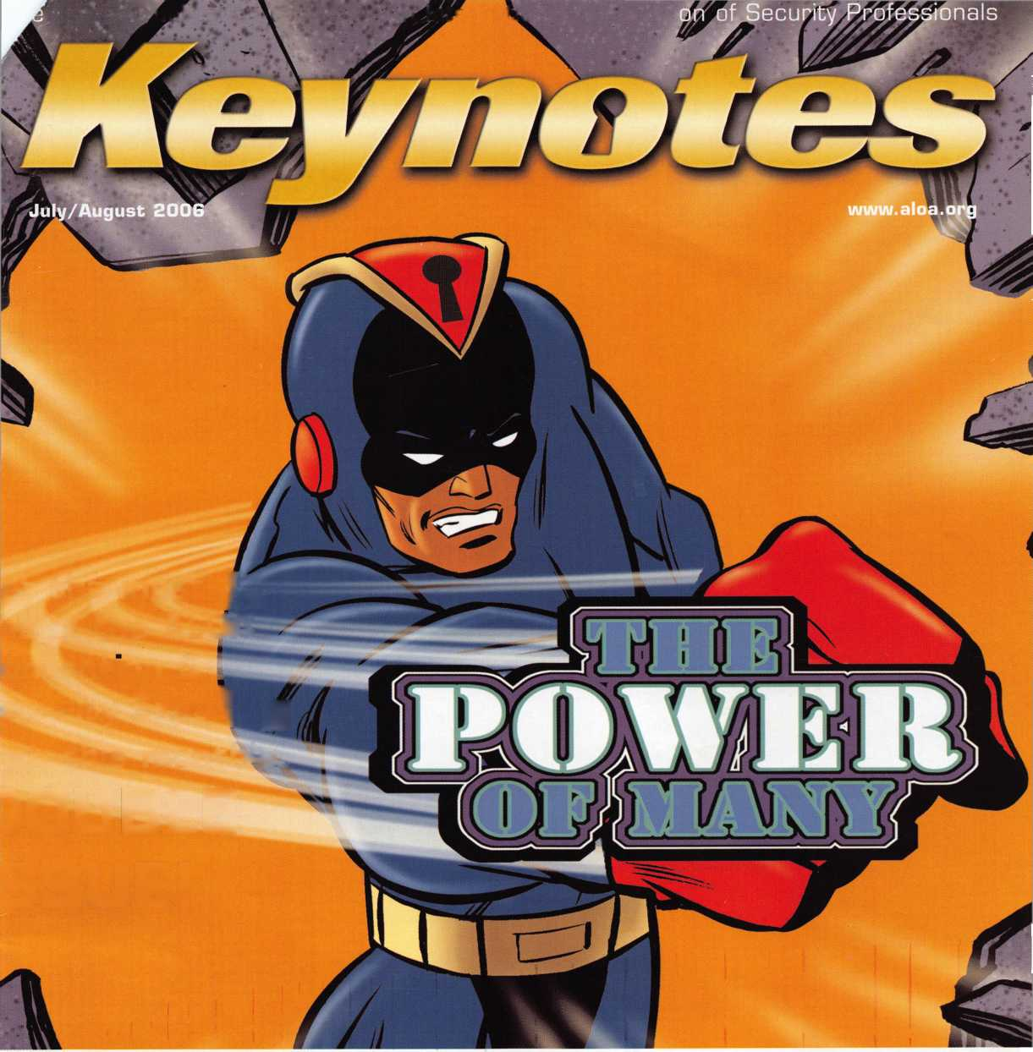

OUR STAND

IT’S QUITE POSSIBLY YOUR MOST

TRUSTED SIDEKICK

Keep it in Good Hands® with Allstate.

As a small business owner, there are few things you rely on more than your vehicle to keep you going. Your local Allstate agent can help protect it and your small business with services you need including

quick certificates of insurance, ID cards, assistance with the claims process, and more. Al from one of the most widely recognized names in the business.

**Are you in Good Hands®?**

*LOcksuit£*

Northbrook, IL. Allstate County Mutual Insurance Company, Irving, TX. All  
service mark of Allstate Insurance Company. ©2005 Allstate Insurance Cor

itate New Jersey Insurance ipany, Northbrook, IL.

/Illstate

You’re in good hands.

1-800-859-0247

**CALL NOW TO LOCATE YOUR NEARBY ALLSTATE AGENT.**

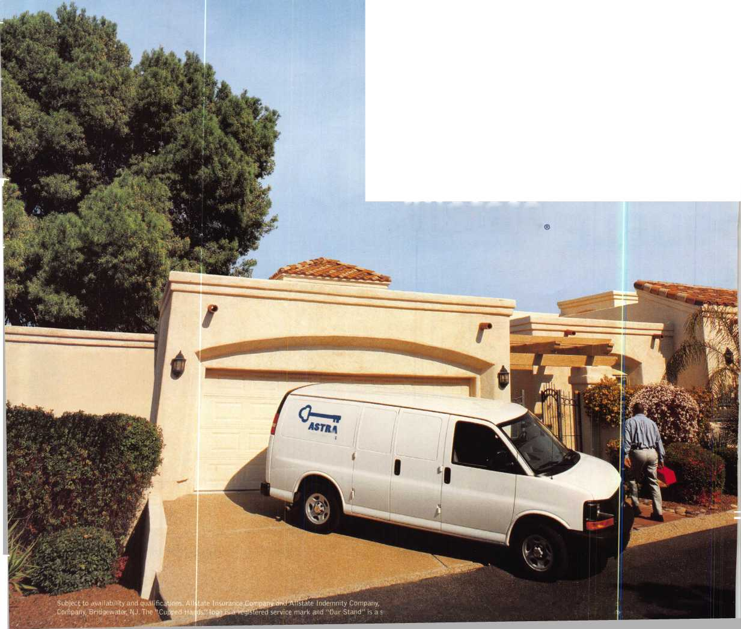

Top Notch Distributors. Inc

**Mark C. — Shipping 15 years of service**

**Janet C. — Shipping 19 years of service**

**Ryan C. — Shipping  
5 years of service**

**Bob S. — Shipping 14 years of service**

Top Notch has set standards in our industry by achieving the highest levels of customer service. We personally check and recheck every step in our process, making sure that your order is defect-free, complete, safely packed and optimally routed to you. In our industry, no one can match our same-day shipping and 99%+ order accuracy rate!

That’s just one way we prove that We Know Service. Top Notch also offers you the architectural hardware industry’s most complete product inventory, the expertise of a staff with an average of 15 years of experience, 12'h hours of highly personalized support a day and three strategic distribution points.

Now, we’ve taken We Know Service one step further with a customer support program called TND is Me! Because fulfilling all of your needs and expectations really comes down to a one-to-one relationship.

“You and me, partners in success.”

**East**

**Pennsylvania 1-800-233-4210 Fax: 1-800-854-4146**

**West**

**Nevada**

**1-800-722-4210 Fax: 1-800-248-3620**

**[www.topnotch.bz](http://www.topnotch.bz)**

**[sales@topnotch.bz](mailto:sales@topnotch.bz)**

**Midwest Missouri 1-800-211-4607 Fax:1-800-211-4608**

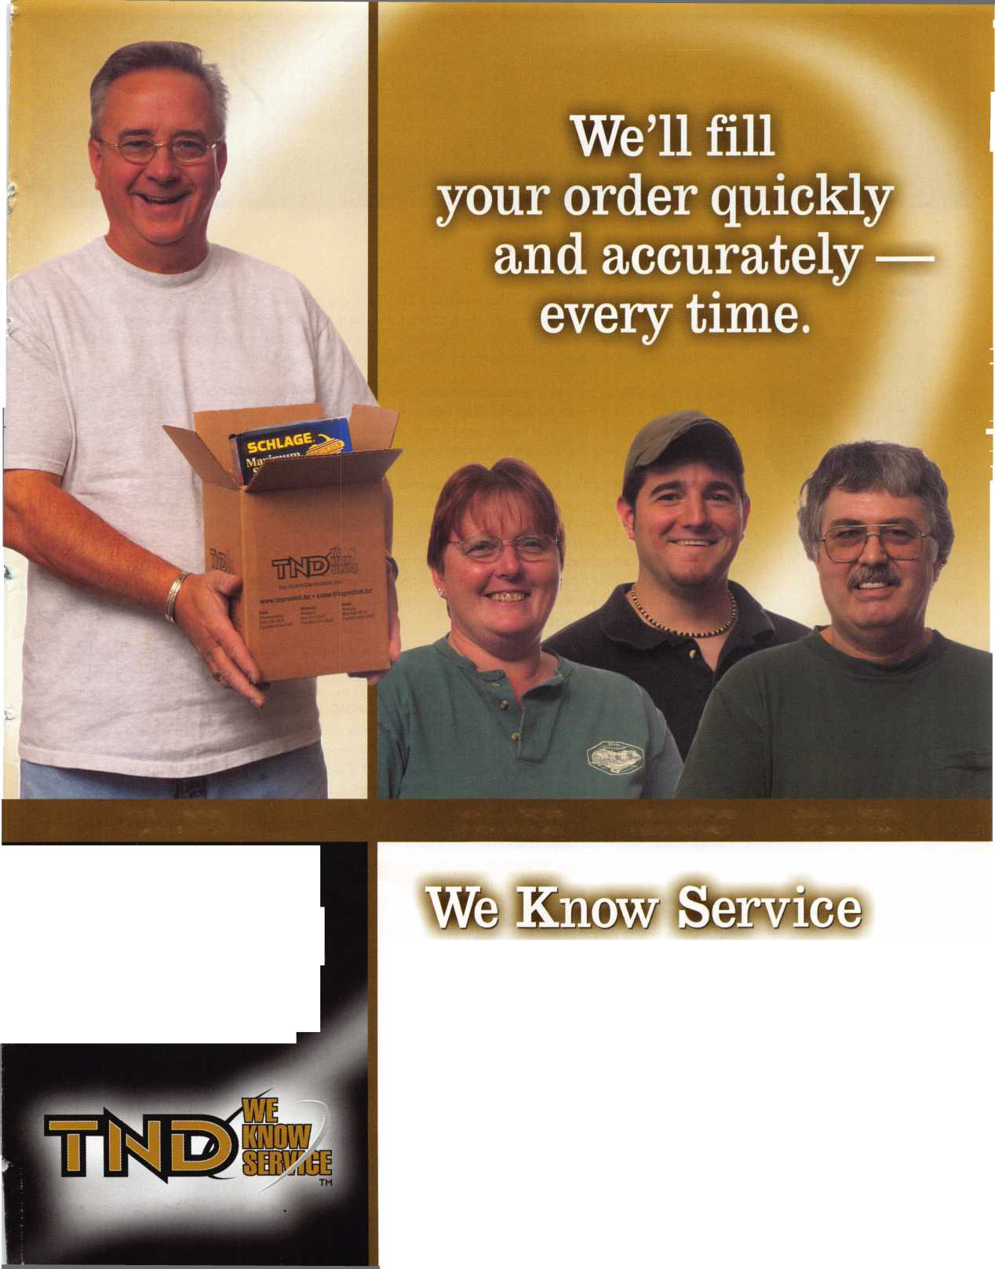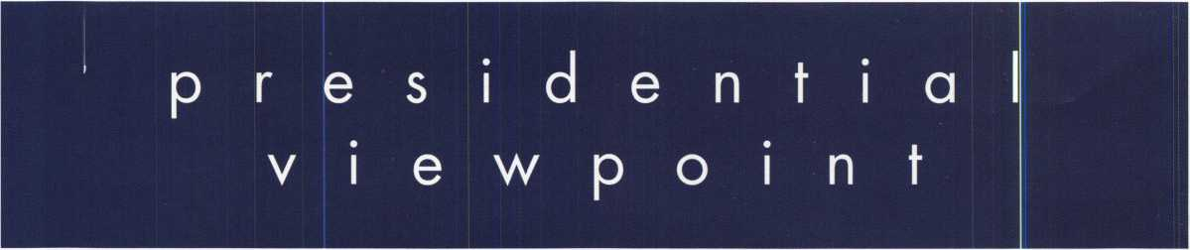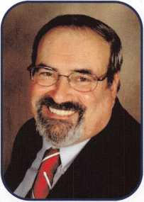

Dear Members and Friends,

Welcome to our Fiftieth Anniversary show issue of Keynotes. If you are a member of ALOA arid reading this issue, Happy Anniversary! If you are not, think about joining so that you can celebrate or seventy-five or one- hundred-year anniversary as a member who remembers when we were just a mere half century. Share in the celebration of knowledge, professionalism and comradeship that is ALOA!

I am sure, that fifty years ago, the founding members of the Associated Locksmiths of Ameri:a had hoped for a world-class association composed of locksmiths and other members of the security industry, but reality has far surpassed their hopes. In recent years I have spoken to some of those founding menrbers and they are truly pleased. They stand as proud parents of a truly-great association.

Belonging to ALOA can bring many personal rewards. The most valuable are the friendships that you can cultivate when attending conventions, educational events and local chapter and affiliates' meetings. Anoth­er derived benefit is that ALOA provides a conduit for information to be distributed for associations in the United States and around the world. By ALOA affiliating with other associations, we can share and dis­seminate information. It can range from legislation to a news item, a new product or a more productive work method. Whether it be local, state, nation or world, every bit of that information effects the whole indus­try. Six months ago I wrote my first Presidential Viewpoint entitled Communication. I still consider that the most important role of an association.

There are those who ask, "What can associations do for me?" Without associations, the quality, quantity and type of education would diminish. Associations keep a watchful eye on the future of our ndustry. They take hold of bad license attempts and mold it into something more beneficial to the industry and the con­sumer. ALOA has a model law which has been used and modified for several state licenses. Associations provide a rallying point, in which all the members can be active and express their views and when we speak as a group, our voices can be heard when dealing with government, manufacturers or other industries. ALOA has an excellent rapport with many associations throughout the world. It is with communicaticn and the free exchange of ideas that each association maximizes its potential.

If all this isn't enough, consider how an association is a nexus for interaction among its members for their mutual good. Even if you can't attend all the meeting and educational events, you can read, communicate or ask questions through the association's newsletter, magazine or internet site. No one person can do it all. It is we, as security professionals, joining together our ideas and strengths that will create a positive image for our industry.

ALOA, like any good association is always on the move, changing to meet new challenges and preparing itself for a bright future. To paraphrase Poet Robert Frost - The woods are lovely dark and deep, But I have promises to keep, And miles to go before I sleep, And miles to go before I sleep.

Take 'er easy!

Sincerely,



Robert E. Mock

Keynotes • July/August 2006

Simple to use, install, and maintain. Basic digital entry as  
simple as a single stand alone digital keypad for economical  
applications - or programmable digital keypads with access  
for hundreds of users and multiple doors and/or gates.

Complete systems that can include electric locks and  
access control devices linked to weigand control boards -  
all manufactured by DKS.

* Durability - backed by more than

50 years of Made-in-the-USA j/tm

manufacturing and expertise

* Outdoor use in all weather
* Easy to install magnetic  
  locks for both doors and  
  gates - a full line available  
  from 300 - 1200 lbs  
  holding force
* Vandal resistant - DKS

keypads feature:  
stainless steel  
faceplates, galvanized  
steel sub-plates, and  
rugged steel cabinets

Pmt Button

To CaH

We use DoorKing because they have a full line of products which provides us with one-stop shopping and they have a great customer service departmentV

*Scott Brose, Bejan Souferian* Co-Owners, Scotland Entry Systems, Inc.

Van Nuys, California

ACCESS CONTROL SOLUTIONS

for over fifty years

surface mount

**Locking and Entry**

single and multi-door access control

flush mount

magnetic lock

*mm*

1504 with intercom

**Designing and Manufacturing a full line of product since 1948**

Gate Operator

Telephone Entry

Parking Control

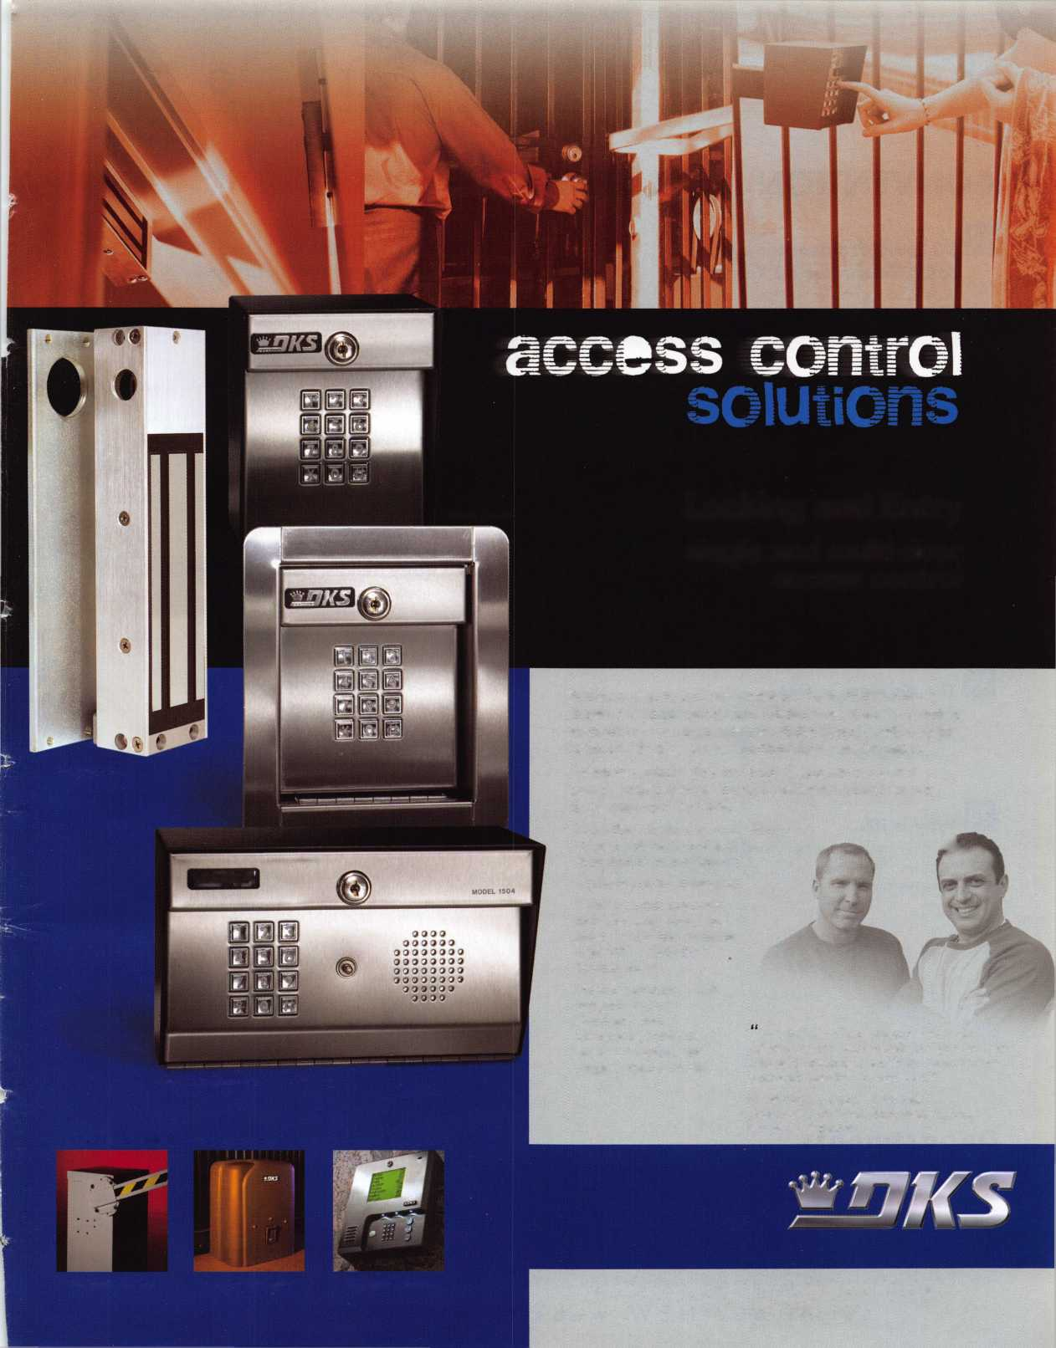

**features**

CONVENTION ISSUE 2006



50 Years of Advancement: ALOA Celebrates 50 Years!

Associated Locksmiths of America is celebrating its 50th anniversary this year. As early as 1929, U.S. locksmiths realized the value of sharing their knowledge with fellow locksmiths. Read on to find out more.

by Claire Cohen, CML



2006 ALOA Exhibitors

A complete listing of this years ALOA convention exhibitors.

**46**

Meet the 2006 ALOA Board!

You voted for them and now, here they are.

**14**

Last Century's Conventions

What would an ALOA convention like this be like 100 years ago? What would the differences would be?



Test Your Recruiting Skills

See how you measure up when it comes to recruiting the next addition to this great andw important organization of ours.

**18**

Locksmith Tricks-ter

Some might think every locksmith is as good as the next, T.F. Stern says,"Yeah, right".

by T.F. Stern

**54**

Bad Bob's Yellow Pages Scheme

Find out how some dealers are giving the security business a bad name and learn how to spot them.

**24**

The Pressure is On!

Greg Perrys skills are put to the test when he arrives for a job that presents him with the unexpected.

by Greg Perry, CML, CPS

**28**

Why is it?...

Murphys Law stikes when you least expect it. Greg Perry takes a look at a few "whys" in the world of locksmithing.

by Greg Perry, CML, CPS

**54**

The 2006 Scholarship Winners!!

Meet the scholarship winners here before you meet them at the ALOA 2006 Convention and Security Expo.

**66**

State of the Association and Financial Report

In this section, find financial information and updates for projects/news from the Associated Locksmiths of America.

**Departments**

|  |  |  |  |  |  |  |  |  |
| --- | --- | --- | --- | --- | --- | --- | --- | --- |
| Presidential |  | Executive | 5 | Calendar | 8 | Classified | 72 | Legislative 70 |
| Viewpoint | 2 | Applicants .... | 6 | Core | 76 | Associate Members | 64 |  |

Visit our NEW website at [www.aloa.org](http://www.aloa.org)

**executive**

Volume 52, Issue 7

Additional contact information for the ALOA Board and most Keynotes authors is  
available through "Locksmith Search" on the ALOA Web site- [www.aloa.org](http://www.aloa.org) or by  
contacting the ALOA office at 3500 Easy Street; Dallas, TX 75247; (800)532-2562;

FAX (214)819-9736; e-mail [aloa@aloa.org](mailto:aloa@aloa.org).

Editor

Betty Southerland [betty@aloa.org](mailto:betty@aloa.org)

Advertising Sales

Kim Hammond voice: 817-645-6778

Fax: 817-645-7599  
e-mail: [adsales@aloa.org](mailto:adsales@aloa.org)

Executive Director

Charles W. Gibson, Jr., CAE [charlie@aloa.org](mailto:charlie@aloa.org)

Associate Executive Director

David Lowell, CML, CMST [david@aloa.org](mailto:david@aloa.org)

Convention & Meetings Manager

Jo Anne Mims [joanne@aloa.org](mailto:joanne@aloa.org)

Operations/Membership Manager

Mary May [mary@aloa.org](mailto:mary@aloa.org)

Director of Creative Services

Betty Southerland [betty@aloa.org](mailto:betty@aloa.org)

Director of IT Operations

Greg K. Jackson [greg@aloa.org](mailto:greg@aloa.org)

Contributors

Jerome Andrews, CML Ray D'Adamo, CML

Paul Chandler, CRL Billy Edwards, CML

Claire Cohen, CML Dan Graffeo, CRL,CMST

Brian Costley, CML, CMST Jim Hancock, CPL

Eric Costley, CRL Jeff Nunberg, CML, CMST

Mission Statement: The Associated Locksmiths of America, Inc. is dedicated to enhancing the professionalism, education and ethics among  
locksmiths and those in related sectors of the physical security industry. With approximately 10,000 members in the United States, Canada and the  
freeworld, ALOA is poised to help members obtain the knowledge, the strength, and the confidence to perform their role in the physical security field  
with pride and dignity. But it is only through active involvement and participation that ALOA can fully achieve its potential—and can help members to  
achieve theirs.

Policies: Keynotes® is the official publication of the Associated Locksmiths of America, Inc. (ALOA). Keynotes® acts as a moderator without approving,  
disapproving, or guaranteeing the validity or accuracy of any data, claim, or opinion appearing under a byline or obtained or quoted from an acknowl-  
edged source. The opinions expressed by the authors do not necessarily reflect the official views of ALOA. Also, appearance of advertisements and  
new products or service information does not constitute an endorsement of products or services featured by the Association. The Association does not  
accept responsibility for the inaccuracy of any data, claim, or opinion appearing in this publication, due to typographical errors on the part of the  
authors, Association staff or its agents.

Editor's Note: This publication is designed to provide accurate and authoritative information in regard to the subject matter covered. It is provided  
and disseminated with the understanding that the publisher is not engaged in rendering legal or other professional services. If legal advice and other  
expert assistance is required, the services of a competent professional should be sought.

Authors' Payment: Payment for eligible submissions to Keynotes will be based on the following criteria: topic, time spent and past contributions. Authors who  
regularly submit to Keynotes® are generally paid a higher rate. The latter is especially true of authors who write to fit specific editorial needs and submit said copy  
by Keynotes® deadlines. As a general guideline: Average payment for a 750 word, business or 'light' technical article would be $200. Payment for a 1500 word  
article involving significantly higher time and research efforts would be $400.

Payment will not be offered for articles submitted by ALOA employees or members of the ALOA Board of Directors (unless material is of a technical  
nature), nor for articles submitted by a company that promote that company's products or services. ALOA reserves the right not to pay for articles sub-  
mitted by an individual(s) that promote a particular company's products or services.

Disclaimer: The Associated Locksmiths of America, Inc., (ALOA), reserves the right to refuse any article for any reason. Additionally, ALOA reserves  
the right to edit, amend or modify any article submitted for publication in order to preserve technical accuracy, clarity, fairness or grammatical cor-  
rectness. ALOA will make the best efforts to notify the author of any changes. The extent of ALOA's liability for any article or information contained  
therein will be a notice of correction or retraction in the next possible issue.

Keynotes® (ISSN 0277 0792) is published monthly except for the combined June/July issue by The Associated Locksmiths of America, Inc.,  
3500 Easy St., Dallas, TX 75247-6416. Telephone: (214) 819-9733; FAX (214) 819-9736; e-mail [aloa@aloa.org](mailto:aloa@aloa.org). Subscription rates for  
members—$15.00 per year. Periodical class postage paid at Dallas, Texas. POSTMASTER: Send address changes to: Keynotes, 3500 Easy St., Dallas,  
TX 75247-6416. © Copyright 2003, All rights reserved. No part of the contents may be reproduced or reprinted in any form without prior  
written permission of the publisher.

Comptroller Kathy J. Romo

Membership Coordinator Shelly Jett

Convention & Meetings Assistant Karen Lyons

PRP/Education Coordinator Mayra Ocon

Mail Room Coordinator Kevin Wesley

Creative Media Specialist Margarita Garza

Accounting Coordinator Joyce Nixon

Executive Assistant Sue Langford

Assistant Education Manager Bob Stafford

Legislation Manager Tim McMullen

Receptionist Shelley Melton

Randy Simpson, CML, CPP Tom Seroogy Robert Stafford, CML Charles Stephenson, CPS

Dave Thielen, CML Dennis Watanabe, CML, CMST

Greg Perry, CML,CPS



President

Robert Mock  
(856) 863-0710

[president@aioa.org](mailto:president@aioa.org)

Secretary

John Soderland, CML, CMST  
(414)327-5625  
secreta ry@aloa. org

Directors, Northeast

Peter Sarailian, CRL  
(201) 944-7547  
[nedirector@aloa.org](mailto:nedirector@aloa.org)

Vernon Kelley, CPL

1. 771-3126  
   [nedirectof@aba.org](mailto:nedirectof@aba.org)

Directors, Southeast

Tom Gillingham, Jr., CML, CPS  
(615) 264-0747  
sed i rector@aba. org

Ken Kupferman, CML  
(813) 961-5784  
[sedirector@aloa.org](mailto:sedirector@aloa.org)

Director, North Central

William Smith, RL  
(920) 893-5282

Guy Spinello, RL  
(815)394-1000  
[ncdirector@ciloa.org](mailto:ncdirector@ciloa.org)

Director, South Central

CD Lipscomb, CML, CPS  
(903) 874-3522  
[scdirector@aloa.org](mailto:scdirector@aloa.org)

Directors, Southwest

Gordon R. Racine, CML  
(719) 384-4707  
swdirecfor@aloa .org

Julie McCluney, CRL  
(714) 636-5652  
[swdirector@aloa.org](mailto:swdirector@aloa.org)

Director, Northwest

Jim Jeffries, CPS  
(877) 241-6978  
nwdirectot@aloa org

Director, European

Hans Mejlshede, CML  
(453) 539-3939  
eu rd i rector@a loa. org

Director, Asian

Joej. Lee, CRL  
(215) 289-2404  
[asiandirector@aloa.org](mailto:asiandirector@aloa.org)

Director, Associate

Paul M. Justen  
(612) 238-4646  
[asdirector@aloa.org](mailto:asdirector@aloa.org)

Trustees

[trustees@aloa.org](mailto:trustees@aloa.org)

Randy Simpson, CML  
(281) 240-5959  
John J. Greenan, CML, CPS  
(773) 486.2030

William Young, CML, CPS

1. 647-5042

Past Presidents

2003-2005 William Young, CML, CPS  
2001-2003 Randy Simpson, CML  
1999-2001 John Greenan, CML, CPS  
1997-1999 Dallas C. Brooks  
1995-1997 David Lowell, CML, CMST  
1993-1995 Breck Camp, CML  
1991-1993 Henry Printz, CML  
1989-1991 Evelyn Wersonick, CML, CPS  
1987-1989 Leonard Passarello, CPL  
1985-1987 Joe Jackman, CML  
1983-1985 Stanley Haney, CPL  
1981-1983 Louis LaGreco, CPL  
1979-1981 John Kerr, RL  
1977-1979 Clifford Cox, CML  
1974-1977 Charles Hetherington  
1972-1974 Gene Laughridge  
197G1972 William Dutcher, RL  
1968-1970 Constant Maffey, RL  
1966-1968 Harold Edelstein, RL  
1964-1966 William Meacham  
1962-1964 Robert Rackliffe, CPL  
196G1962 Edwin Toepfer, RL  
1956-1960 Ernest Johannesen



Keynotes • July/August 2006



Anchorage

Robert E. Grimes CRL

Sponsor: Robert M. Skoats

AL

Decatur

John Orr

Thorsby

Anthony J. Doody II

Sponsor: Danny W. Rudd CPL

AZ

Casa Grande

Raymond W. Hayes

Sponsor: William Lee CRL Goodyear

Timothy L. McGreevy

Sponsor: David M. Lowell CM, CMST New River

Kurtis Ryan

Sedona

Dan Wills

Sponsor: Milton R. Thompson CML

CA

Berkeley

Daniel E. Valdez Jane Barbarow

Goleta

Wel-Jara Johnson Morgan Hill Chris H. Olds

Norwalk

Jorge Morales

Oakland

Jeffrey M. Bovie

Sponsor: Brian A/1. Chan CRL San Francisco

Stephen Green

San Juan Capistrano

Robert J. Swadish

Sunnyvale

Brent S. Chaney

Temecula

Richard A. Morlett

West Hollywood

Marcel Itzhak

Sponsor: Ronnie Haim

CO

Longmont

Matthew A. McBride

Sponsor: Kelly K. McBride CPL

CT

Ledyard

Scott T. Perkins

Sponsor: John K. Humphreys CRL Stamford

Francis Wainwright

Sponsor: Andrew J. Karwoski CRL

DC

Washington

James A. Colaciello Howard S. Deares CPL

FL

Destin

Nicholas Reimer

Miami

David Gonzalez

Vero Beach

Brad R. Volpe

GA

Thomasville

Andy L. Brotzman

ID

Priest River

Clinton W. Coldiron



Bensenville

Gilberto Cervantes

Sponsor: Felipe S. Arce Fairview Heights

Chris M. Waterman

Sponsor: Terrill L. Smith North Chicago

Robert L. Harnden CRL

IN

Indianapolis

Karen Maples

Peru

James S. Arwood

KS

Kansas City

Adam Hines

*Sponsor: Jim Peters*

Louisville

Glen Barnes

**LA**

Jefferson

Lori A. Stone

Sponsor: Diane A/1. Foto CRL

MA

Charlton

David W. Webb

Sponsor: Richard C. Conroy CRL Methuen

James D. McLachlan

*Sponsor: Christopher V. Cunha Jr*

MD

Baltimore

John D. Phillips CRL

Sponsor: Michael E. Jordan Jr, CML Suitland

Calbert Brathwaite

ME

Lewiston

Carrie C. Hinkley

Sponsor: Maurice J. Robichaud CPL

Ml

Farmington

Robert Kowalkowski

MN

Taylors Falls

Chris P. Clasen

Sponsor: Charles E. Batcke CRL, CPS

MO

Saint Joseph

David A. Hahn

MS

Greenville

John T. Harmon

Robinsonville

Mary C. Davenport

Sponsor: Larry R. Dufrene RL

NC

Bahama

Carlie Smith

Sponsor: Richard P. Boynton

NJ

Teaneck

Amir Rubinshtein

NM

Farmington

Georgia G. McDonald

Sponsor: Deborah A. Pipkin

Jonathon T. Ryan

Sponsor: Deborah A. Pipkin

NV

Las Vegas

Richard T. Laffey Jorge M. Tinajero

Timothy Rosenberger

Sponsor: Robert F. Mangine

Ignacio Rivas

|  |  |
| --- | --- |
| |OH | |
| Cincinnati | Lang  mes T. Brickler CML  raner  ry W. McClain CRL  Fields |
| James C.  Sponsor: Jai Trenton  Scott W. F  Sponsor: Tei  James E. 1 |
| OK | |
| Choctaw | . Brill  ihur B. Parker CRL  Proper  ihur B. Parker CRL |
| Donald G  Sponsor: Ar Midwest City  Martin J. !  Sponsor: Ar |
| OR | |
| Bend  Paul D. Donnell | |
| PA | |
| Philadelphia  Jeffrey E. Frazier | |
| SC | |
| Anderson | Jriffin  cky H. Griffin  urnsey  y A. Iglesias CPL |
| George C  Sponsor: Be  Columbia |
| Randy R<  Sponsor: Ra |
| TN |  |
| Knoxville | Carney bert D. Butler  Maloney Sr Williams Jr  cAllister  eorge A. Mester CPL |
| Vance A. <  Sponsor: Ro  Robert J. i  Berlon D.  Nashville  Leon R. M  Sponsor: G> |
| ITX | |

Arlington

Gabriel Guevara

Grand Prairie

Justin Snider

Houston

Ricardo Torres

the

These applicants are scheduled for clearance as members of ALOA. The names are published for member review and comment within 30 days of this Keynotes issue date, respectively, to ensure  
applicants meet standards of ALOA's Code of Ethics. Protests, if any, should be addressed to the Membership Department and must be signed. Active Membership applicants (a) have worked in

industry two or more years. Allied Membership (AL) applicants are not locksmiths, but work in a security-related field. Apprentice Membership (AP) applicants have worked in the industry less than two years.

Keynotes • July/August 2006



Rowlett

Linda M. Showers

Sponsor: Som Showers

UT

Salt Lake City

Ron R. Firneno

Taylorsville

Kameron K. Howell

VA

Annandale

Walter I. Moreno

Sponsor: Tony J. Ashley CRL Arlington

Gerard R. Boll

Sponsor: Charles C. Robertson CML Woodbridge

Michael T. Uttaro

WA

Federal Way

Andrea M. Stevenson-Jones

Wl

West Allis

Dan C. Hofstetter

Kyle M. Whitlow

Sponsor: Mark B. Whitlow CRL

Belgium

Brussels

Johan Menu

Sponsor: Lambert Coumans

Canada

Calgary

Barry D. Legge CRL

Sponsor: Richard T. Johnson CPL

NS

Oxford

James W. Simpson RL Stephen L Simpson

Sponsor: Robert J. Simpson

*QC*

Westmount

Roger Ellis

Sponsor: Claude-Guy Dionne

Denmark

Copenhagen N

Brian DeBlanck

Sponsor: Hans Mejlshede CML

Lehna N. Jensen

Sponsor: Hans Mejlshede CML

Herdis Johansen Jeanette E. Anderson

Sponsor: Hans Mejlshede CML Frederiksberg C

Anders S. Jensen

Herlev

Stig Johan Nielsen

Oelsted

Per Vodstrup

Sponsor: Hans Mejlshede CML

Christian Sorensen

Sponsor: Hans Mejlshede CML

Remon Schjerlund

Sponsor: Hans Mejlshede CML Soeborg

Michael Anker

Sponsor: Hans Mejlshede CML

Jan Hansen

Sponsor: Hans Mejlshede CML

Enaland

Graham T. Skelhorn

Sponsor: Robert Collins

Grant White Sponsor: Robert Collins

Darren Foreman Milton Keynes Lee Nightingale Henry Hardcastle

Fok Siu-Sing

Israel

Bas Yuval

Sponsor: Chen Yehoshua RL

Savik Izraelov

Sponsor: Chen Yehoshua RL

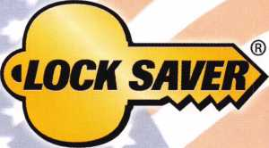

LUBRICANT PROTECTION  
FOR ALL LOCKS

World’s Finest Synthetic Lubricant

Long Lasting Lubrication & Protection

MADE IN THE USA

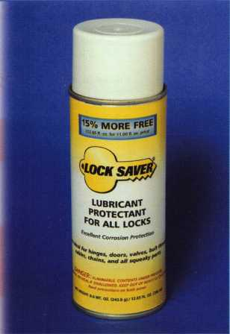

Environmentally Safe, Non-Toxic Will Not Gum Up or Clog Up For All Lock & Key Combinations

* Will Not Attract Dirt, Water or Debris
* Works Well in All Climates
* Temperature Range: -65°F to +450°F

MH

i

TOLL FREE: 800.743.4518

Mil-Comm Products Company, Inc.

Visit Our New Website: [www.mil-comm.com](http://www.mil-comm.com)

Keynotes • July/August 2006

**u p c o m**

events

i n g

|  |  |  |
| --- | --- | --- |
|  | 7/8-16 Associated Locksmiths of America | fjpgftll |
| >] | ALOA 50th Annual Convention & Security Expo |  |
|  | Las Vegas, NV |  |
|  | Contact: 800-532-2562 or visit [www.aloa.org](http://www.aloa.org) |  |

|  |  |  |  |  |  |
| --- | --- | --- | --- | --- | --- |
| AUG | 8/19-20 | OMLA  Classes, Meeting, Swap Meet & PRP  Contact: John Ruperd (417)-926-3689 | 8/19 The Locksmiths Security Association  LSA Hospitality Zone during the 1 2th annual  Woodward Dream Cruise  Contact: Bob Rovinsky (284)644-7939 or [lockprol@sbcglobal.net](mailto:lockprol@sbcglobal.net) | | |
| CL  UJ  CO | 9/15-16 | Doyle Security Products  20th Annual Trade Show & Educational Weekend  Minneapolis, MN  Contact: Chantelle Gallagher  800-333-6953 | Jovan Security Distributors  10th Annual Locksmiths Security Show and Education Conference  September 29-30 and October 1 st, 2006  2350 Midland Avenue, Toronto, ON MIS 1P8  Contact: Larry Malo 416-288-6306 or visit [www.jovanlock.com](http://www.jovanlock.com) | | |
| 1-  U  O |  | | Z  o  o  «/> | November 1 8th  OMLA Class - Access Control, CCTV, Nurse Call, Etc Contact: John Ruperd (417)-926-3689 |  |

**UPCOMING ACE CLASSES UPCOMING PRP SITTINGS**

7/8-16/2006

8/9/2006

8/18-19/2006

8/21-26/2006

9/15/2006

10/5/2006

10/10-13/2006

10/23-28/2006

Las Vegas, Nevada • ACE Classes

ALOA 50th Annual Convention & Security Expo

Contact: ALOA Education

[education@aloa.org](mailto:education@aloa.org)

[www.aloa.org](http://www.aloa.org)

Orlando, Florida • ACE Classes Clark Security Products Contact: Joan Emrick 619-718-7308

Birmingham, Alabama • ACE Classes Alabama Locksmith's Association Contact: Dallas Brooks [dallas287@charter.net](mailto:dallas287@charter.net) 334-826-8990

Dallas, Texas • ACE Classes Associated Locksmiths of America Contact: ALOA Education [education@aloa.org](mailto:education@aloa.org) 800-532-2562x104

Minneapolis, Minnesota • ACE Classes Doyle Security Products Trade Show Contact: Chantelle Gallagher 800-333-6953

Anaheim, California • ACE Classes Clark Security Products Contact: Joan Emrick 619-718-7308

Portland, Oregon • ACE Classes Pacific Locksmiths Association Contact: Bill Botek, CRL 503-644-9881

Appleton, Wisconsin • ACE Classes Fox Valley Technical College Contact: Ann Kading 800-735-3882x2482

|  |  |
| --- | --- |
| 7/13/2006 | Thursday 6:00 pm • Las Vegas, NV • ALOA 2006  Mayra Ocon 800-532-2562 x203 |
| 8/6/2006 | Sunday 8:00 am • Orlando, FL • Clark Security Products  Joan Emrick 619-718-7308 |
| 8/20/2006 | Sunday 9:00 am • Toledo, OH • McElheney Locksmith Inc.  Mike McElheney, CPL 419-244-5851 |
| 8/20/2006 | Sunday 8:00 am • Oklahoma City, OK • Oklahoma Master Locksmith Mike McGrew, CRL 918-333-9136 |
| 8/26/2006 | Saturday 3:00 pm • Dallas, TX • ALOA  Mayra Ocon 800-532-2562 x203 |
| 9/7/2006 | Saturday 9:00 am • Dallas, TX • ALOA  Mayra Ocon 800-532-2562 x203 |
| 10/12/2006 | Thursday 9:00 am • Dallas, TX • ALOA  Mayra Ocon 800-532-2562 x203 |
| 10/13/2006 | Friday 6:00 pm • Portland, OR • Pacific Locksmiths Association  Bill Botek, CRL 503-644-9881 |
| 10/28/2006 | Saturday 8:00 am • Roseville, Ml • LSA  Robert Noble, CML 810-385-9329 |
| 10/29/2006 | Sunday 10:00 am • Cherry Hill, NJ • GPLA  Robert Schuetrumpf, CRL 856-486-9280 |

**Contact the ALOA Education Department for a list of classes and training offered in-house.**

¥

**I**

A MILLION DISASTERS TO PROTECT AGAINST.

OVER 200 STYLES TO CHOOSE FROM.  
JUST ONE NAME TO REMEMBER.

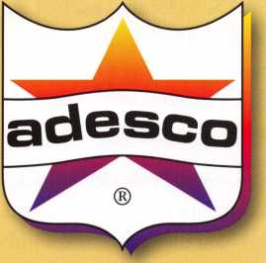

With a newly expanded line of UL@-rated safes, Adesco provides the best available protection against fire, impact, burglary and other disasters. Whether your customer base is primarily retail & commercial, US government, or residential, Adesco has literally hundreds of models and styles to suit their needs and protect their vital records, cash, and assets. Offer the best. Offer Adesco. 1-800-694-9340 • [www.adesco.com](http://www.adesco.com) A member of the FireKing® Security Group.

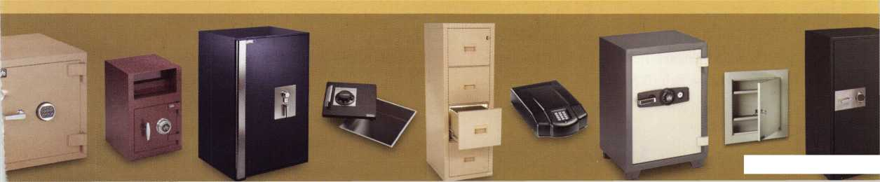

ALOA— Fifty Years of Advancement for the Locksmith Industry

by Claire L. Cohen, CML

As early as 1929, U.S. locksmiths realized the value of shar­ing their knowledge with others in the profession by getting together on a regular basis. The Master Locksmiths of New Jersey are credited as the first association to have initiated monthly meetings.

The New York Locksmith Association, backed by the National Locksmith Suppliers Association and M. Leonard Singer, decided to hold the first “Locksmiths’ Convention and Trade Show” in 1950. At that time, there were only a few locksmith organizations in the United States. It was evi­dent to the New York planning group, based on the turnout and enthusiasm, that this was a success. An idea was born— to grow the event into yearly gathering that would attract nationwide interest. Subsequent years brought more security professionals as the word spread. A banquet was added which filled every event to capacity.

At the 1954 event, there were discussions for the establish­ment of an organization for locksmiths on a national scale.

A committee was chosen to investigate the possibilities. The committee wanted to create an organization composed of those locksmiths who were in close proximity to meet on a regular basis, with limited expenditure of time or money.

Shortly after the convention, a committee met in Philadelphia, ready to meet the challenges presented to them at the 1954 convention. Ernest Johannsen, a Maryland lock­smith, is credited as “ALOAs Founder” and “ALOA Organization Committee Chairman”. Lee Rognon (New York) was appointed as Acting Secretary. Other founders included: Herman Henssler, Jr. (PA), John McLindon (Wash., D.C.), Robert Bell (New Jersey) , Edwin Toepfer

(Wisconsin), Robert Rackliffe (Mass), and Robert Rognon (NY). Although not originally a committee member, because of his intense interest, the committee voted Robert Nelson (PA) full committee privileges. Many meetings later, this committee submitted to the Secretary of New York State a request for a charter for a non-profit organization. With about 200 applications for membership in hand, this request was granted on December 8, 1955—Associated Locksmiths of Americas birth!

Ernest Johannsen became ALOAs first President and served for two terms. Much of the ALOA formation responsibility was on Lee Rognon, who was to go on and serve the associa­tion for almost two decades as its Executive Director.

In the initial planning of ALOA, it was decided that one of the major goals of the organization would be the sponsorship of a national trade show in conjunction with a national con­vention, provided the group who had help plan the 1950-52 and 1954 events would give ALOA its support. When they agreed, at the organizational meeting in 1956, a name was decided—Associated Locksmiths of America, along with the initials ALOA. The original logo, which is still used today, was designed by Leonard Singer (Editor of the Locksmith Ledger).

On July 15, 1956 the first ALOA Convention and Trade Show was held in Chicago, IL marking the 50th anniversary of the ALOA Convention and Security Expo. At that official meeting, the efforts of the founding group were recognized. There were 222 applications for active membership and 9 for Associate Members. To help with the costs of the first con­vention, each committee member loaned ALOA $100. The



Keynotes • July/August 2006

keynote address was given by Harry C Miller, President of Sargent and Greenleaf. Registration for members was free; the fee for wives and non-members was $ 1. Exhibitors consisted of 34 companies. The Safemen Division was introduced to create unity of both branches of the lock and key industry.

By the following year (1957) instead of one national con­vention, four regional meetings were held. The association had grown to 341 members and 10 Associate Members. The ALOA insignia was registered and ALOA members were given permission to use the insignia in advertising. Educational clinics were held at the 4 regional meetings.

Keynotes was registered as the official publication of ALOA in 1958, with a “new look” changing size to 5 ”x 8”.

ALOA members increased by 179 in 1959 and held con­ventions in four cities—all in the eastern half of the U.S.

The early 1960 s saw a new ALOA President. The Bylaws were changed to add a Board of Trustees. The number of exhibitors had grown and so had the attendance at conven­tions. The first full-day classes were taught at the conven­tion. The ALOA Film Lending Library, the ALOA Bonding Program and the ALOA Education Fund were begun. Membership had grown to nearly 1,000 members and 55 associate members. Annual dues went up to $15. Conventions were held in different parts of the country, enabling locksmiths to travel less by hosting conventions in both the Eastern and Western sections of the U.S.

As ALOA celebrated its 10-year anniversary, over 2,000 security professionals and their guests attended the National convention. A Security Standards Committee was begun. Just a few months earlier, the first International Security Conference was held.

At the end of the 1960 s, ALOA introduced a jacket with the ALOA patch for members. Education classes were increased from one day to two days covering nine different subjects. ALOA increased public visibility by contributed microfilm materials and artifacts that were placed in a time capsule and sponsored a security display at the Pentagon.

In the early 1970 s, ALOA office was moved from New York City to Kingston, NY. With more than 2,000 mem­bers, the demand for classes necessitated ALOA to expand its education program, increasing the number subjects taught and offered 3 full days of classes.

ALOA moved its headquarters to Dallas, Texas in 1973. There was now a Chairman of International Affairs. A spe­cial class on Masterkeying and Shop Management was taught to 17 Japanese, in their own language. Due to infla­tion, dues went to $25. The number of exhibitors at the convention had risen to well over 100, and the member­ship was now well over 3,000 members strong. The Education Committee expanded classes to weekend train­ing courses. This was the first time classes were held out­side conventions. Plans were also announced for the ALOA Library/Museum.

“Mr. Securi-T” was adopted and copyrighted as ALOAs public relation symbol in the late 1970 s. The ALOA Education Extension Program continued to thrive in week­end classes held throughout the country. The Stanley Haney Education Scholarship Fund was established.

ALOA had certainly gone international by the early 1980 s. At the Louisville, KY 1980 convention. 5,767 members attended and represented 50 states and 21 countries. With 5 full days of classes, locksmiths were offered over 40 class­es. Now 300 booths exhibited at the trade show. The Robert Bell Museum expanded to five times its original size.

The certification committee was well under way to com­pleting a national certification program and a new chapter of ALOA history was about to be written.

1985 marked the beginning of the Proficiency Registration Program (PRP), where at the Los Angeles, CA convention 200 eager locksmiths took the first PRP written examina­tion. In less than two years, the certification race was on and there were 56 CMLs, 180 CPLs, 1,445 RLs, and 555 members enrolled in the beginning process.

In the late 1980 s, the first instructor class was taught. 23 PRP test dates were offered to members at locations across the U.S. 10 recipients received scholarships from the ALOA Scholarship fund. 25 ALOA chapters were formed.

At the beginning of the 1990 s, Hong Kong became the first ALOA overseas chapter, as over 5,000 attendees attended the convention. The number of ALOA chapters had grown to 35. A record 354 exhibitors were at the trade show. ALOA and SAVTA joined forces.

Keynotes • July/August 2006

**li**

As we approached the end of the 20th century, member services increased. Dues rose to $100 per year. A website: [www.aloa.org](http://www.aloa.org) was introduced to ALOA members. The Professional Glossary of Terms and some Keynotes articles were translated into the Korean language.

Now in the 21st century, ALOA has a new, expanded home in Dallas, Texas. We are stronger than ever, with more than 8000 members and associate members across the globe. ALOA is truly an international organization. The locksmith certification program (PRP) has been grow­ing not only in the U.S., but in other counties, including Mexico and Asia. Certification will be expanded at an international level. A portion of the PRP has already been translated into Spanish, enabling our Latin American neighbors to more easily participate. The focus continues

to be on education and working together for the benefit of our members and our industry. ALOA members are offered a wide range of technical and business classes to keep up with todays changing technology.

The 50th Anniversary Convention in Las Vegas, NV this year will host a “Business Owners Group” concept idea aimed on those running a business, with perhaps different levels or tiers. Special Events marking the 50th anniversary of ALOA will honor past Presidents of ALOA as well as many other award winners and Charter Members, who have all helped shaped the ALOA of today. It is hoped that ALOA members marking this special time in ALOA history will be the contributors to even greater achieve­ment in years to come!

ALOA OPEN GOLF  
TOURNAMENT

ARROW

ASSA Retrofit Security  
Solutions  
Medeco  
ASSA  
Lucky Line  
Strattec, Inc.

KICK-OFF PARTY

ALOA Scholarship  
Foundation  
H.L. Flake  
Pacific Lock

INTERNATIONAL

RECEPTION

Medeco

CONVENTION

BAGS

Kaba llco

LANYARD

SPONSOR

Ingersoll-Rand Security  
Technologies

BANNERS

Videx

ASSA Abloy Americas  
Pacific Lock  
LaGard

POPCORN BAGS

ClearStar

SPECIAL DISPLAY

Corporate Safe

Celebrating 50 years of the ALOA Convention and Security Expo

SECURITY GROUP (Hi) Security & Safety „ SECURITY PRODUCTS

'fact,

**2**

Keynotes • July/August 2006

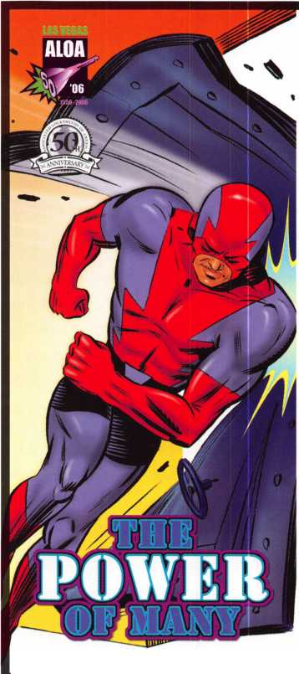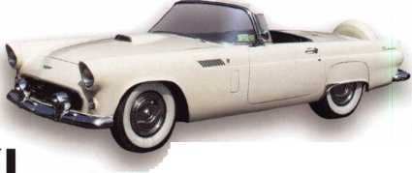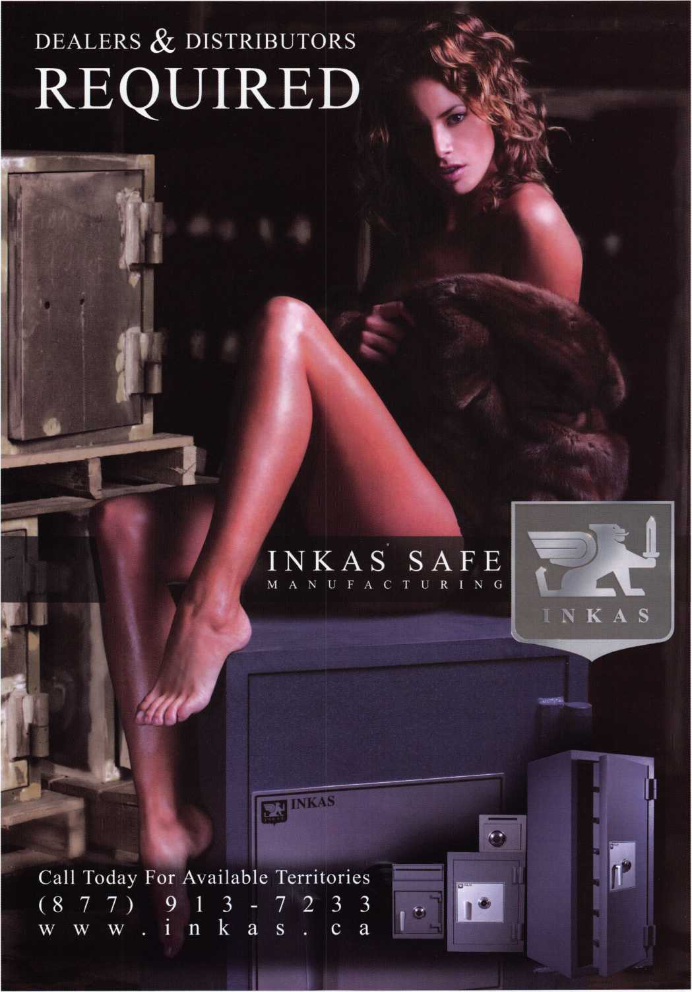

Last Century’s Conventions



This year marks the 50th anniversary of the ALOA Convention and Security Expo. It’s time to prepare for your convention. Or maybe you’re wondering if you’ll attend this year. Before you begin to dwell on the travel and prep time required, ask yourself: Suppose I was attend­ing a convention like this 100 years ago?

To be sure, very few trade and professional meetings of any sort were held a century ago, much less full-fledged gather­ings with the trappings of modern-day conventions. But if you could travel back in time, you’d quickly discover that a convention in those days was a very special event indeed. You’d realize, too, that arranging your attendance these days is nearly effortless. You see, 100 years ago ...

• Getting the word out took a while. Instantaneous e-mail wasn’t around 100 years ago. You’d receive information by surface post. But it might take a week or two to arrive from national headquarters, since most mail traveled by rail or horseback.

Asking questions was pricey. Suppose you had a question about your convention? You could amble down to the nearest telegraph operator and send an inquisitive telegram. But asking that question would be expensive.

Getting there was no fun. Commercial airlines didn’t exist. You might be able to take a train. If you were fortunate you had use of a car — but because only a few thousand miles of paved roads existed, your road trip wouldn’t be very comfortable.

Then again, few areas hosted conventions. Few spots on the North American continent offered facilities large enough for a full-fledged convention. The entire west coast was relatively unpopulated. And the Las Vegas area, scene of extensive convention activity today, had no strip and fewer than a hundred residents a century ago.

The accommodations weren’t like today’s hotels. You would check in by dipping the counter pin in the inkwell and signing the register. The clerk would



Keynotes • July/August 2006

Security Distributors Inc.

**JOVANI**

**SECURITY**

**DISTRIBUTORS**

Minneapolis, MN Tel: 1-800-333-6953 [www.doylesecurity.com](http://www.doylesecurity.com)

Toronto, ON, Canada Tel: 1-888-752-7210 [www.jovanlock.com](http://www.jovanlock.com)

**kdlhardwaresupply**

Seattle, WA

Tel: 1-800-926-7716

[www.kdlhardware.com](http://www.kdlhardware.com)

**FBI FRIED BROTHERS, INC**

Philadelphia, PA Tel: 1-800-523-2924 [www.FBIsecurity.com](http://www.FBIsecurity.com)

***Robert Skeels & Co,***

Carson, CA

Tel: 1-800-734-4539

[www.skeels.com](http://www.skeels.com)

***Hans Johnsen Co,***

Dallas,TX

Tel: 1-888-879-1500 [www.hjc.com](http://www.hjc.com)

***USCAN***

**America’s only**

**full service distributors**

LAS VEGAS

*t at the ALOA 2006 Convention and Security Expo  
Join us to celebrate ALOA’s 50th Anniversary*

*Trade show - July 13-15, 2006 Booth - 720*

2006

**CONVENTION**

**AND**

**SECURITY EXPO**

**Get to know your regional SDI Distributor Leaders in today’s world of security,**

|  |  |  |  |  |  |
| --- | --- | --- | --- | --- | --- |
|  | 1 |  | nr | ■j | ■2 |
|  |  |  | Security Products | | |

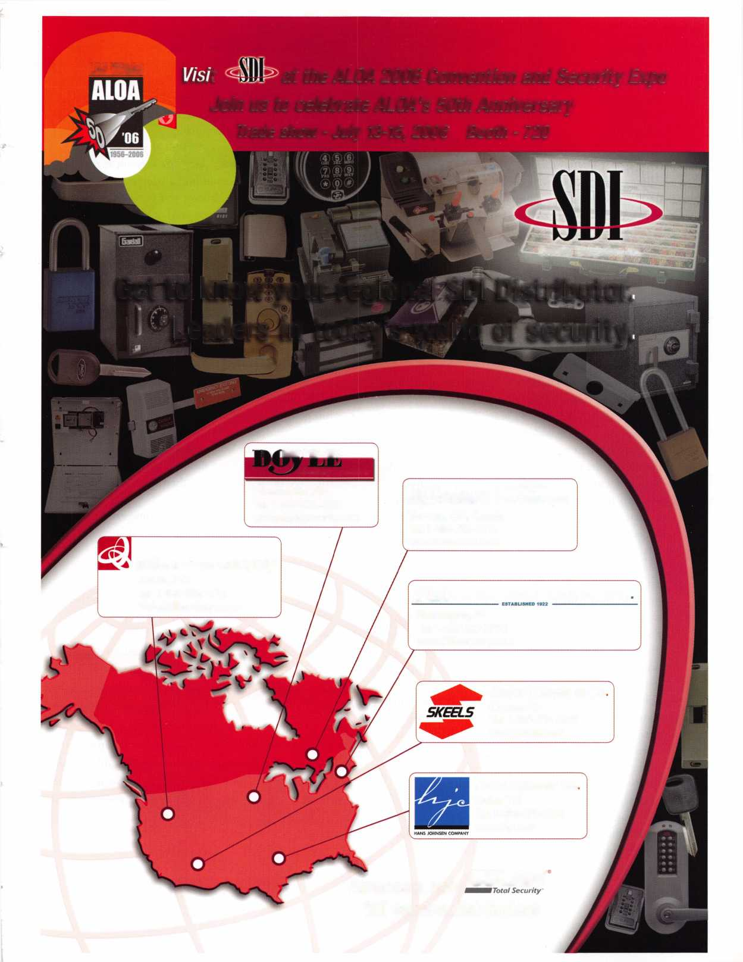

inform you when dinner would be served. Amenities might include an extra lamp or pillow. Concierges, gyms and spas would be many years in the future.

The roads weren’t paved with gold. When you arrived in town for your convention, you probably encoun­tered roads paved with brick. And if you smelled horse manure, if s because the horses traveling those roads deposited it there throughout the day.

Things cost less, but were highly valued. A “package deal” consisting of travel, food, and lodging, might have set you back a stunning $20 or $30 - insignifi­cant by todays standards, but a weighty sum a century ago.

Tips surprised you. Yes, you still had to tip servers and bellhops. But tips were measured in pennies!

The crowd was on the young side. When you arrived at your first gathering, you’d notice that most conven­tioneers were a little on the young side. You see, life spans were much shorter. The average individual in the U. S. only lived to the age of 47.

Badges were home-made. A few conventioneers might sport hand-lettered badges. But preprinted “Hello-my- name-is **...”** badges were 80 years into the future, and throwaway adhesive badges weren’t even conceived. Program content was sparse. A century ago, only a fraction of the products available today even existed. Management as a science hadn’t come to the fore. Modern marketing hadn’t been invented. Government regulation would come many years later, and no feder­al tax system had yet been implemented. Not much to talk about!

Reading matter wasn’t high on the distribution list. Books and periodicals were not common, and infor­mation was usually passed along through the spoken word. In fact, 20% of the overall population was func­tionally illiterate, and fewer than one in ten people had graduated from high school. And printing technology was primitive, making convention handouts expensive by today’s standards.

You didn’t find much luxury. True, a first-class hotel suite offered a comfortable bed and perhaps a sitting area. However, you may very well have had to share a common bathroom down the hall. And you had to make do with bathtubs; showers were quite rare.

Meals were events. No fast food back then.

Microwaves and modern stoves didn’t exist. Hotel food was hearty, but it was prepared the old-fashioned way (sometimes even over open flame), and you could expect to spend several hours over dinner.

* The drink menu was on the light side. You wouldn’t have found most sodas or juices. No chance of flavored teas. You’d probably have the opportunity to order cof­fee (brewed with a hint of bitterness). Whole milk would be on the menu. And for warm afternoons, you could always ask for lemonade.
* Staying in touch was expensive. If you wanted to “call home” to see how things were going at the office or shop, you could find a telephone and make

a call ... but that would cost you between $5 and $20 (depending on where were you), a small fortune in early 1900s currency.

* Not only that, but you’d need a stand-in back home. “Middle management” as we know it didn’t exist 100 years ago. So you’d have to promote one of your trust­ed employees as a stand-in manager. And you’d proba­bly have to pay him more than the twenty or thirty cents an hour he was making.
* You didn’t fund much in the entertainment package. “Attractions” didn’t exist 100 years ago. If you were fortunate, you might get to see a baseball game, or go strolling in one of the new urban parks.
* But getting away from the hotel took some effort. No taxis or tour buses drove through the streets in those days. You’d need a horse and carriage to get around.

Or if the city was large enough, it might offer an elec­tric streetcar system. Or ... then again, you might have been able to rent a bicycle.

* But then again, the town offered some exciting venues. You could check out the amazing revolving doors. Or ride on one of those new-fangled elevators.
* You’d bring extra clothes ... or spend some extra money. Some lodging establishments offered huge washing tubs. Guests could use them to clean their garments - by hand. Most finer hotels offered this service, often for a fee.

One hundred years ago, when your convention was all over, you’d make the long trek home and try to put a few of your convention lessons to work for you. Today you can get to your convention quickly and efficiently. Once there you can acquire an abundance of resources - ideas, product samples, contacts, and more — in a few invigorating action- packed days. And then you can return home and capitalize on your convention time just as efficiently. So as you pre­pare for this year’s convention, think about your mythical convention of 100 years past and prepare with anticipation and enthusiasm.

Keynotes • July/August 2006

in’RALOCC

TOOLS LIMITED

Celebrating 21 years of Innovation

and service to the locksmithing communi

SAFE TOOLS

NEW!

ITL Sidewinder

Our newest family member!

A high-performance, multiple sidewinder key-cutter with an unexpectedly affordable price.

950

ITL 9000

The original computer key-code machine.

ITL 9700A

The heavy-duty one. Used in correctional and educational institutions throughout the U.S.

ITL 950 series

The portable ones. Designed especially for installation in mobile locksmiths' vans.

Yes, we have our standards!

The following are common features for our ITL 9000,9700 and 950 series:

Customizable to cut Medeco™ keys. Some machines come with a Medeco™ head and cutter as standard.

Pre-loaded with 600+ manufacturer depths and spaces

99 sets of customizable depths and spaces

One cutter emulates all flat widths

RS232 communication port enables connection to laptop or computer

Compatible with 90% of commercially available coding software

CF function enables corrections to +/- .009 to adjust cuts for older locks

ITL 950C

ITL 2000 Safe Dialer

Finds a safe's combination

Inin HQ nt Al IIA within an average of 6 hours.

JUIII UO dl HLUH Avoids dri,lin9and damage

as we kick-off our 21st anniversary celebrations. to customers'safes

Prizes to be won

Visit our booth for a chance to win a key-cutting machine worth over $4,000.

We are giving away carbide cutters, insert caddies, lock boxes, code software updates and more during our anniversary year.

See our website for details.

[www.intralocktools.com](http://www.intralocktools.com)

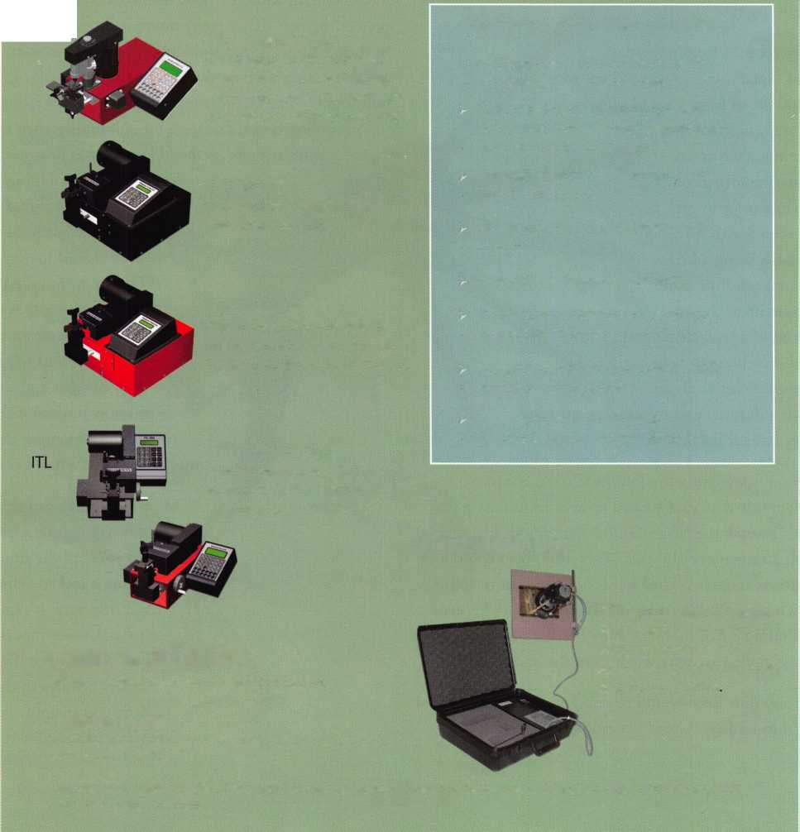

Locksmith Tricks-ter

byT.F. Stern

The State of Texas has mandated locksmith licensing along with mandatory continuing education to guarantee that Every Locksmith is Qualified to Handle Every Possible Situation that might arise. The public knows this and so it really doesn’t matter which locksmith they call. Every lock­smith is just as good as the next, they might think.

I say, “Yeah, right”.

I used to enjoy watching the Johnny Carson Show.

Ed McMahon had an exaggerated style of introducing the character, “Karnak the Magnificent,” with his all-inclusive impossible summary of abilities: “Everything you could ever want to know about...” Then he would hand off to Johnny, saying “Wrong, Oh, Master ofMetamucil\ rolling his eyes while hesitating a half moment as he flashed a boyish grin. This always pulled an extra laugh from the audience.

I like the way Jim Reed would respond when somebody told him they’d lost a key, “Great! (sounding like Tony the

Tiger™) Now, I’ll be able to make my car payment this month!”. He wouldn’t give them time to dwell on what he’d said, following it with an apologetic laugh to let them know he was only trying to lighten up the moment with a joke.

Years ago, I installed deadbolts, before I decided that work­ing on cars was what I enjoyed the most. I would take all the measurements, drill the holes as the customer went about pretending that they weren’t interested in my drilling holes in their house. I’d stop suddenly, a panicked look on my face and blurt out, “Oh no, this was the right door for the dead­bolt, right?” The blood would drain from their face as their eyes bugged out. I’d laugh mischieviously, then smile and wink at them so they’d know I was just messing

with their brain. The air would return to their lungs as they remembered that I was indeed working on the right door. It’s called having fun, something that will pro­vide future customers as they go about telling their friends what a great job and how professional you were. Did I mention that it’s important to do a great job too?

Most locksmiths can read a key’s profile to produce a working key. I do it all the time when opening a locked vehicle.

(As a side note; it’s important to make sure that the lock you are about to bypass actually belongs to the person asking you to apply your magic tricks. Following

I regularly get calls from potential customers explaining in a worried voice about a lost set of keys. I could silently nod my head, not that they would see me, take down the necessary information, quote them a price to get them on their way; Or lis­ten to what is being asked for which takes a little more effort. Sometimes, they don’t just need a replacement key, they need somebody to help make them feel better about being such a dummy and to pull that off takes more than basic locksmith skills.

**8**

Keynotes • July/August 2006



Remember When?

“'SECTORS

S> ALOA /.

**,ent»o«**

* Did you know that the ALOA Logo was created in 1956 by Mr. Leonard Singer, the same year “Dear Abby” first appeared in newspapers?
* Did you know that ALOA once gave away an 800- pound live bull to a convention attendee?

All this and  
MORE inside

Keyed Up:

50 Years of the

Associated

Locksmiths of

America!

Keyed Up: 50 Years of the Associated Locksmiths of America tells the story of ALOA with exciting visuals and fun facts created to entertain you and inspire you. This special-edition hardcopy display book is sure to become a collector’s item.

Your picture may be inside! This edition includes a special section featuring images of attendees, exhibitors and instructors present at the 2006 50th Anniversary of the

ALOA Convention and Security Expo.

Preorder your copy today!

$29.95

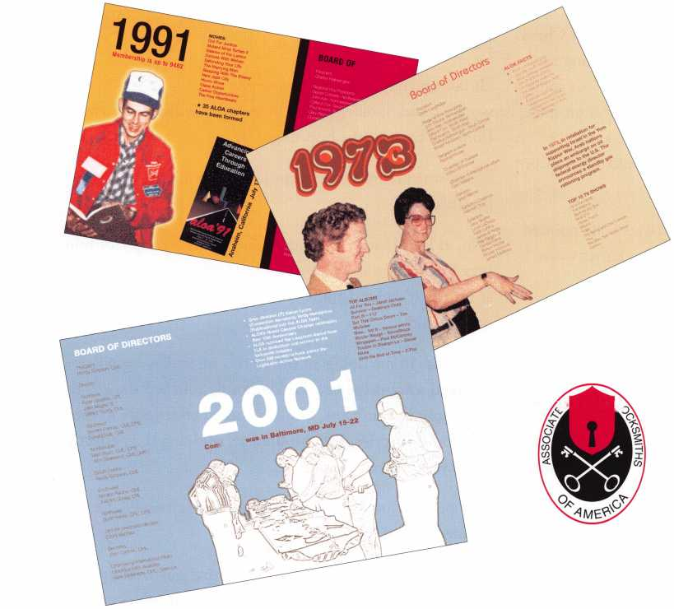

ALOA’s Positive ID Policy, get some proof: a driver’s license, an insurance card with a matching name along with the VTN to satisfy yourself prior to working.)

Sometimes the keys are hanging in plain sight and with a little effort the information can be had. I have one of those neat little ocular tools which permits me to magnify the image which is a real help for my aging eyes.

I was once reading the profile of a key inside an old Chevy truck. The customer and his friends keenly watching my activities. They’d expected me to use a Slim Jim™ or some similar opening tool. It dawned on me that I was on stage, **performing.** The spot light was aimed and the audience hushed in eager anticipation. “Maybe I should sell popcorn at intermission”, I said to myself.

“What’s that thing do?”, the customer asked as he pointed to my fancy little magnifier. I was reading a rather worn original six-cut GM door key at the time.

“Oh, the sides of original GM keys are imprinted with an invisible key code. This thing has infrared filters so I can read those codes.”, I joked. You’ve got to have some fun at work. Plus, veiled answers extend the mystery of the lock­smith profession.

The most fun I had on a lockout was on a similar set up. Upon arriving, I was able to read the door key without making a big deal of it. The cuts were so clearly defined as to make it child’s play. I walked to the back of my truck, clipped a key and the thought occurred to me, “Have some fun. The job’s as good as done!” I took a second key from the rack, a blank and showed it to the customer.

“These are made out of some kind of fancy alloy material designed by NASA. I got them at the locksmith conven­tion last month and I’ve been waiting to try them out.

You’re my first chance to see if they really do work. They’re supposed to cut themselves right there inside the lock.”, I fibbed.

“No way!”, exclaimed the customer with an incredulous look on his face. (I’ve intentionally omitted the all-too- common expletive between **No** and **Way).** He half believed it might be true, while discounting such a possibility as totally unbelievable BS. I palmed the blank and in its place I inserted the already-cut key.

“It takes a couple of minutes for the chemical reaction to work”, I said, looking at the time and standing back away from the car as if the heat might be too intense.

“That won’t damage my paint job or anything, will it?”, he asked.

“No, at least that’s what they claim.” After a couple of min­utes I went over and tapped on the key to “set the cuts” or at least that’s what I think I told him. “It should be done now.” I said.

“No sense in me doing all the work”, offered as I guided his hand toward the key. He cautiously touched the key to make sure it wasn’t hot. The key turned effortlessly in the lock to his surprise. He withdrew it, studying the perfectly cut key in amazement.

“I hope only locksmiths can buy these fancy keys!”, he shouted.

I never did ’fess up to what I’d done; that guy could pass a lie detector test about it today. I hope the next locksmith is up to the challenge and has a box of those self-cutting NASA key blanks ready. A Slim Jim™ just won’t be near as professional.

**20**

Keynotes • July/August 2006

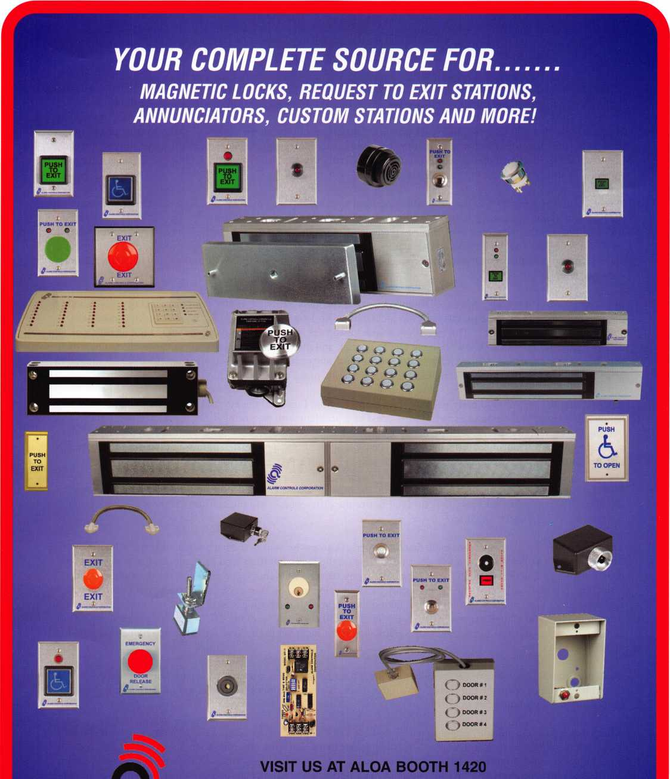

***ALARM CONTROLS CORPORATION***

**19 BRANDYWINE DRIVE P.O. BOX 280 DEER PARK, NY 11729 PH: 800 645-5538 FAX: 631 586-6500**

**EMAIL: [INFO@ALARMCONTROLS.COM](mailto:INFO@ALARMCONTROLS.COM)  
WEB: ALARMCONTROLS.COM**

Pacific Lock Company

When I joined the family business a little over a year ago, we had much work to do. In that year, we have revamped our company from the ground up. Formerly known as Federal Lock, a California corporation, Pacific Lock Company (PACLOCK®) has trimmed and focused its product line. At the same time, we’ve developed innovative business ideas that will do more than just make our company profitable ~ our ideas will make your company more profitable. Our new ideas will be the reasons why your customers return to buy padlocks from jam instead of the big, discount retailer down the street. PACLOCK is offering you the ability to sell a unique product that only you can sell: a padlock with your customer’s name on it.

Why is this so important? I can say that after speaking with hundreds of individual locksmiths across the country in the past few months, it is clear to me that the locksmith-padlock business is in jeopardy. Let me be more specific ~ if you sell other manufacturer’s high security padlocks, then your business is in jeopardy. Have you noticed that your customers are now buying solid-body padlocks at far reduced pricing from the high-volume discount retailers? Have you seen the other manufacturers’ products gradually showing up on the shelves of the big discount retailers? How can a locksmith compete?

In the past, consumers could purchase laminated locks at the local hardware center. But high security, solid-body 6- pin rekeyable locks had to be purchased from locksmiths. No longer is this the case. High security is now being sold at “everyday low prices”. The catch is that your customers think they’re buying the same high quality lock at a much cheaper price. We all know, though, that looks can, and often are, deceiving. I recently purchased one such lock from a big retailer. It looked to be as durable as the comparable lock my company manufactures. It looked to be as capable as the lock my company manufactures. But its looks truly were deceiving.

After pulling the 1-3/4” solid body padlock from its packaging, I inserted the key and turned the cylinder. Nothing happened. “Hum,” I thought to myself, “there must be a problem with the spring.” Well, I was wrong. There was nothing wrong with the spring because the lock had no shackle spring! What’s more, I noticed on the back of the packaging in small lettering that the cylinder was only a 4-pin. I was a bit miffed at this, but then I remembered that I paid about $6 less for this lock than I would have had I bought a PACLOCK 100 Series lock.

Sure, I noticed the cost-savings measures taken by the big manufacturer and understood how the lock had been cheapened. But would your everyday customer notice the differences? My guess is, no. So how can a locksmith compete in such an unfair situation?

The PACLOCK solution is to earn back that customer’s business by selling them a padlock that has additional value to your consumer. Put your customer’s business name on the lock. Put their logo on the lock. Put whatever they want on the lock and charge them for it. There are many reasons why your customers will see the value in this capability, but I will offer just one. High security locks are expensive. Businesses often spend a lot of money replacing locks that get “lost” by employees taking them home. If the business were able to put their name on the front of the lock, then these expensive locks are much less likely to go “walking off.” Sure, they may spend an additional couple of bucks to get their name engraved on the lock, but in the long run they save money because they “lose” less locks.

More importantly, you have re-secured your business because your customer can no longer buy that highly customized padlock from the big retailer down the street. Your customers have to come back to you because they cannot buy these padlocks anywhere else.

Again, this is just one quick example of why PACLOCK’s “Your Logo, Your Locks”® program will help you win back your customer base. Not to mention, this is just one example of the innovative ideas that PACLOCK has brought to the padlock industry this year. We encourage you to visit with us at the ALOA convention and pick up your free, commemorative 50th Anniversary ALOA padlock. We’ll be happy to show you why there is no better manufacturer of padlocks than Pacific Lock, your partner in the padlock business.

**INDY**

**LOCK**

**SHOW**

PARTS

888.562.5565

**[www.paclock.com](http://www.paclock.com)**

**Brass .75**

**Steel $0.95**

No *minimum orders*No *setup fees\**

*Guaranteed 10-business day shipping  
on ALL orders*

*Make money in ways you never could  
before by charging your customers for  
"your engraving service."*

***"Your Logo, Your Locks*** Pricing Example

**Aluminum .45**

**PACIFIC LOCK**

**CREATING MANUFACTURERS,  
ONE LOCKSMITH AT A TIME**

Starting to lose your padlock business to the big retailer down the street? Realizing that special keys or keyways won't prevent your customers from leaving you for low prices? Then stop selling padlocks made by a manufacturer who is now directly competing with you by selling through big retail chains! Sell your customers a product that they can only buy from you...a PACLOCK with THEIR logo.

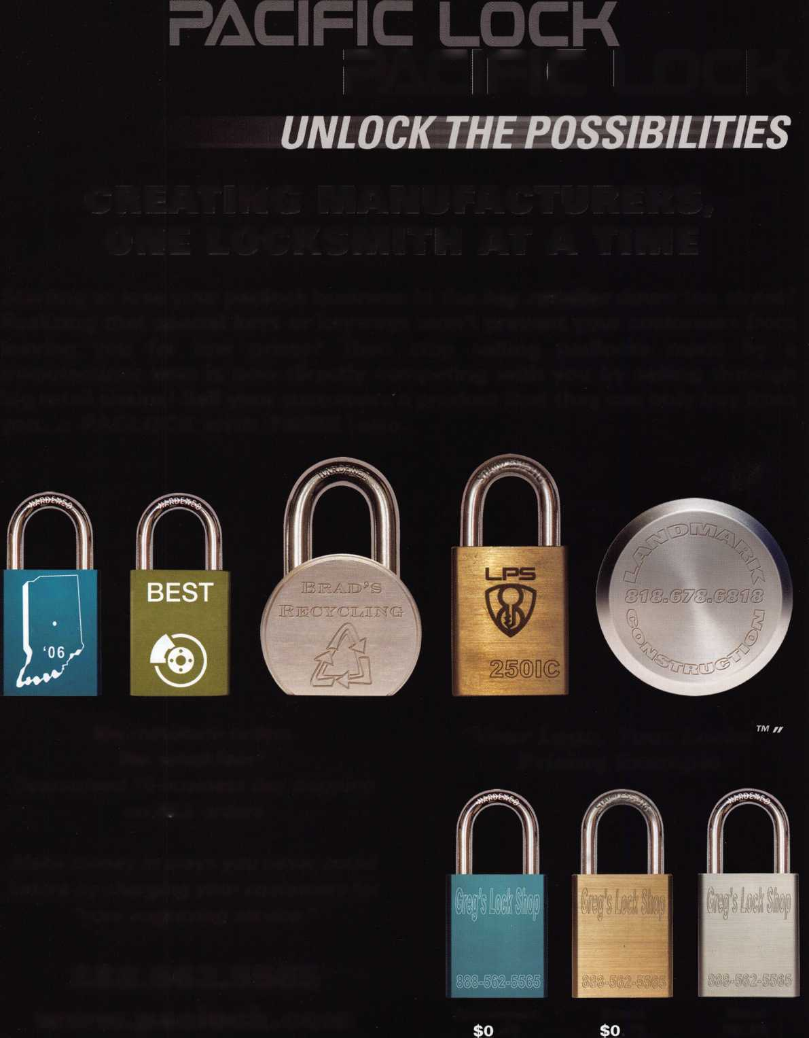

The Pressure is

Greg Perry, CML, CPS

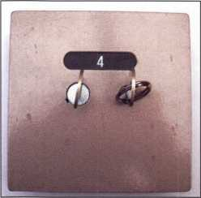

1

The job was scheduled over  
the weekend for 8:30 AM  
Monday morning. A hotel  
guest had lost his key and  
needed a safe deposit box  
opened. Assuming it was an  
S&G 4440 or perhaps a  
Security with a pin tumbler



The number on the back of the lock reads 106 but all the info I have from the factory calls it a VI0. Some lever locks can be drilled and picked, others pull the nose, and the levers will drop and manipulate the foot over to retract the bolt. I’ve opened the X4 from them but what is the most efficient way to open a VI0.

I checked my reference materials for thoughts on the most efficient way to open this lock. I found a template from the factory giving a dimension of 1/2” up 7/8” over from the centerline of the renter’s nose away from the guard nose to drill the fence off at the point it enters the lever pack using a 3/8” bit. This measurement requires replace­ment of the drawer front including the lock, and appears to be aimed at an untrained person. The hotel already told me they are retiring this bank of boxes so they didn’t care how it was opened. Being under pressure to get it open I used this measurement and opened the box quickly. Once this box was open it was time to disassemble a differ­ent drawer for future reference.

The first thing to notice is this box does not have hinges; instead the door is a part of the drawer or bond box.

Photo 2 shows a top view of the assembly. The operation is as follows: insert the guard key and turn, insert the renter’s key, turn and pull the drawer out. The front is cast aluminum and the bond box is plastic so the unit is not very heavy. Jim Miles designed this lock and box to avoid the use of hinges and keep the cost very low. The front or door is held to the box with eight screws. Once these are removed the plastic bond box can be set a side for us to work on the lock. The next major difference is the lock case. Unlike most safe deposit locks, the VI0 uses the door as the lock case. Instead of removing the front, this lock has a back cover to remove. Photo 3 has two of the screws reinstalled with nuts as spacers to hold the metal cover/back of the lock in place.

Looking inside the lock with the back cover removed we see the two piece bolt assembly, both noses and the lever

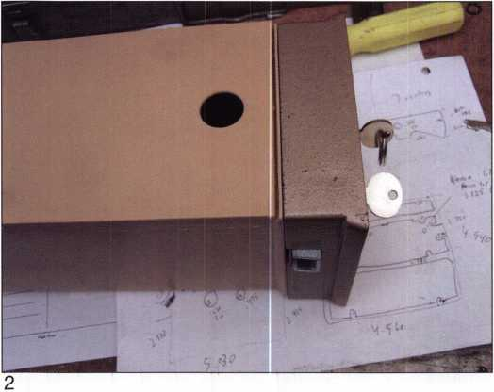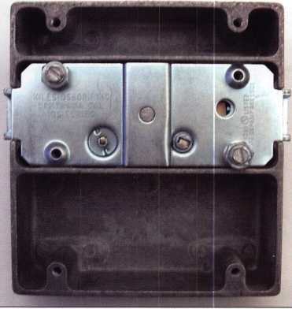

cylinder I was on my way to a quickie opening. When I  
arrived I found out the guest was leaving on a plane at

10:00 and  
it wasn’t a  
4440 or  
pin tum-  
bler.

Instead I  
found the  
Miles  
Osborne  
model 106  
or V10 like  
the one  
seen in  
photo 1.



Keynotes • July/August 2006

I

I

i

i

Fl reking/Gary MEILINK

t/OR SAFES THAT FIT EVERY NEED AND BUDGET, COUNT ON THE TRUSTED BRANDS OF FlREKlNG® SECURITY GROUP. ADESCO® OFFERS SAFES FOR GOVERNMENT, COMMERCIAL AND RESIDENTIAL CUSTOMERS. MEILINK® PROVIDES FIRE- AND BURGLARY-RATED SAFES FOR BANKS, SCHOOLS AND RETAIL ESTABLISHMENTS. AND FlREKlNG FEATURES UL®-RATED FIRE/ IMPACT/BURGLARY RESISTANT SAFES BACKED BY OVER 50 YEARS OF SECURITY EXPERIENCE. PLUS, EACH BRAND COMES WITH EXCLUSIVE 24/7/365 TECHNICAL SUPPORT. SO FIND OUT MORE ABOUT FlREKlNG SECURITY GROUP. YOUR CUSTOMERS TRUST YOU TO RECOMMEND THE BEST. TRUST US TO PROVIDE IT.

a/

**FireKing**

SECURITY GROUP W

[www.fireking.com](http://www.fireking.com)

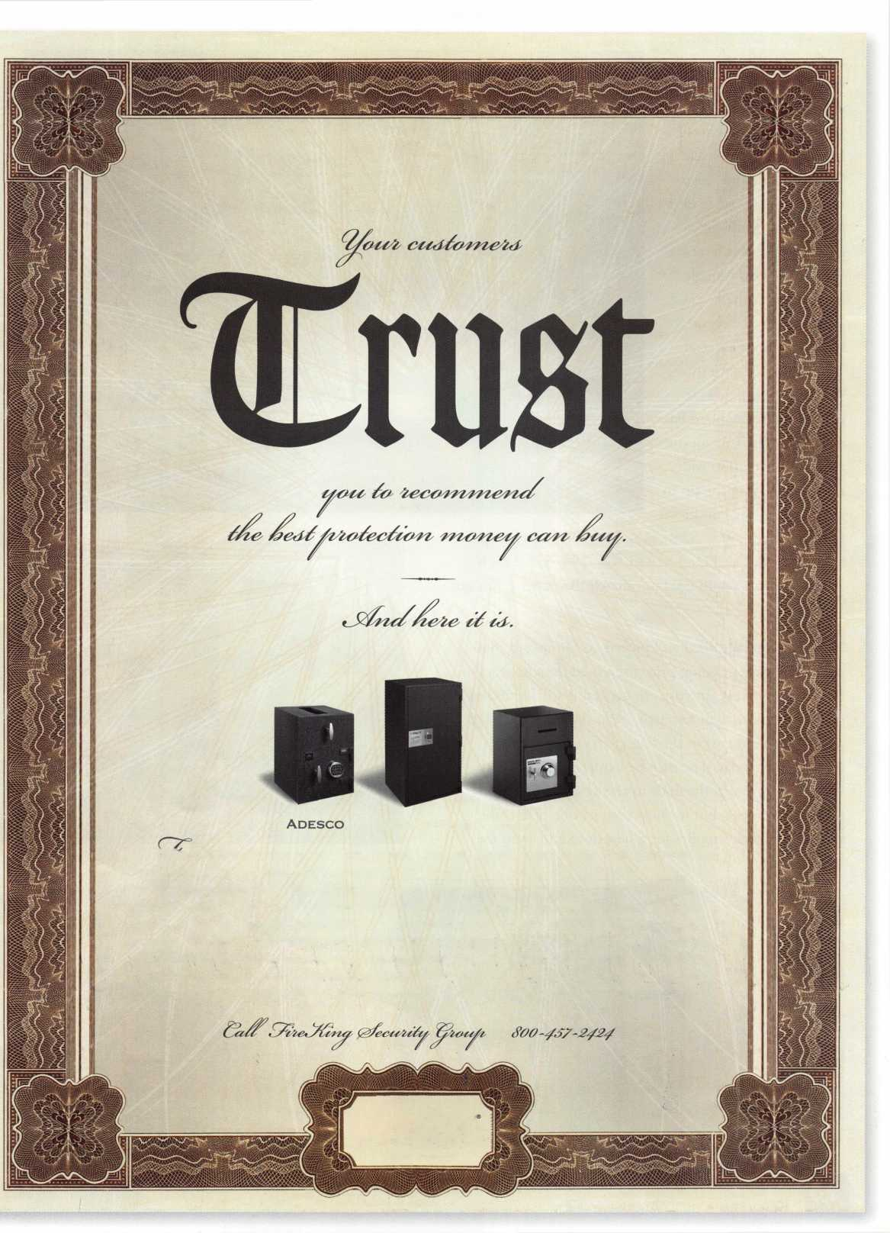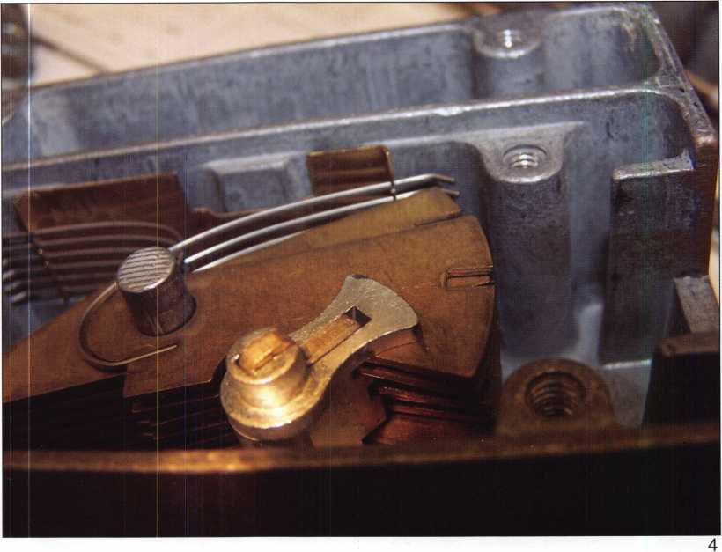

stack. This also allows us a  
view of the lock operation  
with the key inserted as  
seen in photo 4. This lock  
has only one lever stack.

The six guard and seven  
renter levers alternate on a  
single post. Both the  
guard and renters levers  
line up to allow a single  
fence to enter the lever  
stack. All the levers are  
brass with stainless steel  
springs stacked into them.

The renters side has six  
depths while the guard has  
only five. The cuts on the  
renters key are .080 wide,  
the spacing from the tip to  
the center of the cuts are as

follows: .685, .605, .525, .445, .365, .285, .205; depths  
are: 1 = .430 2 = .392, 3 = .343, 4 = .294, 5 = .245, 6 =  
.196. The first depth does not match the pattern, I’m not  
sure why.

This lock can be drilled and picked at .60 up and .640 over. The current going price for a used door appears to be around $30.00 our cost. In general it still seems less costly to replace than to repair. As a side note the origi­nal replacement cost in the late 1970s was $10.00 to $15.00. Some day they may be harder to find or you may need to return the door to service without waiting for a replacement, but for now contact one of the used safe deposit lock supplies for a new door and swap the box number.

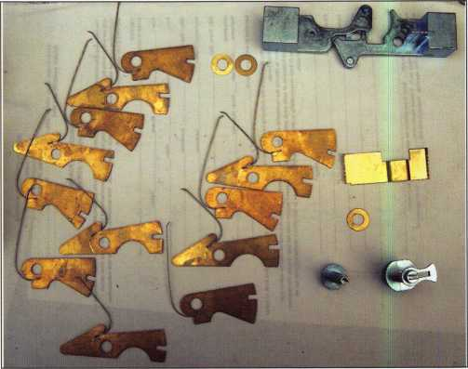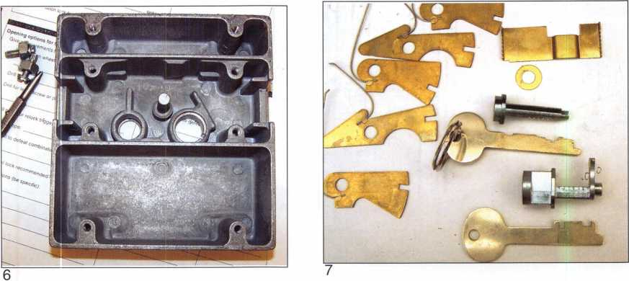

Keynotes • July/August 2006



KEY CODE SERVICE

With proper ID and security clearance

we can get codes for most cars.

Fax us at 1 -800-695-6810  
or call 1-800-741-4764  
for more information.

Hello, I'm Doug Jameson of Jameson Code Services. We would like to try and make your  
business just a little easier when you make a key. We can furnish a key code to you for almost  
all cars. There is no charge should the code we provide not work. We can have most codes  
back to you within 30 minutes. Some codes are even quicker such as Ford and Toyota. We  
furnish a pin number for Chryslers, also brake codes and immobolizer codes  
for Hondas and Acuras. We have been in the key code business since 1995 and learn a little  
more everyday. We are open Monday thru Friday 8:30 a.m. to 6:00 p.m. All codes are  
$15.00. This includes a vat number if needed. The $15.00 also includes the pin number,  
brake code and immobolizer code. Corvettes are a special category as the vat numbers are  
not often available. We would appreciate your input and welcome suggestions for improving  
our service. Give us a call at 214-630-0477 to set up your account or to have any questions  
answered. Looking forward to servicing all locksmiths. Fords and Chryslers within 15 minutes!

FYI: We are now open on Saturdays 9:00 a.m. to 1:00 p.m.

All codes are $15.00 on Saturday

We are accepting applications from ALOA Members only.

Fax us at 1-800-695-6810  
or call 1-800-741-4764

Why Is It? Murphys Law for Locksmiths

Greg Perry, CML, CPS



Why Is It:

Customers always wait until  
quitting time to call with the  
problem they’ve had all day.

Opening a lock takes the  
longest for the most unfriendly  
customer you’ve had all month.

Some customers assume that  
just because you advertise  
"24-hour emergency service"  
you are awake at 2 or 3 in  
the morning just waiting for  
their call.

The worst jobs always start  
as the easy ones you try to  
squeeze in just before you  
are due home to take the wife  
and kids out of town or out  
to dinner.

Customers always think we  
have some magic key to  
open their door, and they  
want to borrow it to save a  
few dollars.

The spanner wrench hole is always at the bottom of the lock.

**28**

Keynotes • July/August 2006



II Rand

Real Security Is When Do-Overs  
Take Place Only On Your Personal Time

When you install Schlage® locks, you know you've done the job right. After all, our products are among the most durable and dependable on the market today. They're also easy to install, repair and maintain, so they generate fewer callbacks. Which means you're free to concentrate on other things. Like learning how to pick up the 7-10 split.

Real Security Sets You Free

[www.schlage.com](http://www.schlage.com)

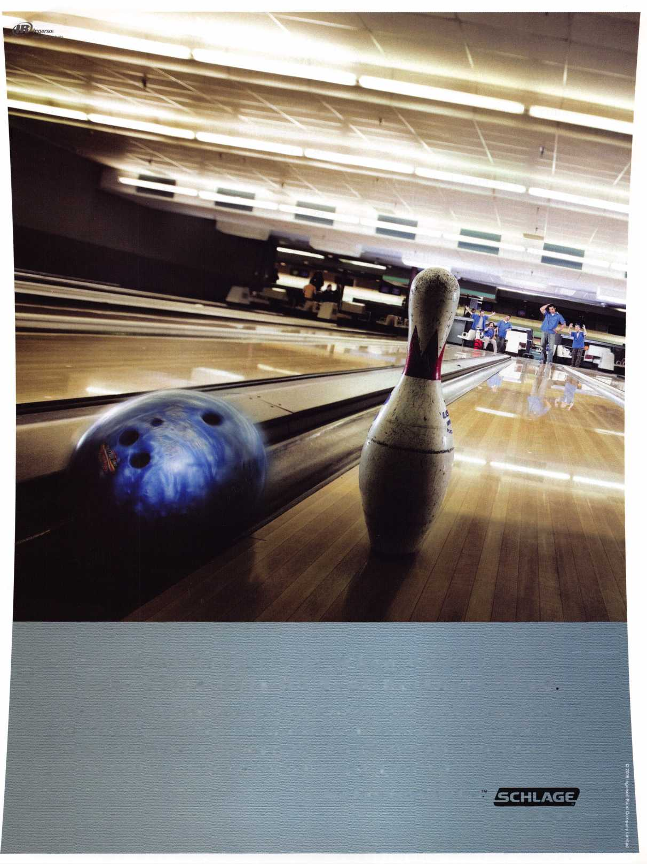

Why is it the only part you drop and cant find, is the one you don’t have a replacement for on the truck.

The warranty job is for that same unfriendly customer who now thinks you’re incompetent.

Carpenters install far more locks then locksmiths but can’t seem to install them correctly.

Police or fire departments will open your car but not your house or change a flat tire.

The customer always has to have the job done today but can’t pay for **60** or **90** days.

The new customer promises lots of work if only you’ll get this first job completed today, at a discount. (I always wonder why they’re leaving their old locksmith.)

Large companies want you to extend them credit without references and time to check them out, but if you ask them to ship you materials they want references from you.

Customers put the broken part of the key into the lock and then call you when it won’t work.

No matter how low you go there is always some competitor who undercuts your price by a few bucks to get the job. (Soon you’ll have to pay your customers to work for them)

Some locksmiths under-inflate their price but over-inflate their abilities. When they get in over their head they call the competition they out bid to ask for help and wonder why they don’t seem eager to help a fellow locksmith.

Customers have an over-inflated view of what their “antique” safe is worth and how great it is until you inform them of how much it is going to cost them to open it or haul it away.

Some customers know way more than you do about locksmithing, at least they always want to tell you how to perform the work, but I guess they call you anyway because they left their tools at home.

People always have a friend or relative who knows how to open (fill in the blank) in just seconds with no evidence.

They want a discount from the quoted price if you get done fast but won’t pay a cent more if it takes twice as long.

The customer wants field warranty service for the part he bought in the shop.

**30**

Keynotes • July/Aug 2006

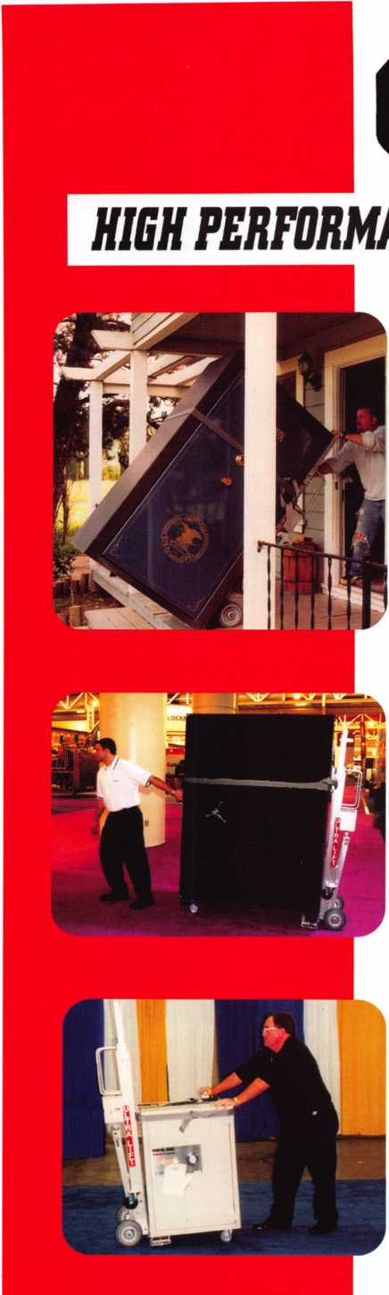

***OPERATOR SAFETY***

Injuries can be virtually eliminated. Ultra Lift does the lift­ing so that operator effort required to complete a move is minimized. Heavy loads are broken back with ease. The operator stays in control by using a combination of motor power, balance and leverage in every phase of a move.

***REDUCE LABOR COSTS***

Fewer people are required for any move with Ultra Lift. Manpower can be scheduled more productively. Labor savings often pay for the Ultra Lift in one month.

***ELIMINATE DAMAGE***

Loads are broken back, set down and moved under power with maximum leverage and operator control. Gentle handling eliminates bumps, bounces and damage to the load and premises.

***INCREASE PROFITS***

Increased operator safety, reduced labor cost and elimina­tion of damage to the load and premises all contribute to significant increases in profits.

FOR LITERATURE, VIDEO OR ON-SITE DEMONSTRATION, WRITE OR CALL:

ULTRA LIFT CORPORATION

475 STOCKTON AVENUE, UNIT E SAN JOSE, CA 95126 800-346-3057 408-287-9400 FAX 408-297-1199 E-mail: [info@uItraIift.com](mailto:info@uItraIift.com) [www.ultralift.com](http://www.ultralift.com)

ULTRA LIFT supplies the power - so you don't have to. One person can safely and easily handle loads that usually require 2 or 3 people, even up or down stairs. Two people can handle most safes to 1500 pounds. If safety is your concern, ULTRA LIFT is the best move you'll ever make!

U.S. PATENT 4.570.953

New Certifications in 2005

**New CML's:**

Baldwin, Jeffrey G  
Denville, NJ

Woods, Edward R.  
Hobart, IN

King, Paul L.  
Bremerton, WA

Brickler, James T.  
Cincinnati, OH

Haddad, Charles G.  
Utica, NY

Kupferman, Ken  
Tampa, FL

Sullivan, Michael T.  
Needham, MA

Meres, Leo M.

Holly Hill, FL

King, Daniel  
Bremerton, WA

Rink, Lee W.

Holly Springs, NC

Barnett, Charles J.  
Poca, WV

**New CPI/s :**

Brown, III Stewart K  
Charlottesville, VA

Reed, Anthony W.  
Hanover, PA

Timmann, William E.  
Easton, PA

Barnett, Stephen E.  
Middlesboro, KY

Dunlap, James L.  
Alexandria, VA

Stracke, Charles D.  
Roanoke, VA

Harvey, Randy K.  
Sycamore, IL

Gale, James W.  
Clifton, CO

Kay, Ron  
Denver, CO

Nickel, Dean A.  
Redmond, WA

Bourey, Peter L.  
Raleigh, NC

Middick, Mike C.  
Canon City, CO

Pauli, John V.

Roseville, Ml

Blanchard, William C.  
Portland, OR

Bruder, Michael T.  
Pennsauken, NJ

Fadgen, William A.  
Albuquerque, NM

|  |  |
| --- | --- |
| Reeves-Messner, Thomas Sunnyvale, CA | Jantz. Nick  Greeley, CO |
| Womack, Wesley A. Youngtown, AZ | Poindexter, Phillip W.  Canon City, CO |
| Nitkowski, Steven E. Menasha, Wl | Stowe, Don E.  Lawrence, KS |
| Walling, Daniel R.  Dubuque, IA | Messerer, Matthew  Des Moines, WA |
| Black, Jesse B.  Monroe, WA | Bright, Jackie  Fayetteville, NC |
| Henry, Gary L.  Eugene, OR | Wilson, Keith E.  Fayetteville, NC |
| Wallin, Robert L.  Hampton, VA | Martinez, Tom  Fort Collins, CO |
| New CRL's :  Marshall, Robert A. Charlottesville, VA  Sanford, David F. Charlottesville, VA  Caudill, Eugene L.  Dallas, TX  Fields, Mark A.  Kingsport, TN  Irick, David  Elizabethton, TN  Peters, Henry C. Jr.  Kingsport, TN  Lynk, William M.  Grosse Pointe Farms, Ml  Lepowsky, Josh D.  Rockfora, MN  Stewart, John R.  South Beloit, IL  Heidemann, Charles A. Elkville, IL | Albarran-Cuevas, Guillermo Cuernavaca, MX  Apanco, Jose Luis  Mexico City, DF  Arizmendi, Arturo  Toluca, MX  Avalos Bedolla, Erik  Morelia, Ml  Ayala Franco, Santiago C. Cuernavaca, ML  Cruz Garcia, Javier Cuernavaca, MR  Flores, Sergio  Mexico City, DF  Guerrero Chavez, Alejandro Mexico City, DF  Gutierrez-Reyna, Juan Carlos Mexico City, DF  Hinojosa-Estrado, Juan  Carlos  Mexico, DF |
| Kahle, Chad A.  Rockford, IL | Huerta, Antonio Alonso Puebla, PL |
| Leys, Paul  Park Ridge, IL | Nava-Martinez, Leonardo Mexico City, DF |
| Welch, Jeff L  Auburn, AL | Rico Ortega, Alberto  Mexico City, DF |
| Bradley, Ryan N.  Clinton, IA | Rios-Delgado, Paulino  Mexico City, DF |
| Fisher, William  Indianapolis, IN | Robles-Vazquez, Raul  Mexico City, DF |
| Gyure, Euaene  Springfield, IL | Salvatierra-Delgado, Jesus Autlan De Navaro, JL |
| Terry Martha Faye  Giddings, TX | Salvatierra-Delaado, Victor Naucalpan, MX |
| Lasley, Aaron M.  Oxnard, CA | Sanchez-Bustamente, Luis R. Mexico City, DF |
| Meadows, Kevin  El Cajon, CA | Villalobos-Ramos, Julio Zapopan, JL |
| Blanks, Tyler S  Fort Collins, CO | Brewer, Joshua D.  Lake In The Hills, IL |
| Holton, Jay H.  Arvado, CO | Delaere, James  Algonquin, IL |

|  |  |
| --- | --- |
| Hardy, Stephen  Stockbridge, GA | Emby, Neil  Toronto, ON |
| Porter, Dan  Flower Mound, TX | Landry, Keith D. London, ON |
| Aulbach, Corey J.  Sturgis, Ml | Howdle, David M. Altoona, IA |
| Batchelder, Kurt N.  Vail, CO | McMillen, Richard Clark, MO |
| Condray, Gary M.  Pell City, AL | Balcerzak, Henry J. Ocala, FL |
| Hornung, David  Verona, Wl | Clark II, David E. Bradenton, FL |
| Italiano, Samuel V.  Tropy, IL | Johnson, Brian M. Sarasota, FL |
| Shoemaker, Harold G  Cedar Rapids, IA | Rahn, Bruce T. Savannah, GA |
| Barry, William M.  Avenel, NJ | Gillmer, Keith A. Manitou Springs, CO |
| Boyd, Aaron Woofloongabba, Qd | Williams, Jason K. Bremerton, WA |
| Hornung, David  Verona, Wl | llsley, Henry H. Hanover, NH |
| Kindley, David M.  South Bend, IN | Rosko, John M. Chittenango, NY |
| Ochal, David B. Schaumberg, IL | Sacco, Paul M.  Utica, NY |
| Peebles, James D. Jr. Sheffield, AL | Tarsi, Gabriel G. Meriden, CT |
| Shackle, Philip Edward Palatine, IL | Cornell, James Lafayette, IN |
| Tucker, Jerry L.  Elkhart, IN | Wallin, Michael D. Hampton, VA |
| Bowman, Larry D.  Kansas City, MO | Burge. David A. Cleveland, OH |
| Doten, Christopher K. Tampa, FL | Lyon, Christian  New York, NY |
| Fielden, James K.  Center Line, Ml | Metz. David  Plainfield IL |
| Gardner, Paul O.  Colorado Springs, CO | Peer, David  New York, NY |
| Heare, Marshall L.  St. Peters, MD | Klinker, Robert J. Jefferson City, MO |
| Heller, Erik  Mason, OH | Rollins, Michael S. Decatur, IL |
| Lauahhunn, Joseph M. Shelby Township, Ml | Dixon, James N., IV St. Leonard, MD |
| Nathan, Rogers K. Independence, KY | Moser, Chad M.  York, PA |
| Root, Randy  Manassas, VA | Small, Bradley M. Palmyra, VA |
| Spinello, Joseph G. Rockford, IL  Valdez, Antoinette M. Colorado Springs, CO | Youtz Andrew R. Middletown, PA |
| Honecker, Gerald L. Rockford, IL |  |

Keynotes • July/August 2006

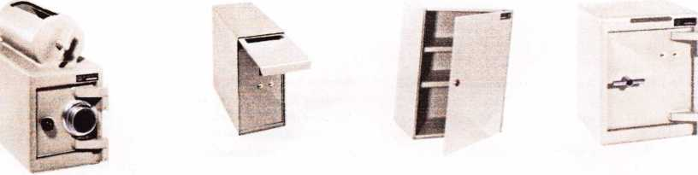

A & B Safe Corporation

Manufacturers of Quality Depository Safes & Chests

114 South Delsea Dr. Suite 3



Glassboro, NJ 08028

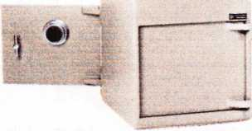

800-253-1267 Fax 856-863-1208

[info@a-bsafecorp.com](mailto:info@a-bsafecorp.com)

[www.a-bsafecorp.com](http://www.a-bsafecorp.com)

4

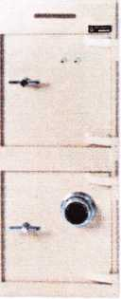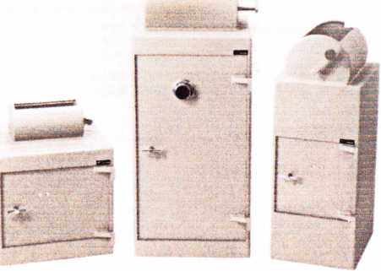

Over Seventy-Five Models In Stock

ALOA 2006 Exhibitors

**(Exhibitor Names listed in RED are Associate Members)**

1-800-LOCKSMITH #1614

73 Greentree Drive #16, Dover, DE 19904 800-562-5764; 718-236-4504 fax Contact: Jacob Goldberg

1 -800 UNLOCKS, Inc. #1130

2110 Spencer Road, Richmond, VA 23230 804-377-9396; 804-421-0079 fax www. 1 -800-unlocks.com; e-mail: [barry@l-800-unlocks.com](mailto:barry@l-800-unlocks.com) Contact: Barry P. Wilson or Jeff Musser "Dispatch Service" Marketing Opportunity

1st in Hardware #131

2901 Whittington Ave, Suites F&G;

Baltimore, MD 21230 410-646-9900; 866-646-0045 fax www. 1 stinhardware.com; e-mail: [info@lstinhardware.com](mailto:info@lstinhardware.com) Contact(s): Ed Korenge, John Edwards Distributor-Alarms; Builders Hardware; Business/Technical & Educational; Electric/Electronic Security; Lock Devices; Tools & Supplies; Storefront Door Hardware

A-l Security/Lockcraft #500

3001 West Moore St. • Richmond, VA 23230 804-359-9003; 804-359-9415 fax [www.demandal](http://www.demandal) .com; e-mail: [service@demandal.com](mailto:service@demandal.com) Contact(s): Frank McCarthy ManufactureroTools & Supplies

**A&B Safe**

**Manufacturer, Inc. #600**

114 S. Delsea Dr. Suite 3 Glassboro, NJ 08028 800-253-1267; 856-863-1208 fax [www.a-bsafecorp.com](http://www.a-bsafecorp.com); e-mail: [info@a-bsafecorp.com](mailto:info@a-bsafecorp.com) Onsite Contact(s): Edward C. Dornisch,

Sweetie A. Dornisch Manufacturer-Safes/Vaults

ADI, Inc. #1121

263 Old Country Rd • Melville, NY 11747 631-692-1000; 631-692-3011 fax [www.adilink.com](http://www.adilink.com); e-mail: [info@adi-dist.com](mailto:info@adi-dist.com) Contact(s): Cliff OiShea Distributor-Alarms; Bank Security;

Builders Hardware; CCTV/Photo imaging; Electric/Electronic Security; Lock Devices

Aable Locksmiths #906

47 Marlboro Drive, Milford, CT 06461

203-882-0600; 203-882-0600 fax

[www.aablelocksmiths.com](http://www.aablelocksmiths.com);

e-mail: [frankaable@aol.com](mailto:frankaable@aol.com)

Contact(s): Frank & Elizabeth

Manufacturer, Wholesaler-Automotive; Builders

Hrdware; Tools & Supplies

Abloy Door Security . ...# 301

9630 Trans Canada Hwy • Montreal, Quebec, Canada H4S 1V9 800-465-5761; 800-730-3570 fax [www.abloy.ca](http://www.abloy.ca); e-mail: [martin.day@abloy.ca](mailto:martin.day@abloy.ca) Contact(s): Martin Day, Steve Timmons,

Terry Siow, Jarma Issakainen Manufacturer-Lock Devices; High Security Locks

**ABUS Lock Company #921**

23910 N. 19th Ave. Ste. 56,

Phoenix, AZ 85027 623-516-9933; 623-516-9934 fax [www.abuslock.com](http://www.abuslock.com); e-mail: [abuslock@abuslock.com](mailto:abuslock@abuslock.com) Contact(s): Grant Laitala Manufacturer—Lock Devices

Access Hardware

Supply #937

14359 Catalina Street San Leandro, CA 94577 510-483-5000; 510-483-4500 fax Contact: John Ream

**Accredited Lock Supply #1035**

1161 Paterson Plank Road Secaucus, NJ 07094 201-865-5015; 201-865-5031 fax [www.acclock.com](http://www.acclock.com); email: [mail@acclock.com](mailto:mail@acclock.com) Contact(s): Charles Weaver, Joel Blum,

Eric Hagee

Distributor-Automotive; Builders Hardware; Business/Technical & Educational; CCTV/Photo Imaging; Electric/Electronic Security; Lock Devices; Tools & Supplies; Safes/Vaults

**Adams Rite Manufacturing#704**

260 Santa Fe Street • Pomona, CA 91767 909-632-2300; 909-632-2369 fax [www.adamsrite.com](http://www.adamsrite.com); e-mail: [dhopkins@adamsrite.com](mailto:dhopkins@adamsrite.com) Contact(s): Donna Hopkins Manufacturer—Alarms; Builders Hardware; Electric/Electronic Security; Lock Devices

**ADEL Fingerprint Technology,**

**LLC. #1127**

20311 Valley Blvd Suite L, Walnut, CA 91789 909-595-1222; 909-595-1667 fax [www.adelfingerprint.com](http://www.adelfingerprint.com); e-mail: [minyi@adelfingerprint.com](mailto:minyi@adelfingerprint.com) Contact!s): Yi Min

Manufacturer, Wholesaler-Lock Devices

**Adrian Steel Company #1121**

906 James Street • Adrian, Ml 49221 517-265-6194; 517-265-5834 fax Contact(s): Todd Goldmeyer Manufacturer —Tools & Supplies

**Advanced Diagnostics USA# 1337**

180-C South Spruce Ave., So.

San Francisco, CA 94080 650-876-2020; 650-876-2022 fax [www.autokeys.com](http://www.autokeys.com) Contact: John Steiner Manufacturer, Distributor-Automotive;

Tools & Supplies; MVP, T-Code, T-Code Pro-Transponder Experts

**Alarm Controls Corp. #1420**

19 Brandywine Drive, P.O. Box 280,

Deer Park, NY 11729

631 -586-4220 or 800-645-5538;

631 -586-6500 fax [www.alarmcontrols.com](http://www.alarmcontrols.com); w[ww.john@alarmcontrols.com](mailto:ww.john@alarmcontrols.com) Contact(s): John Benedetto Manufacturer-Alarms; Builders Hardware; Electric/Electronic Security; Timers, Power Supplies, Request to Exit Plates

Alarm Lock Systems, Inc.# 108

345 Bayview Ave. • Amityville, NY 11701 631 -789-4871; 631 -789-3383 fax [www.alarmlock.com](http://www.alarmlock.com); e-mail: [salesinfo@alarmlock.com](mailto:salesinfo@alarmlock.com) Onsite Contact(s): Bob Swoope,

Tony Dozier, Dave Bracey Manufacturer — Alarms; Lock Devices

**All 5 Lock #323**

70 Enterprise Drive Bristol, CT 06010 860-583-1691; 860-583-4516 fax Contact: Joseph Nemec Manufacturer- Lock Devices

**Allstate Insurance Co. #1500**

5100 W. Higgins Road, R1 A,

South Barrington, IL 60010 847-557-2181; 847-551 -2732 fax [www.allstate.com](http://www.allstate.com); e-mail: [abisO@allstate.com](mailto:abisO@allstate.com) Contact: Anita Bishop Insurance

Altronix #1106

140 58th St., Brooklyn, NY 11220 718-567-8181 ext. 133; 718-567-9056 fax [www.altronix.com](http://www.altronix.com); e-mail: [fowen@altronix.com](mailto:fowen@altronix.com) Contact(s): Frank Owen, Bob Yonce Manufacturer-Electric/Electronic Security

**AmericanAutoLock.Com #1301**

1039 North Christian Street Lancaster, PA 17602 800-860-5625; 717-581-8353 fax [www.americanautolock.com](http://www.americanautolock.com); e-mail: [bill@lock.com](mailto:bill@lock.com)

Contact(s): Bill Neff, Tom Lynch Manufacturer, Distributor, Wholesaler- Automotive; Lock Devices; Tools & Supplies; Transponder Chip Technology-Computer Software

American Eagle

Lock Co. #627

144 Newport Rd •Leola, PA 17540 717-656-4281; 717-656-0818 fax [www.americaneaglelockco.com](http://www.americaneaglelockco.com); e-mail: [moconnor@pdqlocks.com](mailto:moconnor@pdqlocks.com) Contact: Michael OfConnor-717-940-3819 Manufacturer — Builders Hardware;

Lock Devices

American Lock

Company #120

137 W. Forest Hill Ave; Oak Creek, Wl 53154 708-534-2000 or 800-323-4568; 708-534-0531 fax [www.americanlock.com](http://www.americanlock.com); e-mail: [contactus@americanlock.net](mailto:contactus@americanlock.net) Contacts): Dave Kraninger, Paul Switzer Manufacturer-Lock Devices

American Safe Technologies#534

1925 Enterprise Ct.

Libertyville, IL 60048 847-362-9800 Contact: Ed McGunn

**American Security Products#613**

11925 Pacific Ave. • Fontana, CA 92337 800-421-6142; 951-685-9685 fax [www.amsecusa.com](http://www.amsecusa.com); e-mail: [contacts@amsecusa.com](mailto:contacts@amsecusa.com) Contact(s): Bob Sallee, Tony Maniaci, Tim Reeves, Pat Baker, Judd Penske, Tracy Russell Manufacturer —Safes/Vaults

Architectural Control Sys.#631

10666 Gateway Blvd, St. Louis, MO 63132 314-432-5588; 314-432-2090 fax [www.acsi-inc.com](http://www.acsi-inc.com); e-mail: [jhoos@acsi-inc.com](mailto:jhoos@acsi-inc.com) Contacts): John Hooss Manufacturer-Builders Hardware; Electric/Electronic Security

Arco Industrial Corp. #1113

No. 9 Lane 120, Jui-Kuang Rd.,

Taipei, Taiwan 105 02-2514-0012; 2541-0017

[www.elis.com.tw](http://www.elis.com.tw); e-mail: [elis@elismail.com.tw](mailto:elis@elismail.com.tw) Contact(s) Felicia Chang, Howard Lee Manufacturer-Automotive; Builders Hardware; Lock Devices; Key Duplicating Machines

Keynotes • July/August 2006

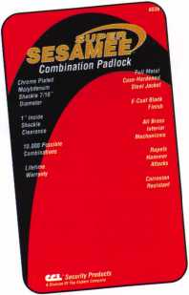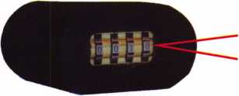

Security Products

**A Division of The Eastern Company**

**301 West Hintz Road Wheeling, IL 60090 Telephone: 800.733.8588 Fax: 847.537.1881 [www.cclsecurity.com](http://www.cclsecurity.com)**

Locks

Features & Benefits

* Industrial Strength Combination Lock!
* Resists Hammer and Re-bar Attacks!
* Hardened Steel Full Metal Jacket!
* Hardened Steel Full Metal Jacket Shroud!
* Weather Resistant Black Electrocoating!
* 7/16” Chrome Plated Molybdenum Shackle!
* Inside Shackle Clearances: 1 ” and 2”!
* Shackle Pull Strength: 2,750 pounds!
* All Brass Inner Mechanism!
* Four All Brass Dials!
* 10,000 Changeable Combinations!
* Quick Delivery: Shipped from Stock!

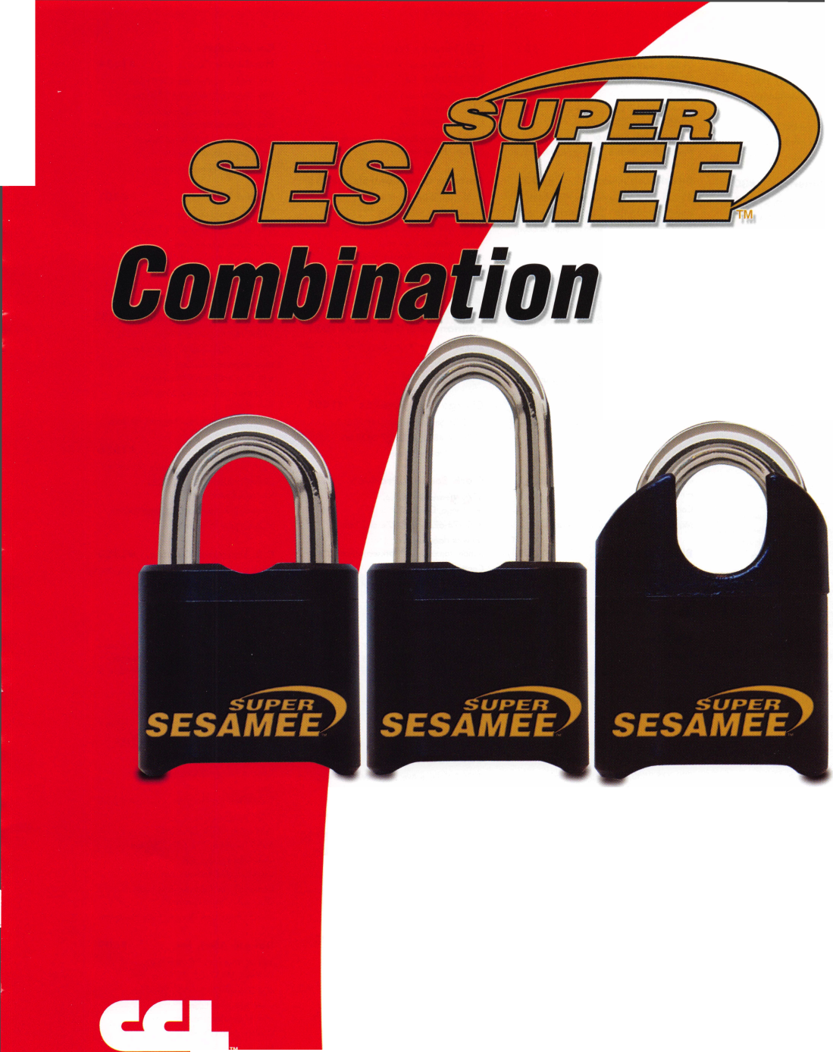

Arrow Lock &

Door Hardware #301

325 Duffy Ave. • Hicksville, NY 11801

800-221-6529; 877-288-6480 fax

[www.arrowlock.com](http://www.arrowlock.com)

Onsite Contact(s): Joanne McCarthy

Manufacturer—Builders Hardware; Lock

Devices

ASSA ABLOY Americas #301

110 Sargent Drive, New Haven, CT 06511 203-624-5225; 203-785-8108 fax [www.assaabloy.com](http://www.assaabloy.com) Contact(s): Melissa Mozzarella Manufacturer-Builders Hardware; Electric/Electronic Security; Lock Devices

ASSA High Security Locks#301

110 Sargent Drive, New Haven, CT 06511 800-235-7482; 800-892-3256 fax [www.assalock.com](http://www.assalock.com) Contact: Tom Demont

Manufacturer-Lock Devices; High Security Locks

Associated Locksmiths of America, Inc. (ALOA)

3500 Easy Street. • Dallas, Texas 75247 1 -800-532-2562; 214-819-9736 fax [www.aloa.org](http://www.aloa.org); [aloa@aloa.org](mailto:aloa@aloa.org) International Locksmiths Trade Association Robert Mock, President ALOA Legislative — Up to the minute news

and information on legislation affecting your business. Key Personnel: Tim McMullen, Government Affairs ALOA Scholarship Foundation — Provides funding for promising locksmiths. Key Personnel:

Tim Abner, Larry Barnes Booth 1504

ALOA Anniversary Booth#1501

Auto Security Products #825

P O Box 10 • Redmond, WA 98073 425-556-1900; 425-558-1205 fax [www.carlocks.com](http://www.carlocks.com) Contact(s): Steve Shain, Ross Logan Manufacturer—Automotive; Lock Devices

Auto Tech Security Systems#237

3732 Grissom Lane Kissimmee, FL 34741 407-870-8816; 413-832-2770 fax Contact:Brent Johnson

Avco Key & Novelty #226

P.O. Box 130 East Northport, NY 11731

800-332-5397

Contact: Mike Avena

Bad Dog Tools #606

P.O. Box 851 Bristol, Rl 02809 401 -253-1330; 401 -253-1377 fax Contact: Ann Strong

**Bianchi USA, Inc. #833**

31336 Industrial Parkway, Suite 3.,

North Olmsted, OH 44070 800-891-2118; 216-803-0202 fax [www.bianchil770usa.com](http://www.bianchil770usa.com); e-mail: info@bianchil 770usa.com Contacts): Erin Kocab or Joy Skowron Manufacturer-Tools & Supplies; Key Machines

BiLock/Login Lock #1022

53 Railroad Ave, Southington, CT 06489 860-378-0302; 860-378-0340 fax [www.bilock.com](http://www.bilock.com); e-mail: [tom@loginlock.com](mailto:tom@loginlock.com) Contact(s): Tom Divito, Danny Gurvis Manufacturer-Lock Devices

Biogate, Inc. #1331

1614 S. Reservoir St., Pomona, CA 91766 909-786-9336; 909-455-0188 fax [www.biogateus.com](http://www.biogateus.com); e-mail: [biogateus@biogateus.com](mailto:biogateus@biogateus.com) Contact(s): Chae Yi, Steve Richardson Manufacturer-Electric/Electronic Security; Biometric Fingerprint Door Locks

Blackhawk Products #325

25913 County Road T.5 Dolores, CO 81323 970-882-7191 [www.blackhawk7.com](http://www.blackhawk7.com); e-mail: [staff@blackhawk7.com](mailto:staff@blackhawk7.com) Contact: Roger Weitzenkamp Manufacturer —Computer software

Blue Dot Safes #1601

1945 S. Burgundy Place Ontario, CA 91761 (909)390-3000 Contact: Berge Jalakian

BMG Door

Hardware, Inc. #1131

187 W. Orangethorpe Ave St. E,

Placentia, CA 92870 714-572-0098; 714-572-0978 fax Contact: Sam Chun

**Boyle & Chase, Inc. #1300**

72 Sharp Street, Hingham, MA 02043 800-325-2530; 800-205-3500 fax [www.boyleandchase.com](http://www.boyleandchase.com); e-mail: [sales@boyleandchase.com](mailto:sales@boyleandchase.com) Contact: Tom O'Donnell Distributor-Alarms; Builders Hardware; Electric/Electronic Security; Lock Devices; Tools & Supplies

CAL Royal Products #635

6605 Flotilla St. City of Commerce, CA 90040 323-888-6601; 323-888-6699 fax Contact: Pat Mulcahy

CAL Security

Enterprises, Inc. #909

16380 NW 84th Avenue, Miami Lakes, FL 33016

305-827-9384; 305-827-9387 fax [www.calldoubleboltlock.com](http://www.calldoubleboltlock.com); e-mail: [drubiol227@aol.com](mailto:drubiol227@aol.com) Contacts) Michael Hernandez, Doris Rubio Manufacturer-Lock Devices

**CCL Security Products #725**

301 W. Hintz Road • Wheeling, IL 60090

800-733-8588; 847-537-1881 fax

[www.cclsecurity.com](http://www.cclsecurity.com); e-mail:

[info@cclsecurity.com](mailto:info@cclsecurity.com)

Contacts): Bill Walsh

Manufacturer —Builders Hardware; Lock

Devices; Travel Security Products

Camden Door Controls #925

5151 Everest Drive Unit #6 Mississauga, Ontario L4W-2Z3 Canada 1-877-226-3369; 905-366-3378 fax [www.camdencontrols.com](http://www.camdencontrols.com); e-mail: [info@camdencontrols.com](mailto:info@camdencontrols.com) Contact(s): Heidi Goldberg Manufacturer —Electric/ Electronic Security; Lock Devices; Handicap Activation Devices

Cannon Safe/Gun Vault#1021

216 S. 2nd Ave. • San Bernadino, CA 92408

909-382-0303

Contact: Mike Baker

Charge Card Systems #1401

1532 56 Street Brooklyn, NY 11219 718-437-4805; 718-407-0433 fax Contact: Moshe Preizler

**Clark Security Products #524**

4775 Viewridge Avenue,

San Diego, CA 92123

1. 974-6740; 858-974-6720 fax

[www.clarksecurity.com](http://www.clarksecurity.com);

e-mail: [ron.cooling@clarksecurity.com](mailto:ron.cooling@clarksecurity.com)

Contact: Ron Cooling

Distributor —Builders Hardware

ClearStar

Security Network #1324

1140 University Ave. Berkeley, CA 94702 510-841 -4807; 510-841 -7915 fax [www.clearstar.com](http://www.clearstar.com); e-mail: [security@clearstar.com](mailto:security@clearstar.com) Contact(s): Jay Long Restricted-Access Website for Locksmiths & Safe Techs

CODELOCKS, LLC. #1231

2930 B College Ave., Costa Mesa, CA 92626

714-979-2900

Contact: R. Foster

Commercial Van Interiors#! 120

8840 St. Charles Rock Road St. Louis, MO 63114

800-759-7477; 314-427-1525 fax [www.commercialvan.com](http://www.commercialvan.com) Distributor—Vehicle Upfitter

**COMPX Security Products#221**

P.O. Box 200, Mauldin, SC 29662 864-297-6655; 864-297-9987 fax [www.compx.com](http://www.compx.com); e-mail: [lgalvao@compx.com](mailto:lgalvao@compx.com) Contacts): Lou Galvao Manufacturer —Electric/Electronic Security; Lock Devices

Construction

Hardware Co. #1334

216 Pacific St., Pomona, CA 91768 909-594-9093; 909-595-8050 fax www. con str uction ha rd wa reco .com ; e-mail: [dstewart@constructionhardwareco.com](mailto:dstewart@constructionhardwareco.com) Contact(s): Dan & Jo Anne Stewart,

Carol Crummitt, Art Del Rio Distributor—Builders Hardware

Corbin Russwin #301

225 Episcopal Road, Berlin, CT 06037 800-543-3658; 800-447-6714 fax [www.corbin-russwin.com](http://www.corbin-russwin.com) Contact: Lee Garver Manufacturer-Builders Hardware; Electric/Electronic Security; Lock Devices

Corporate Safe Specialists#533

14800 McKinley Ave. • Posen, IL 60469 708-371 -4200; 708-371 -3326 fax [www.corporatesafe.com](http://www.corporatesafe.com); e-mail: [ruizm@corporatesafe.com](mailto:ruizm@corporatesafe.com) Contact(s): Mandy Ruiz, Mike McGunn,

Karl Watson

Safes/Vaults-Locks and Keypads for Safes

CP Films, Inc. #1036

4210 The Great Road, Fieldale, VA 24089 276-627-3000; 276-627-3032 fax [www.llumar.com](http://www.llumar.com)

Contact(s): Randy Garcia, Gregg McKay Manufacturer-Window Film

C.R. Laurence Co., Inc. #1323

2503 E. Vernon Ave., Los Angeles, CA 90058 800-421-6144; 800-262-3299 fax [www.crlaurence.com](http://www.crlaurence.com); e-mail: [crl@crlaurence.com](mailto:crl@crlaurence.com) Contact(s): Paul Daniels, Bili Gyore Manufacturer, Distributor-Builders Hardware; Electric/Electronic Security; Lock Devices;

Tools & Supplies; Bullet Resistant Window & Transaction Hardware

**Cross Country**

**Automotive Services #1201**

One Cabot Road, Medford, MA 02155 781-306-3253; 781-395-6706 fax Contact: Nancy DfAmbrosio

**D&D Technologies #1213**

7731 Woodwind Dr.

Huntington Beach, CA 92647 800-716-0888; 714-677-1299 fax [www.ddtechglobal.com](http://www.ddtechglobal.com); e-mail: [info@ddtechusa.com](mailto:info@ddtechusa.com) Contact(s): Jim Paterson, Rod Kraft,

Gary Lisko, Steve Pleasants Manufacturer-Lock Devices, Gate Hardware

Dakota Alert, Inc. #609

109 W. Main St., P.O. Box 130,

Elk Point, SD 57025 605-356-2772; 605-356-2584 fax [www.dakotaalert.com](http://www.dakotaalert.com); e-mail: [sales@dakotaalert.com](mailto:sales@dakotaalert.com) Contact: Jason Quam Manufacturer-Alarms



Keynotes • July/August 2006

*r.immii*

SCHLAGE

CAL-ROYAL

DOR-O-MATIC

jKuoraoircbmac

PIP CHICAGO

%!3

MONARCH

LCN

ComX

NATIONAL

**Visatack**

OLYMPUS^

QxrXL0CK'INC

LORI

ASSA CbrnX

TIMBERLINE

SARGENT

DON-IO

**| ylRROW**

VON DUPRIN

LOCKCRAFT^

**BIANCHI**

I LAB IMA fOR

**PRQ-LQK**

*fn^rRutan*

l *Locksmith Tools MM* ^«LmShmmnT

*HATASTBCR* iik. *ffcoSDD*

***M}eda&c& \****

*AUTOMOTIVE*

**tt^Pm**

A1 DEMAND A1 LOCKCRAFT 03

**® A S P *DETERMINATOR***

***VISA***

*access comm*



*^Xjtytan*

STRATTEC

> ***DETERMINATOR***

***MAJOR*** *HATA :* ‘

*Wedgeccr™*

***VIVA LAS VEGAS***

***VISIT THE H.l. rum GO.***

***@ BOOTH 3311 431***

***LAS VMQAS GQNVmPtTION QmMtmM***

***EXITrf^-***

*Booth*

***HD^Sge Co.***

**o o o o o o**

**© © o o © o**

**\*■ N n V «A <0**

**IU 111 lit Hi IU 111**

**•J -J -4 *1 -J -4**

**(0 (fl (fl Ifl (I) I/)**

**OOOOOOOO**

**©o©ooo©o**

©©OT-Nfo^rin

**»> ♦> »« t-**

ALOA 2 s! m ti si

Cn Cfj CA C/j

**Entrance**

***Extremely Competitive  
E/Z Free Freight Minimums***

*M*

***Same Day Shipping* 1**

***Service with a Smile* c:**

***High Fill Rate* £|**

***Hard to Find Items ^ %***

/:// Order Web Site C“X‘l..

*vrww.HLFLAKE.com*

***Order 24 hours a day  
Updated Every Business Day  
Extra Discount for Web Orders  
Personalized Inventory Lists***

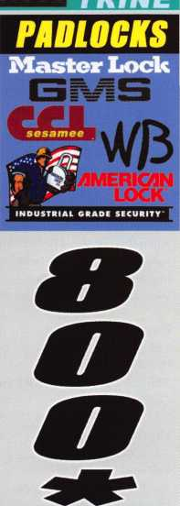

OG ON TO... ___ __ _ ___

[WWW.HlFlAKA.com](http://WWW.HlFlAKA.com)

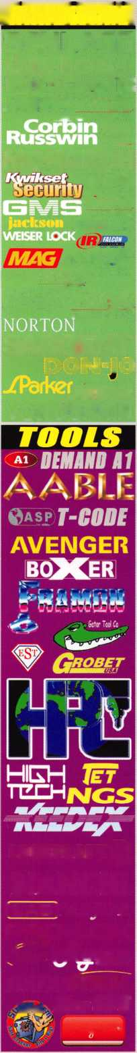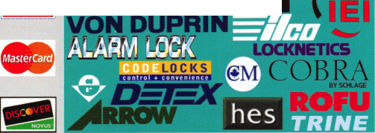

Defiant Safe Co. #1111

3140 Towerwood Drive • Dallas, TX 75234 972-243-3711; 972-241 -7669 fax Contact: David Randall Wholesale Manufacturer—Safes/Vaults; Defiant Safe Moving System (safe chariot)

**DETEX Corp. #1013**

302 Detex Drive • New Braunfels, TX 78130 800-729-3839; 836-620-6711 fax [www.detex.com](http://www.detex.com); e-mail: [grb@detexcorp.com](mailto:grb@detexcorp.com) Contact(s): Trice Kastein Manufacturer-Lock Devices

Dida Locks #702

15050 North 54th Place Scottsdale, AZ 85254 602-421-8548; 602-795-8669 Contact: Kevin Chen

**Don-Jo Mfg. #422**

P O Box 929 • Sterling, MA 01564 978-422-3377; 978-422-3467 fax [www.don-jo.com](http://www.don-jo.com); e-mail: [info@don-jo.com](mailto:info@don-jo.com) Manufacturer—Builders Hardware; Lock Devices; Architectural Hardware Accessories

**Door Jamb Armor #1411**

150 Leuning St, Ste 5 S.

Hackensack, NJ 07606 888-582-2294; 201-490-5389 fax Contact: Glenn Young

**DoorKing, Inc. #1024**

120 S. Glasgow Avenue

Inglewood, CA 90301

800-826-7493; 310-641-1586

fax [www.doorking.com](http://www.doorking.com);

e-mail: [info@doorking.com](mailto:info@doorking.com)

Contacts: Lamar Jackson, Larry Simons

Manufacturer —Electric/ Electronic Security

DORMA

Architectural Hardware #231

Dorma Drive, Drawer AC Reamstown, PA 17567 717-336-3881; 717-336-2106 fax [www.dorma-usa.com](http://www.dorma-usa.com); e-mail: [archdw@dorma-usa.com](mailto:archdw@dorma-usa.com) Contact(s): Don Kirby, Bill Espinola,

Lloyd Seliber

Manufacturer —Builders Hardware; Electric/Electronic Security; Lock Devices.

**Dugmore & Duncan, Inc. #321**

30 Pond Park Rd. • Hingham, MA 02043 781 -927-2127; 781 -749-2869 fax [www.dugmore.com](http://www.dugmore.com); e-mail: [ed@dugmore.com](mailto:ed@dugmore.com) Contact(s): Ed Minishak Distributor—Builders Hardware; CCTV/Photo Imaging; Electric/Electronic Security; Lock Devices; Tools & Supplies

Eclipse Industries #1327

1923 Commercial Street Escondido, CA 92029

760-746-1016; 760-739-0072 fax

[www.eclipsesafe.com](http://www.eclipsesafe.com); e-mail:

[eclipseind@earthlink.net](mailto:eclipseind@earthlink.net)

Contact(s): Martin Stinson, Kelly Stinson

Manufacturer-Safes/Vaults

ekey USA Systems, LLC. # 1225

6150 53rd Avenue East, Bradenton, FL 34203

941 -782-1227; 941 -256-3555 fax

[www.ekeyusa.com](http://www.ekeyusa.com);

e-ma i I: hassa n. ha res@ekey u sa. com

Contacts): Hassan Hares

Distributor-Biometric Fingerprint

Access Systems

**E-Lock USA #1034**

109 Hunterscreek Lane Ste B Troy, VA 22974 434-589-5913; 438-589-3783 fax Contact: Scott Trail

ESP Lock Products/

Hudson Lock #1321

81 Apsley Street Hudson, MA 01749-1549

800-434-8960; 978-562-9859 fax

[www.hudsonlock.com](http://www.hudsonlock.com);

e-mail: [amy.fuller@hudsonlock.com](mailto:amy.fuller@hudsonlock.com),

[sari.thibault@hudsonlock.com](mailto:sari.thibault@hudsonlock.com)

Contact: Sari Thibault, Amy Fuller

Manufacturer- Lock Devices; Tools & Supplies

**FireKing Security Group #911**

101 Security Parkway

New Albany, IN 47150

812-948-8400; 812-941 -0120 fax

[www.fireking.com](http://www.fireking.com);

e-mail: [marketing@fireking.com](mailto:marketing@fireking.com)

Contact(s): Steve Aronson

Manufacturer —CCTV/Photo Imaging;

Safes/Vaults

Folger Adam EDC #301

22630 N. 17th Ave, Phoenix, AZ 85027-1303 623-582-4626; 623-582-4641 fax [www.folgeradamdoorcontrols.com](http://www.folgeradamdoorcontrols.com); e-mail: [sales@folgeradamedc.com](mailto:sales@folgeradamedc.com) Contact: Kristie Maggs, Chuck Christiansen, Peter Lowenstein

Manufacturer-Electric/Electronic Security;

Lock Devices

**Framon Manufacturing Company #733**

909 Washington Ave. • Alpena, Ml 49707

989-354-5623; 989-354-4238 fax

[www.framon.com](http://www.framon.com);

e-mail: [phil@framon.com](mailto:phil@framon.com)

Contacts): Phil Agius

Manufacturer —Tools & Supplies

Fuki Co., Ltd. #607

1 -28-23, Hon-lsshiki, Edogawa-ku

Tokyo 133-0044 Japan

81-3-3654-4169; 81-3-3655-4169 fax

[www.fuki4169.com](http://www.fuki4169.com);

e-mail: [twolock@ha-bekkoame.ne.jp](mailto:twolock@ha-bekkoame.ne.jp)

Contact: Manaru Goto

Manufacturer, Distributor-Tools & Supplies

Gardall Safe Corp. #1031

P.O. Box 240, Syracuse, NY 13206 315-432-9115; 315-434-9422 fax [www.gardall.com](http://www.gardall.com); e-mail: [info@gardall.com](mailto:info@gardall.com) Contacts): Mark Koesterer-Sales Manager Manufacturer-Safes/Vaults

GE Supra Products, Inc. #1221

4001 Fairview Ind. Drive SE,

Salem, OR 97302 503-581-9101; 503-375-6421 fax www. geaccesspoi nt. com; e-mail: [felechia-burleigh@ge.com](mailto:felechia-burleigh@ge.com) Contacts): Rick Boes, Felecia Burleigh Manufacturer—Automotive; Lock Devices

GEICO Emergency Road Services #1433

One Geico Center Macon, GA 31296

800-841-9160

ContactJeff Jordan

GMS Industries, Inc. #1312

25-11151 Horseshoe Way Richmond BC V7A 4S5 888-774-5625; 604-448-1249 fax [www.gmslock.com](http://www.gmslock.com) Contacts) Mike Tong, Ken Erickson Manufacturer-Lock Devices

Guardian Safe Company# 1026

38 Grace Cress.

Barrie Ontario Canada L4N 9S5 705-722-8894; 705-722-7254 fax [www.guardiansafes.com](http://www.guardiansafes.com); e-mail: [sales@guardiansafes.com](mailto:sales@guardiansafes.com) Contact(s): Paul OiHara, Patricia Ruse,

Greg Smith

Distributor- Safes/Vaults

HES #301

22630 N. 17th Avenue • Phoenix, AZ 85027 623-582-4626; 623-582-4641 fax [www.hesinnovations.com](http://www.hesinnovations.com); e-mail: [sales@hesinnovations.com](mailto:sales@hesinnovations.com) Contacts): Chuck Christiansen,

Peter Lowenstein

Manufacturer-Electric/Electronic Security;

Lock Devices

H.L. Flake Company #331

5031 1-45 South, Houston, TX 77023 713-926-3200 or 800-231-4105; 888-329-0601 fax [www.hlflake.com](http://www.hlflake.com)

Contact(s): Dan Floeck, Jeff Floeck, Bill Tilley, Arnold Ramirez

Distributor-Bank Security Equipment; Automotive; Builders Hardware; Business/Technical & Educational; Electric/Electronic Security; Lock Devices; Tools & Supplies; Safes/Vaults

**HPC, Inc. #620**

3999 N. 25th Ave • Schiller Park, IL 60176 847-671-6280; 847-671-6343 fax Contact(s): Francie Hoffman [hpc@hpcworld.com](mailto:hpc@hpcworld.com); [fhoffman@hpcworld.com](mailto:fhoffman@hpcworld.com) Manufacturer-Automotive; Business/Technical & Educational; Tools & Supplies; Safes/Vaults;

Key Cabinets & Security Storage

**Hammerhead**

**Industries, Inc. #130**

1501 Goodyear Ave, Ventura, CA 93003 805-658-9922; 805-658-8833 fax [www.gearkeeper.com](http://www.gearkeeper.com); e-mail: [info@gearkeeper.com](mailto:info@gearkeeper.com) Contact: Mark Bursek Manufacturer-Key Retractors

High Tech Tools #1304

1628 NW 28th Street • Miami, FL 33142 305-649-7014; 305-541-0074 fax Contact: Tony Vigil

Homeowners Marketing# 1313

12444 Victory Blvd 2nd Fl,

N. Hollywood, CA 91606

1. 232-2134; 818-505-9729 fax [www.homeown.org](http://www.homeown.org); e-mail: [ellie@homeown.org](mailto:ellie@homeown.org)

Contact(s): Ellie Davis, Barry Weiner MaiIing Lists/Marketing

Howard Keys #931

1610 Industrial Center Circle Charlotte, NC 28262 704-509-4944; 704-509-6248 fax Contact: Howard J. Goldberg

**IDN, Inc. #501**

2401 Mustang Dr. Ste. 100 Grapevine, TX 76051

1. 421 -5470; 817-421 -5470 fax Contact(s): Mike Groover Distributor —Alarms; Bank security equipment; Automotive; Builders Hardware; Business/Technical & Educational; CCTV/Photo imaging; Electric/Electronic Security ; Lock Devices ; Tools & Supplies; Safes/Vaults

ILCO Key Systems #101

400 Jeffreys Rd., Rocky Mount, NC 27804 252-446-3321; 252-446-4702 fax [www.kaba-ilco.com](http://www.kaba-ilco.com); e-mail: [info@irm.kaba.com](mailto:info@irm.kaba.com)

Contact(s): Chuck Murray, John Greening Automotive; Lock Devices; Tools & Supplies

Info USA

(Sales Genie.com) #1134

5711 S. 86th Cir. Omaha, NE 68127

402-593-4502

[www.salesgenie.com](http://www.salesgenie.com); e-mail:

[bob.martin@infousa.com](mailto:bob.martin@infousa.com)

Contact(s): Brad Roselle

Unlimited Business & Consumer Sales

Leads & Mailing Lists

**Ingersoll Rand Security Technologies #201, 211**

111 Congressional Blvd. # 200 Carmel, IN 46032 317-805-5700; 317-805-5777 fax [www.irsecurityandsafety.com](http://www.irsecurityandsafety.com); e-mail: [pat_olmstead@irco.com](mailto:pat_olmstead@irco.com) Contact: Pat Olmstead

Alarms; Builders Hardware; Electric/Electronic Security; Lock Devices

Inkas Safe Mfg. #907

64 Signet Drive, Toronto, On M9L 2Y4 Canada 877-913-7233; 416-744-3535 fax [www.inkas.ca](http://www.inkas.ca); e-mail: [jmartin@inkas.ca](mailto:jmartin@inkas.ca) Contact: Jim Martin Manufacturer-Safes/Vaults

Intermountain

Lock & Security #707

3106 S Main St. Salt Lake City, UT 84115

1. 486-0079; 801-485-7205 fax Contact: Greg Bohnstedt

Keynotes • July/August 2006

**RD**

bylELAJGARD

**Visit** LA GARD’s **booth # 1110, at ALOA**

AND REGISTER TO PARTICIPATE IN ONE OF OUR

FREE SEMINARS! You **can even earn a**

CERTIFICATE FOR EACH SEMINAR ATTENDED.

**Seminars will take place every hour and**

COVER A DIFFERENT PRODUCT.

**Take one or take all four!**

**Each of our classes is being offered**

ONLY ONCE A DAY.

* **Classes Are Hands On**
* **Class Sizes Are Limited, So Register Early**
* **Certificates and aThank You Gift Will Be Given Out to Every Student**

**Products Covered Include**

LGBASICF **LGCOMBO**

**LPAUDIT SMARTING**

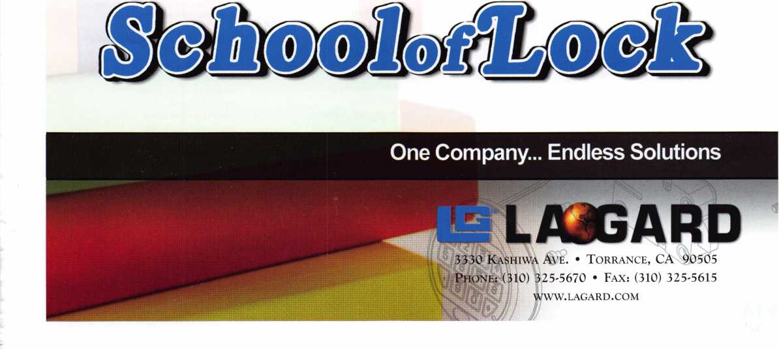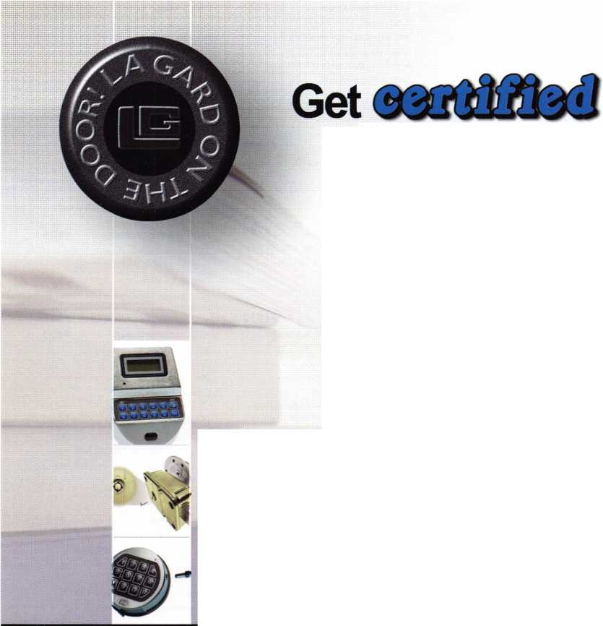

JMAUSA #507

2409 Avenue J, Suite A, Arlington, TX 76006 817-385-0515; 817-385-4850 fax Contact: Mike Conti

**Jet Hardware Mfg. Corp. #112**

800 Hinsdale St. • Brooklyn, NY 11207 718-257-9600; 718-257-0973 fax [www.jetkeys.com](http://www.jetkeys.com); e-mail: [keys@jetkeys.com](mailto:keys@jetkeys.com) Contact(s): George Buchinger, Marc Auerbach Manufacturer —Key Blanks, Key Displays,

Key Cutting Machines, Utility Locks

**KABA Access Controls #101**

2941 Indiana Ave.

Winston Salem, NC 27105 336-725-1331; 336-725-8814 fax www. ka ba - i Ico. com ; e-mail: [cself@kaa.kaba.com](mailto:cself@kaa.kaba.com) Contact(s): Michael Kincaid, Rich Lang Manufacturer—Electric/Electronic Security; Lock Devices

KABA Safe + Container Locks (Kaba-Mas) #101

749 Short Street, Lexington, KY 40508

1. 253-4744; 859-255-2655 fax

[www.kaba-mas.com](http://www.kaba-mas.com);

e-mail: [customerservice@kml.kaba.com](mailto:customerservice@kml.kaba.com)

Contact(s): Carl Sideranko, Steve Pollack

Manufacturer-Bank Security Equipment;

Safes/Vaults

Keedex Manufacturing #420

12931 Shackelford Lane Garden Grove, CA 92641 714-636-5657; 714-636-5680 fax [www.keedex.com](http://www.keedex.com); e-mail: [info@keedex.com](mailto:info@keedex.com) Contact: Julie McCluney Manufactuer- Automotive; Builders Hardware; Electric/Electronic Security; Lock Devices; Tools & Supplies; Gate Boxes

**Kenstan Lock Company #1236**

101 Commercial St. Plainview, NY 11803 516-576-9090; 516-576-0100 fax [www.kenstan.com](http://www.kenstan.com); e-mail: [rharrison@kenstan.com](mailto:rharrison@kenstan.com) Contact(s): Bill Bullwinkel, Pilar Guerrero Manufacturer/Distributor-Builders Hardware; Lock Devices; Showcase & Cabinet Locks

**Keri Systems, Inc. #435**

1530 Old Oakland Rd. Ste 100 San Jose, CA 95112 800-260-5265; 408-441-0309 fax [www.kerisys.com](http://www.kerisys.com); e-mail: [sales@kerisys.com](mailto:sales@kerisys.com) Contact(s): Mike Bevan, Vince DeJulius Manufacturer-Electric/Electronic Security

**KEY-BAK #1320**

4245 Pacific Privado; Ontario, CA 91761 909-923-7800; 909-923-0024 fax [www.keybak.com](http://www.keybak.com); e-mail: [mikew@keybak.com](mailto:mikew@keybak.com) Contact(s): Michael Winegar, Maria Lopez Manufacturer-Tools & Supplies

Keyless Ride #935

800 Paloma Dr. Ste 110,

Round Rock, TX 78664 512-310-5757 [www.keylessride.com](http://www.keylessride.com); e-mail: [sales@keylessride.com](mailto:sales@keylessride.com) Contacts): Noel Lopez Manufacturer/Wholesaler-Automotive

Klassy Keys, Inc. #1502

63 Carrs Tavern Road • Clarksburg, NJ 08510 888-844-5397; 800-610-6670 fax Contact(s): Bob DeJonge

KSP-Killeen

Security Products #926

33 Hermon St., Worcester, MA 01610 800-577-5397; 508-753-2183 fax [www.iccore.com](http://www.iccore.com); e-mail: [kzawalich@iccore.com](mailto:kzawalich@iccore.com) Contact(s): Doug Maston, C.O.O., Karen Zawalien, V.P. Sales & Marketing Manufacturer-Lock Devices

**Kustom Key, Inc. #1011**

1010 Aviation Drive,

Lake Havasu City, Arizona 86404 800-537-5397; 800-235-4728 fax [www.kustomkey.com](http://www.kustomkey.com); e-mail: [sales@kustomkey.com](mailto:sales@kustomkey.com) Contact! s): Tony Profera Manufacturer-Lock Devices; Tools & Supplies

Kwikset Corp. #1124

19701 DaVinci; Lake Forest, CA 92610 949-672-4508; 949-672-4825 fax [www.kwikset.com](http://www.kwikset.com) Contact: Anna Van Patten Manufacturer-Lock Devices

**LAB Security # 1124**

700 Emmett St. Bristol, CT 06010 800-589-6037; 860-583-7838 fax [www.labpins.com](http://www.labpins.com); e-mail: [sales@labpins.com](mailto:sales@labpins.com) Contacts): Mike Sigmund, Alan Mauro Manufacturer-Tools & Supplies; Tumbler Pins & Re-pinning Kits

**LAGARD, Inc. #1110**

3330 Kashiwa St. • Torrance, CA 90505 310-325-5670; 310-325-5615 fax [www.lagard.com](http://www.lagard.com); e-mail: [theone@lagard.com](mailto:theone@lagard.com) Contact(s): Tasha Birdwell, Jim Betancourt Manufacturer —Safes/Vaults

Lectro Truck/I.M.S. Inc. #1203

310 South 10th Street, Oostburg, Wl 53070

920-564-6272; 920-564-2322 fax

[www.lectrotruck.com](http://www.lectrotruck.com);

e-mail: [information@lectrotruck.com](mailto:information@lectrotruck.com)

Contact: Jason Tagel-Director of Sales &

Marketing

Manufacturer —Tools & Supplies; Stair Climbing Hand Trucks

**Lockmasters, Inc. #701**

5085 Danville Rd. • Nicholasville, KY 40356 859-885-6041; 859-885-7093 fax [www.lockmasters.com](http://www.lockmasters.com); e-mail: [maryfosters@lockmasters.com](mailto:maryfosters@lockmasters.com) Contact: Cheryl Holland Distributor—Automotive; Builders Hardware; Electric/Electronic Security; Lock Devices; Tools & Supplies; Safes/Vaults

LS Group #1233

1952 Gallows Road, Suite 100 Vienna, VA 22182 703-442-0537; 703-891-0843 fax Contact: Matthew B. Chang

LSI #700

5085 Danville Rd. • Nicholasville, KY 40356 866-574-8724; 859-885-7093 fax Contact: Cheryl Holland

Lock and Load

Safe Co., Inc. #1412

2492 Wall St. Jonesboro, GA 30236 800-595-5008; 770-473-4035 fax [www.lockandloadsafe.com](http://www.lockandloadsafe.com); e-mail: [jim@youngatgsp.com](mailto:jim@youngatgsp.com) Contact: James A. Raymer Manufacturer-Safes/Vaults; Special Flush Mount Gun safe with built in Burglar Alarm Contacts

**LockPicks.com/**

**Brockhage Tools #1336**

P.O. Box 1900, 1750 Rogers Ave.

San Jose, CA 95109

800-480-0875; 408-437-3129 fax

[www.lockpicks.com](http://www.lockpicks.com);

e-mail: [info@lockpicks.com](mailto:info@lockpicks.com)

Contact(s): Barrett Brockhage, Damon Davis

Manufacturer, Distributor-Automotive;

Tools & Supplies

**Locksmith Ledger International #1030**

3030 Salt Creek Lane Ste 200 Arlington Heights, IL 60015 847-454-2702; 847-454-2759 fax Contact: Nancy Brokamp Locksmith industry publication-has provides up-to-the-minute valuable information for nearly 6 decades.

Locksmithing,

Unlimited #1108

828 S. Broom St.

Wilmington, DE 19805-4245 302-575-0993; 302-571-1677 fax [www.locksmithingunl.com](http://www.locksmithingunl.com); e-mail:[ted@locksmithingunl.com](mailto:ted@locksmithingunl.com) Contact(s): Ted Gula Manufacturer-Tools & Supplies

**Lucky Line Products, Inc. #104**

7890 Dunbrook Rd. »San Diego, CA 92126 800-654-6409ext20; 800-334-9709 fax [www.luckyline.com](http://www.luckyline.com); e-mail: [kmarciel@luckyline.com](mailto:kmarciel@luckyline.com) Contacts): Jan Howard-Morutka,

Kanoe Marciel

Manufacturer-Key Accessories

MAG Mfg. #327

15381 Assembly Ln.

Huntington Beach, CA 92649 714-891 -5100; 714-892-6845 fax Contacts): Kent McLaren Manufacturer —Builders Hardware

MBA USA, Inc. #1025

200 Orchard Drive Nicholasville, KY 40356-2357 859-887-0496; 859-887-9491 fax [www.mbausa.com](http://www.mbausa.com); e-mail: [sales@mbausa.com](mailto:sales@mbausa.com) Contact(s): Mark Bates

Distributor—Business/Technical & Educational- Lock Device; Tools & Supplies; Training

MDS Incorporated #908

317 Bracken Lane*Brandon, FL 33511 813-653-1180; 813-684-5953 fax Contact: Bob Battle

Manufacturer, Distributor—CCTV/Photo Imaging; Borescopes/Magnascopes

MTS International #602

2415 S. Dairy Ashford Ste 10-C Houston, TX 77077 281-920-4747; 281-920-4748 fax Contact: Marcel DeSouza

Main's Lock Supply #1020

13630 2nd Street, Yucaipa, CA 92399 909-795-2320; 909-795-3123 fax [www.iccores.com](http://www.iccores.com); e-mail: [randy@iccores.com](mailto:randy@iccores.com) Contact(s): Judy Main Distributor: I.C. Cores

**Major Manufacturing, lnc.#1212**

1825 Via Burton • Anaheim, CA 92806 714-772-5202; 714-772-2302 fax [www.majormfg.com](http://www.majormfg.com); e-mail: [bill@majormfg.com](mailto:bill@majormfg.com) Contact(s): Bill DeForrest, Dave Cox Manufacturer-Installation Tools

Markar Products Inc. #704

68 Ward Road • Lancaster, NY 14086

1. 685-4104 OR 800-866-1688; 716-685-3919 fax [www.markar.com](http://www.markar.com); e-mail: [information@markar.com](mailto:information@markar.com) Contact(s): Kathie Miller Manufacturer —Continuous Hinges, Door Assemblies, Lite Kits, Louvers, Pivots

MARKS USA #927

5300 New Horizons Blvd.

Amityville, NY 11701 631-225-5400; 631 -225-6136 fax [www.marksusa.com](http://www.marksusa.com); e-mail: [wjs@marksusa.com](mailto:wjs@marksusa.com) Contacts): William Sporre Manufacturer-Lock Devices

Master Lock Company #124

137 W. Forest Hill Avenue

Oak Creek, Wl 53154

414-571 -5625 or 800-308-9244,

800-308-9245 fax

[www.masterlock.com](http://www.masterlock.com); e-mail:

[masterlock@mlock.com](mailto:masterlock@mlock.com)

Contacts): Dave Kraninger, Paul Switzer

Manufacturer — Lock Devices

Keynotes • July/August 2006

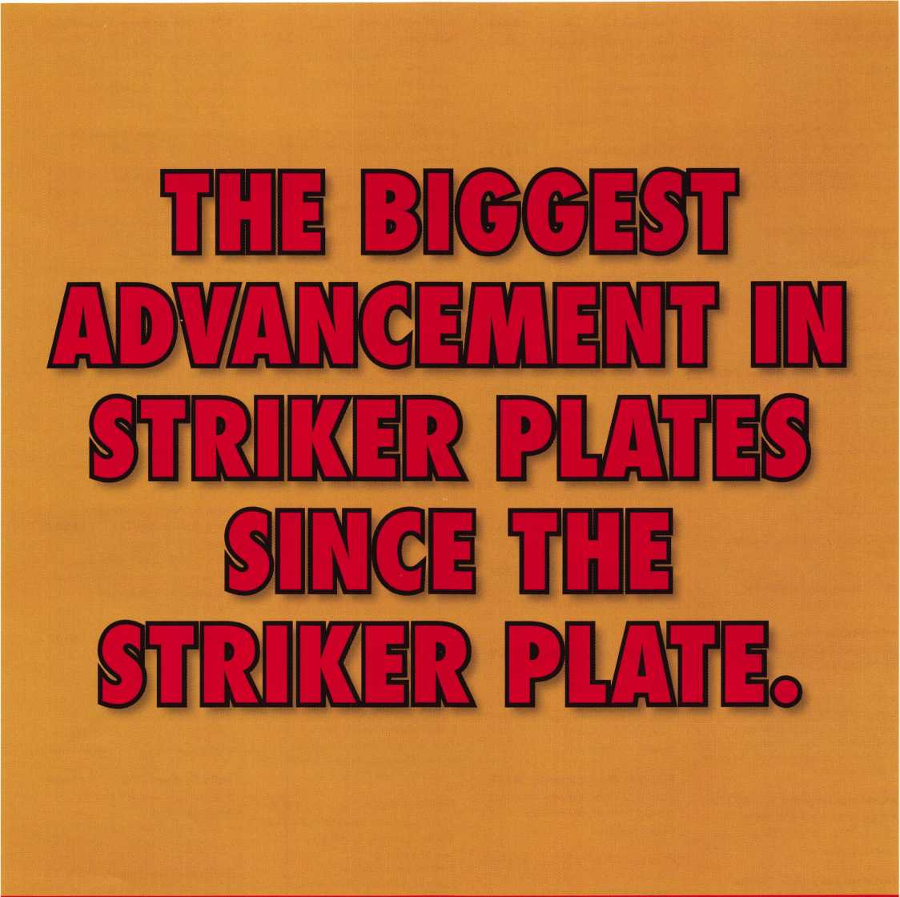

Introducing the revolutionary Sure-Strike? The patent pending design not only resists kick-ins, sawing, and prying by would-be  
burglars, it also self-adjusts to misaligned bolts and shifting doors.. .making it truly the most innovative striker plate system around.  
Easy to install and even easier to sell. Sure-Strike is sure to be a hit for distributors and locksmiths everywhere.



888-474-2341

**[www.sure-strike.com](http://www.sure-strike.com)**

**Sure-Strike is a product of WMW innovation Co. ©2006**

**Max cess Card**

**Systems, Ltd. #1206**

410 Avenida Ossa San Clemente, CA 92672 800-713-4823 (USA);

852-2419-0116-(Hong Kong) fax [www.maxcess-card.com](http://www.maxcess-card.com); e-mail: [maxcess@netvigator.com](mailto:maxcess@netvigator.com) Contact(s): Bruce Sedley, Dennis Davies Manufacturer-Mechanical Card Access System with replacement card-operated cylinders that fit most locksets/Featuring instant code chang­ing of locks without disassembly when cards are lost.

**Medeco High Security Locks #301**

3625 Allegheny Drive • Salem, VA 24153

800-675-7558

[www.medeco.com](http://www.medeco.com)

Contact: Tom Zuckerwar

Manufacturer —Lock Devices

Midwest

Wholesale Hardware #608

1000 North Century Ave.

Kansas City, MO 64120 800-821-8527; 800-621-6581 fax [www.midwestwholesale.com](http://www.midwestwholesale.com); e-mail: [hdwsales@midwestwholesale.com](mailto:hdwsales@midwestwholesale.com) Contact: Leo Czyz, Mel Jay Jr., Jim Manley, Kyle Holloway

Wholesale—Builders Hardware; Electric/Electronic Security

**Mil-Comm Products, Co., Inc. #301**

2 Carlton Ave, East Rutherford, NJ 07073 201 -935-8561; 201 -935-6059 fax Contact: Margaret Liebig

**MUL T-LOCK USA, Inc. #301**

300-1 Route 17 South • Lodi, NJ 07644 903-778-3320; 973-778-4007 fax [www.mul-t-lockusa.com](http://www.mul-t-lockusa.com); e-mail: [sales@mul-t-lockusa.com](mailto:sales@mul-t-lockusa.com) Contact(s): Ron Rachlin, Ortal Aish Manufacturer —Builders Hardware; Electric/Electronic Security; Lock Devices; Tools & Supplies; Key Machines, Master Key System Design

Mustang Company #1326

P.O. Box 369 Port Rickey, FL 34673 727-956-6753; 727-957-1366 fax Contact: Mark James

National Auto Lock Service #1423

180-B South Spruce Ave., South

San Francisco, CA 94080

800-954-5454; 650-875-0123 fax

[www.Iaserkey.com](http://www.Iaserkey.com)

Contact(s): Michael Hyde

Manufacturer, Wholesaler, Distributor- Alarms;

Automotive; Business/Technical & Educational;

Lock Devices; Tools & Supplies; Transponder

Experts

Norton Door Controls #301

3000 Highway 74 East, Monroe, NC 28112 800-438-1951; 800-338-0965 fax [www.nortondoorcontrols.com](http://www.nortondoorcontrols.com) Contact: Jeff Schoener Manufacturer-Builders Hardware

Olympus Lock, Inc. #424

18424 Highway 99, Lynnwood, WA 98037

206-362-3290; 206-362-3569 fax

[www.olympus-lock.com](http://www.olympus-lock.com);

e-mail: [info@olympus-lock.com](mailto:info@olympus-lock.com)

Contact: Beth Nielsen

Manufacturer —Lock Devices

OSI Security Devices #1315

1580 Jayken Way • Chula Vista, CA 91911

619-628-1000; 619-628-1001 fax

[www.omnilock.com](http://www.omnilock.com); e-mail:

sales@om n i lock, com

Onsite Contact(s): Rick Rasmussen

Manufacturer-Electric/ElectronicSecurity

PDQ Manufacturing #626

2754 Creek Hill Rd. • Leola, PA 17540

1. 656-4281; 717-656-6892 fax

[www.pdqlocks.com](http://www.pdqlocks.com);

e-mail: mocon nor@pdqlocks .com

Contact: Michael OiConnor,

cell-717-940-3819

Manufacturer-Builders Hardware; Lock Devices

Pacific Lock Company #513

21618 Marilla St. Chatsworth, CA 91311 888-562-5565; 818-678-6600 fax [www.paclock.com](http://www.paclock.com); e-mail: [sales@pacloc.com](mailto:sales@pacloc.com) Contact(s): Gregory Waugh, Gary Yang, Josh Fleagane, Bob McDonough High Security, solid body padlocks with unique logo branding capabilities on orders of all sizes

Pacific Security Products# 1207

1641 W. Main St. #211 Alhambra, CA 91801 626-570-4655; 626-289-2326 fax Contact: Jay Chang

Perma-Vault Safe Co. #1209

72 Ash Circle Warminster, PA 18974 800-662-3360; 215-293-9952 fax [www.perma-vault.com](http://www.perma-vault.com); e-mail: [sales@perma-vault.com](mailto:sales@perma-vault.com) Contact: Norman Bartwink Manufacturer-Safes/Vaults

Peterson Manufacturing #137

P. O. Box 744 • East Rochester, NY 14445 585-385-3896; 585-586-0425 fax Contact: Ken Persson

**Phoenix Safe Int'l. #1107**

P. O. Box 608. • Lebanon, IN 46052 765-483-0954; 765-483-0962 fax [www.phoenixsafeusa.com](http://www.phoenixsafeusa.com); e-mail: pgolden@phoen ixsafeusa .com Contact(s): Penny Golden Distributor — Safes/Vaults

Pop-A-Lock #1227

1018 Harding St. Ste 101

Lafayette, LA 70503

337-233-6211; 337-233-6655 fax

[www.popalock.com](http://www.popalock.com);

e-mail: [scottclause@systemforward.com](mailto:scottclause@systemforward.com)

Contact: Scott Clause-Marketing Director,

Rob Reynolds

Automotive; Lock Devices-Locksmith, Car Door Unlocking, Roadside Assistance Service

**Positive Identity**

**Solutions #511**

118 Overhill Drive, Suite 101 Mooresville, NC 28117 704-235-5035; 704-235-5037 fax [www.pids.usa.com](http://www.pids.usa.com); e-mail: [jkeck@pids-usa.com](mailto:jkeck@pids-usa.com) Contacts): Mark Ahuna, Roger Parks Wholesaler, Distributor-Electric/Electronic Security

PowerMate/

LP International, Inc. #1330

151 Savannah Oaks Drive,

Brantford, ON N3T 5P9 Canada 519-759-3292; 519-759-3298 fax [www.powermate.info](http://www.powermate.info); mak@powermate.info Contact: Ivan Vander Deen Manufacturer-Tools & Supplies;

Lifting Devices for Safes

Professional Business Products #1414

620 W. Commerce Rd • Commerce, Ml 48382

248-360-3979 or 800-355-6322;

248-360-3982 fax

[www.pbp2000.com](http://www.pbp2000.com);

e-mail: [sales@pbp2000.com](mailto:sales@pbp2000.com)

Contact: Kristy Emerick

Distributor —Business Forms, Labels &

Promotional Products

PRO-LOK #824

655 North Hariton Street

Orange, CA 92868

714-633-0681; 714-633-0470 fax

[www.pro-lok.com](http://www.pro-lok.com);

e-mail: [marshall@pro-lok.com](mailto:marshall@pro-lok.com)

Manufacturer—Automotive; Tools & Supplies;

Safes/Vaults

**Promet Safe Incorporated# 1137**

259 Sullivan Ave Unit D,

South Windsor, CT 06074

1. 436-6246; 860-436-6876 fax [www.promet-safe.com](http://www.promet-safe.com); e-mail: [sales@promet-safe.com](mailto:sales@promet-safe.com) Contact(s): Dmitry Chulisov, Managing Director; Steve Munz, Regional Sales Manager Manufacturer- Safes/Vaults

**Protex Safe Co. #806**

21212 Vanowen St. Canoga Park, CA 91303

1. 610-8030; 818-610-8004 fax [www.protexsafe.com](http://www.protexsafe.com); e-mail: [tal@protexsafe.com](mailto:tal@protexsafe.com) Contact(s): Tal Winner, President,

Shai Chason, President Electric/Electronic Security; Lock Devices; Safes/Vaults

Rodman & Co., Inc. #1226

7047 Vineland Ave.

North Hollywood, CA 91605 818-765-5552; 818-765-8158 fax [www.rodmanandcoinc.com](http://www.rodmanandcoinc.com) Contacts): Ted Baum, Dean Longo Distributor-Drill Bits, Nibbler, Hand Tools

**ROFU International Corp.#924**

7107 28th Street East • Tacoma, WA 98424 800-255-ROFU or 253-922-1828 phone 888-840-7272 or 253-922-1728 fax [www.rofu.com](http://www.rofu.com); e-mail: [aloa@rofu.ws](mailto:aloa@rofu.ws) Onsite Contact(s): Julie Collins-VP,

Ken Erickson-VP

Manufacturer —Electric/Electronic Security; Lock Devices; Access Control

**Rutherford Controls**

**Int'l. Corp. #522**

210 Shearson Crescent,

Cambridge, Ontario Canada NIT 1J6 519-621 -7651; 519-621 -7939 fax [www.rutherfordcontrols.com](http://www.rutherfordcontrols.com); e-mail: [sales@rutherfordcontrols.com](mailto:sales@rutherfordcontrols.com) Contact(s): Helmut Ruff, Greg Drake,

Cecil Thornton

Manufacturer, Distributor- Electric/Electronic Security; Lock Devices

**SDC #427**

3580 Willow Lane

Westlake Village, CA 91361

800-413-8783; 805-494-8680 fax

[www.sdcsecurity.com](http://www.sdcsecurity.com);

e-mail: [service@sdcsecurity.com](mailto:service@sdcsecurity.com)

Contacts): Shane Geringer, Kelly Boyce

Manufacturer-Electric/Electronic Security;

Lock Devices

Safe & Vault Technicians Association (SAVTA) #1502

3500 Easy St. • Dallas, TX 75247 214-819-9771; 214-819-9736 fax [www.savta.org](http://www.savta.org); e-mail: [dialcenter@aol.com](mailto:dialcenter@aol.com) Safe Technicians Trade Association Contact: Mike Oehlert

Safety By Design #127

707 Spirit 40 Park Dr. Suite 100,

Chesterfield, MO 63005

636-449-0707; 636-449-0708 fax

[www.turnerlock.com](http://www.turnerlock.com);

e-mail: [info@turnerlock.com](mailto:info@turnerlock.com)

Contact(s): Steve Leinenbach, Bob Boehlow

Manufacturer-Builders Hardware; Lock Devices

Salto Systems, Inc. #1409

3080 McCall Drive Suite 3 Atlanta, GA 30340 866-80SALTO; 770-452-6098 fax Contact: Therese Sandnes

**Sargent & Greenieaf, Inc.#621**

One Security Drive • Nicholasville, KY 40356 859-885-9411; 859-885-3063 fax [www.sglocks.com](http://www.sglocks.com), e-mail: [sales@sglocks.com](mailto:sales@sglocks.com) Contact(s): Phil Pitt Manufacturer —Lock Devices

**SARGENT**

**Manufacturing #301**

100 Sargent Drive N.

New Haven, CT 06511 800-727-5477; 203-776-5992 fax [www.sargentlock.com](http://www.sargentlock.com) Contacts): Tom Mayer Manufacturer —Builders Hardware; Electric/Electronic Security; Lock Devices

42

Keynotes • July/August 2006

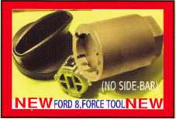

FORD 8, (NO SIDE BAR IGNITION FORCE TOOL) NEW! PATENTED

WITH THIS TOOL, YOU CAN TURN FORD 8,NO SIDE BAR IGNITIONS TO THE ON POSITION,PUSH RETAINER IN SLIDE LOCK OUT, FOR FAST REPAIR,REPLACEMENT,OR STARTING CAR IN AN EMERGENCY. IN LESS THAN 5 MINUTES. MADE OF TOOL STEEL TO LAST A LIFETIME.65.00 PLUS 600 S&H.

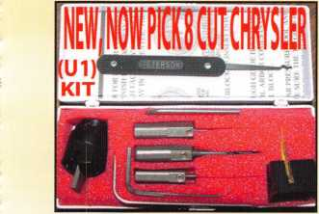

Universal Ford Flush-Mounted/Chrysler 8-Cut Ignition Removal Kit #U1 (patented)

Use this tool on all Ford flush mount ignitions, with or without side bar, large and small diameter face, all types of focus locks. With adapter, you can do virtually all Chrysler, Dodge, and Jeep 8-cut ignitions with no damage to lock. Similar kits sell for over $100.00 and only do Chrysler. Fit key and replace. In less than 5 minutes, you will have them out. Kit includes: 1 force tool (to remove face); 3 drill & arbors; 3 drill guides for all access holes; side B AR pressure tool; turn wrench; tumbler holding tool (to assemble and disassemble). No other tool needed with this kit. SHOW SPECIAL: get free adapter for Chrysler, Dodge and Jeep with each kit. $155.00 +$6.00 S&H

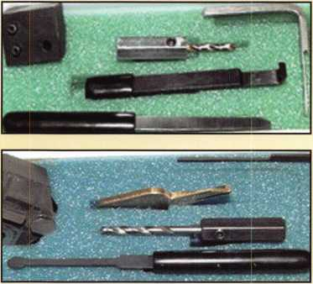

1998 Up G.M. In-Dash Ignition Removal Kit (patent 5454245)

Remove plastic ring and chrome cap in seconds. Make access hole to pick side bar. Turns cylinder to ACC position to remove lock in less than 5 minutes with no damage to lock. Your first job will pay for this kit. $70.00 + $6.00 S&H

1996 Up Ford 8 Tumbler Ignition Removal Kit and Side Bar Breaker Tool (patent 5701773)

Use force tool to turn ignition to "on" position in less than 60 seconds. To start car or for fast ignition lock removal or use kit to push side bar in, turn cylinder to "on" position for fast removal without any damage. Fit key, replace same lock. $90.00 + $6.00 S&H

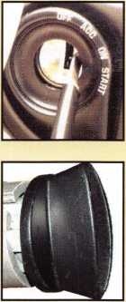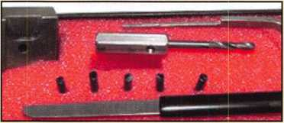

1994 Up G.M. 9 Tumbler Ignition Removal Kit (patent 5454245)

The locks have longer side bars than the older type and must be in the "on" position to remove. This kit will do that with no damage to the lock. Fit key and install same lock. Does all types, vats, mrd, top hat, module, etc. Your first job will more than pay for this kit. New with update to do module locks, blazers, suburbans, pick-ups, etc. $80.00 +$6.00

S&H

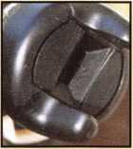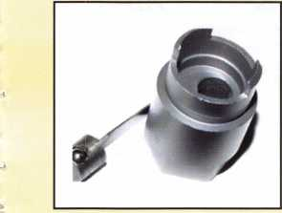

Ford "Quick-On" (patent 5454245)

Now turn all 10-cut ignition cylinders to the "on" position for fast removal-in less than 60 seconds. Sable, Taurus, all styles even those with airbags. No damage to housing.

$65.00 + $6.00 S&H

No-Nonsense Squeeze Lock Plug Remover

(patent 5165158)

Now you can remove all squeeze lock plugs in 15 seconds or less from all GM, Ford, Chrysler, AMC, and Jeep. No more fumbling, gadgets, cut fingers, broken tabs, or the need for 3 hands! It's so easy you can do it in the dark while it's still in the glove box.

$50.00 + $6.00 S&H

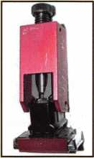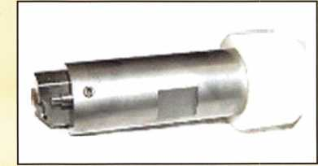

The G.M. Trunk & Door Persuader

The unique tool will open virtually all GM trunks and doors through the current year when tool fits into the cylinder core cavity in less than 50 seconds. No drilling, pulling, picking, special tools or electricity needed. When customer's key does not open trunk because: Problem 1: spring retainer popped up into outer shell; Problem 2: One side of side bar sprung off. Side bar does not retract; Problem 3: key or cylinder worn. Side bar does not retract; Problem 4: Key jammed in lock at "turned" position, etc. With The Persuader you will open these locks in less than 50 seconds with no damage to lock. Just repair and replace. There is nothing to wear out. Yes, if needed, it will open with no key. Note: Because of The Persuader's capabilities, it will be sold to locksmith only. $45.00 + $6.00 S&H

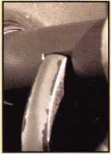

Frank Markisello guarantees all his products to do as stated.

[www.aablelocksmiths.com](http://www.aablelocksmiths.com) • 47 Marlboro Dr. • Milford, CT 06460 • (203)882-0600 • fax (203)882-0600

Stop By Booth #906  
And see all new products!

**SCHWAB Corp. #807**

110 Professional Ct., Lafayette, IN 47905 765-447-9470; 765-447-8278 fax [www.schwabcorp.com](http://www.schwabcorp.com); e-mail: [sm@schwabcorp.com](mailto:sm@schwabcorp.com) Contact(s): Ron Lashbrook, Ron Elzy Manufacturer-Safes/Vaults

**SDI/Robert Skeels & Co. #721**

8901 Chancellor Row Dallas, TX 75247-5363 214-879-1555; 214-879-1525 fax Contact(s): Howard Johnsen, Paul Justen Distributor-Automotive; Builders Hardware; Electric/Electronic Security; Lock Devices; Tools & Supplies; Safes/Vaults

**Securifort, Inc. #1322**

45 Cayouette

Tingwick, Quebec, Canada JOA 1LO

1. 359-2226; 819-359-2218 fax Contact: Carol Evans

Securitech Group, Inc. #527

54-45 44th Street • Maspeth, NY 11378

1. 392-9000; 718-392-8944 fax Contact: Mark Berger Electric/Electronic Security

**Securifrron Magnalock Corp.**

**#301**

550 Vista Blvd. • Sparks, NV 89434 775-355-5625; 775-355-5633 fax www. secu r i tron. com Contact(s): Mark McBroom Manufacturer —Electric/Electronic Security

Security Lock Distributors#421

7110 Placid St, Las Vegas, NV 89119 800-847-5625; 800-878-6400 fax [www.seclock.com](http://www.seclock.com); e-mail: [david@seclock.com](mailto:david@seclock.com) Distributor-Builders Hardware; CCTV/Photo Imaging; Electric/Electronic Security; Lock Devices

Security Plus, Inc. #1306

3612 N. 16th St. Phoenix, AZ 85016 602-234-3883; 602-234-3882 fax Contact(s): Steven Marcou, President,

Theo Nielsen, Sales Manager

Security Products, Inc. #633

30950 Corral Drive #B Coarsegold, CA 93614 800-452-5276; 559-642-2699 fax [www.securityproductsinc.com](http://www.securityproductsinc.com); e-mail: [rbe@sti.net](mailto:rbe@sti.net) Contact(s): Robert Barr

Manufacturer, Wholesaler, Distributor-Alarms, Bank Security Equipment; Builders Hardware; CCTV/Photo Imaging; Lock Devices

**Select Engineered Systems# 1429**

7991 W. 26th Ave. Haileah, FL 33016 305-823-5410; 305-823-5215 fax Contact: Stacy Berlemann

Select Hinges/

Select Products Limited #326

9770 Shaver Road • Portage, Ml 49024 800-423-1174; 269-323-3815 fax [www.select-hinges.com](http://www.select-hinges.com); e-mail:[bobc@select-hinges.com](mailto:bobc@select-hinges.com) Contacts): Bob Cronk Manufacturer—Builders Hardware

SERLAC #1308

930 W. Brandon Blvd Brandon, FL 33511

Simons Voss Technologies#!307

10125 S. 52nd St, Franklin, Wl 53132

414-421-2481; 414-421-2496 fax

[www.simons-voss.us](http://www.simons-voss.us);

e-mail: [info@simons-voss.us](mailto:info@simons-voss.us)

Contact(s): Amy Driver-Trade Show Manager,

Warren Simonsen-VP Operations

Manufacturer-Electric/Electronic Security;

Lock Devices

Smith Southern Equipment #1405

2210 W. 34th Street Houston, TX 77018 713-818-3681; 713-956-8588 fax Contact: Ruben Lopez

Southwest Specialty Products #425

236 E. Pima St. Scottsdale, AZ 85004 602-307-0901; 602-307-0909 fax [www.cansafe.net](http://www.cansafe.net); e-mail: [sspecialty@qwest.net](mailto:sspecialty@qwest.net) Contact(s): Sandy Patchefsky Manufacturer—Can Safes

**STRATTEC Security Corp. #121**

3333 W. Good Hope Road Milwaukee, Wl 53209 414-247-3333; 414-247-3564 fax [www.aftermarket.strattec.com](http://www.aftermarket.strattec.com); e-mail: [jbaker@strattec.com](mailto:jbaker@strattec.com) Contact(s): Dona Barczewski Manufacturer-Automotive

**Streetwise Security Products #1235**

235 F. Forlines Rd., Winterville, NC 28590 252-830-5577; 252-830-5542 fax www. streetwisesecu rity. net; e-mail: [sales@streetwisesecurity.net](mailto:sales@streetwisesecurity.net) Contacts): Mike Carey, Joe Rose Manufacturer-Security Products: Stun Guns, Alarms, Pepper Spray, etc.

Strong Arm Security lnc.#l 115

2228 Kenry Way So.

San Francisco, CA 94080 650-952-7710; 650-794-0541 fax [www.strongarmdrills.com](http://www.strongarmdrills.com); e-mail: [jvdrills@aol.com](mailto:jvdrills@aol.com) Contact: Jimmy Sung

Manufacturer, Distributor-Tools & Supplies; Safecracker drill bits and Drill Rigs

Sungil Safe Co., Ltd. #1430

4765 Buford Highway, Norcross, GA 30071 678-768-7888; 678-924-9404 fax [www.sungilsafe.com](http://www.sungilsafe.com); e-mail: [sales@snasafe.com](mailto:sales@snasafe.com) Contacts): William Lee, Jimmy Sung Wholesaler-Safes/Vaults

The Determinator #1421

P.O. Box 895 • Ocoee, FL 34761 800-561 -0443; 407-884-6730 fax E-mail: [determinatortom@aol.com](mailto:determinatortom@aol.com) Contact(s): Tom Tusing Manufacturer-Automotive

The Key Wizard #1415

1034 Featherwood Ave.

Henderson, NY 89015 702-845-7908 Contact: Gerald Howell

**The Locksmith Store, Inc. #133**

1229 E. Algonquin Rd Unit E.

Arlington Heights, IL 60005 847-364-5111; 847-364-5125 fax [www.locksmithstore.com](http://www.locksmithstore.com); e-mail: [info@locksmithstore.com](mailto:info@locksmithstore.com) Contact: Josh Swiderek Distributor-Automotive; Builders Hardware; Business/Technical & Educational; Electric/Electronic Security; Lock Devices;

Tools & Supplies

The National Locksmith #230

1533 Burgundy Parkway Streamwood, IL 60107

1. 837-2044; 630-837-1210 fax Contact: Marc Goldberg

**Timemaster, Inc. #732**

157 Venture Court Suite 9

Lexington, KY 40511

888-798-8464; 800-798-8463 fax

[www.time-master.com](http://www.time-master.com)

Contact: Tim Abner

Distributor

**Townsteel #1006**

707 N. Barranca Ave. Bldg #6 Covina, CA 91723 626-858-5080; 626-858-3393 fax [www.townsteel.com](http://www.townsteel.com); e-mail: [sales@townsteel.com](mailto:sales@townsteel.com) Contact(s): Dennis Ma Manufacturer-Lock Devices; Safes/Vaults

Triplett #730

One Triplett Drive. Blufton, OH 45817 419-358-5015; 419-358-7956 fax [www.triplett.com](http://www.triplett.com); e-mail: [sales@triplett.com](mailto:sales@triplett.com) Contact: Ted Suever-419-236-3246 cell Manufacturer-Test Equipment

**U.S. Lock #601**

77 Rodeo Drive • Brentwood, NY 11717

1. 243-3000; 631-243-0275 Fax [www.uslock.com](http://www.uslock.com); e-mail: [keuler@uslock.com](mailto:keuler@uslock.com) Contacts): Kathy Euler

Distributor—Alarms; Bank security equipment; Automotive; Builders Hardware; Business/Technical & Educational; CCTV/Photo imaging; Electric/Electronic Security; Lock Devices; Tools & Supplies; Safes/Vaults

Ultra Lift Corporation #1007

475 Stockton Avenue Unit E San Jose, CA 95126

1. 346-3057; 408-297-1199 fax Contact: George W. Dabb

Victor E-Lok, Inc. #1435

17 N. Santa Teresita Irvine, CA 92606 949-916-1200; 949-916-1300 fax Contact: Jimmy Yu Manufacturer

**Videx, Inc. #612**

1105 NE Circle Blvd. • Corvallis, OR 97330 541 -758-0521; 541 -752-5285 fax [www.videx.com](http://www.videx.com); e-mail: [sales@videx.com](mailto:sales@videx.com) Contact(s): Tish Phillips Manufacturer—Electric/Electronic Security;

Lock Devices

WiLife #1506

132 E. 13065 S Suite 200 Draper, UT

1. 316-4700; 801-316-4701 fax e-mail: [elandaker@wilife.com](mailto:elandaker@wilife.com) Contact: Erika Landaker

Wilson Safe Company #136

3031 Island Ave, P.O. Box 5310,

Philadelphia, PA 19142-0310 800-345-8053; 215-492-7104 fax [www.wilsonsafe.com](http://www.wilsonsafe.com); e-mail: [info@wilsonsafe.com](mailto:info@wilsonsafe.com) Contact(s): Ray Wilson Manufacturer-Safes/Vaults

WMW Innovations Co. #1427

2466 Prairie Hill Dr • Frisco, TX 75034

214-866-0001

Contact: Scott Myer

Manufacturer of Sure-Strike, an innovative striker plate system that dramatically increases security and solves the age-old problem of deadbolt misalignment.

Yale Commercial Locks and Hardware #301

100 Yale Avenue, Lenoir City, TN 37771 800-438-1951; 800-338-0965 fax [www.yalelocks.com](http://www.yalelocks.com)

Contact: Lori Robb Brown, John Presley Manufacturer—Builders Hardware; Electric/Electronic Security; Lock Devices

ZIPFLockCo. #227

830 Harmon Ave • Columbus, OH 43223 800-848-1577; 800-228-6320 fax [www.zipflockco.com](http://www.zipflockco.com); e-mail: [zipflockco@aol.com](mailto:zipflockco@aol.com) Contact(s): Rick Zipf

Wholesale, Distributor—Automotive; Builders Hardware; Business/Technical & Educational; Electric/Electronic Security; Lock Devices; Tools & Supplies.



Keynotes • July/August 2006

PowerMate

♦ PowerMate® does 100% of the lifting and is ergonomically designed to reduce physical effort used to move heavy loads by 87%.

♦ Increases job efficiency and productivity.

♦ Significantly lowers labor costs.

♦ Create referrals and repeat business.

♦ Best in Class post sales support and on-site training.

To learn how PowerMate® is the “SOLUTION” for you, call..

1-800-697-6283

[www.powermateJnfo](http://www.powermateJnfo)

PowerMate® is a Registered Trademark of

L P INTERNATIONAL INC.

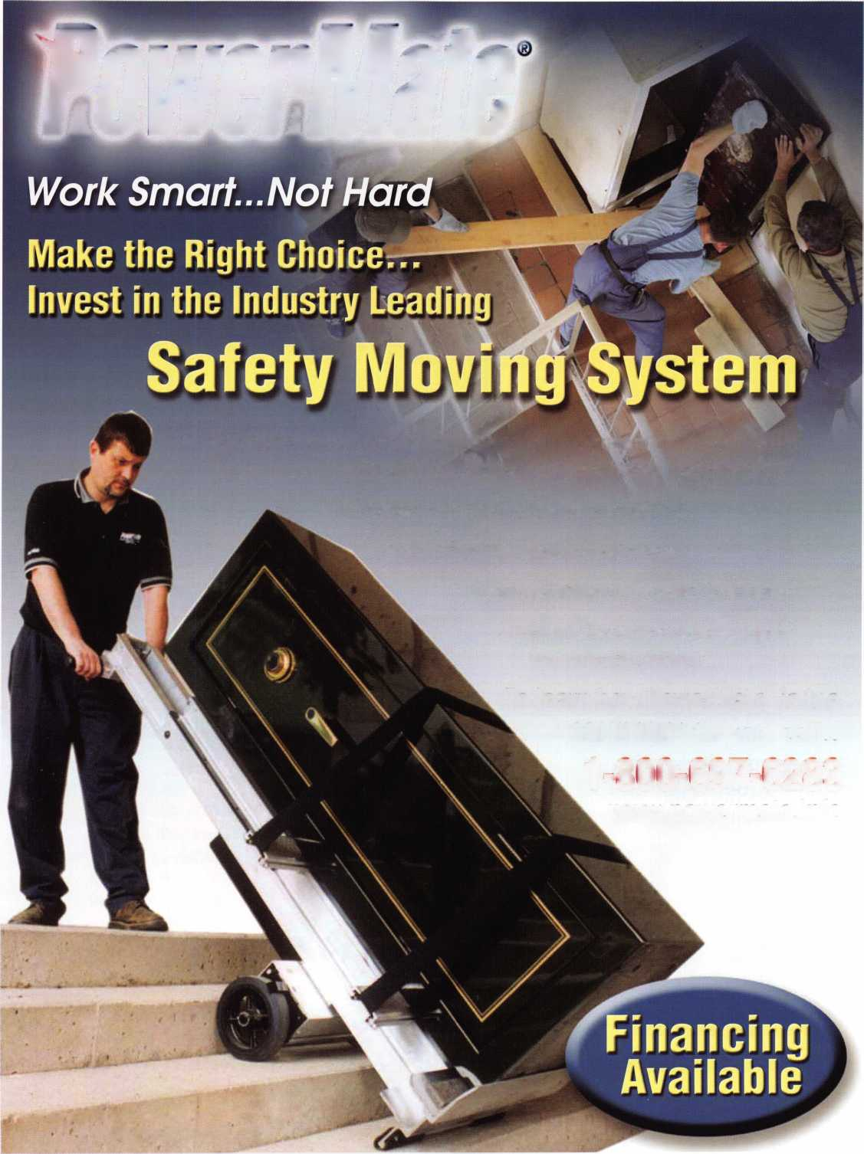

Bill Smith, RL

■

Meet the Board 2006

Election Results Posted 6/13/06

**~Tl*i**

PRESIDENT

ivooeri mouv

Hi

John Soderland

INTERNATIONAL

DIRECTOR

Hans Mejlshede, CML

**NORTH**

***vim***

REGION NDIRECTOR

**(TIED)**

Jim Jeffries

m

th Whiting, CML, CFL

*** NOTE: The ALO

Directors will addre:

situation at a later  
A run off election

be held on the  
7th of July.

Guy Spinello, RL

wi

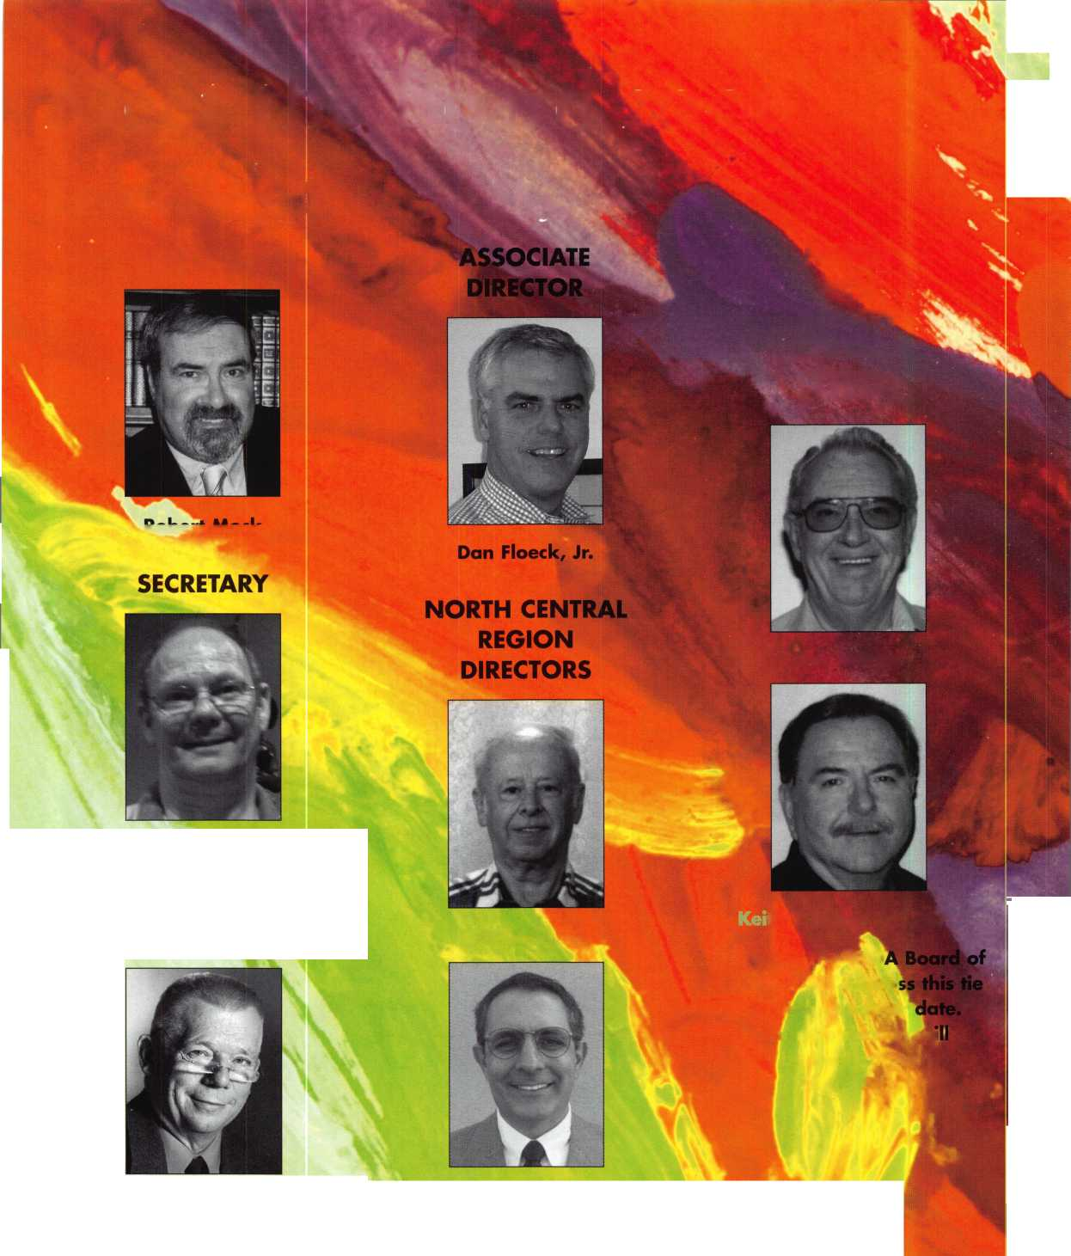

SOUTHWES

William Young, CML.

illingham

SOUTH

CENTRAL

REGION

DIRECTOR

fSIwiP f

CD Lipscomb, CML, CPS

Robert (Bobby) DeWeese, CML

ION

Greg Parks, CRL

NORTH

EAST

tan, CRL

»I -

REGION

DIRECTORS

Tom Foxwell, Sr.

John Greenan

TRUSTEES

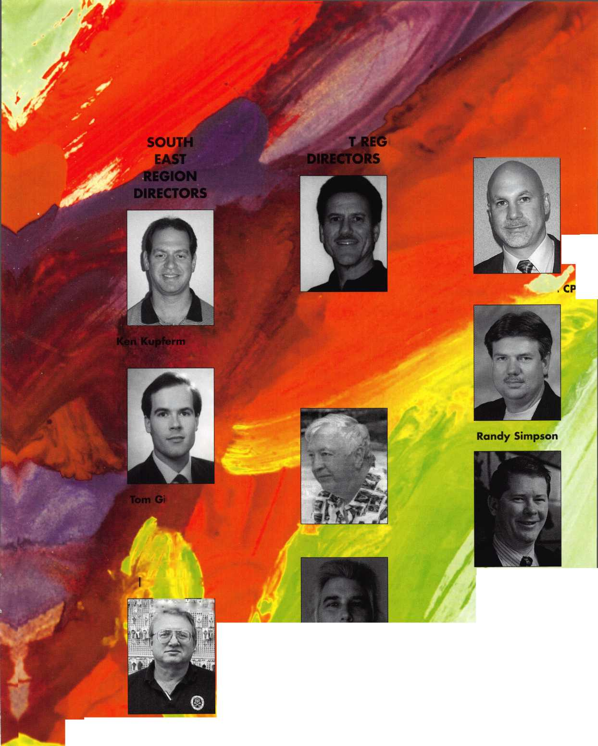

Test Your Recruiting Skills

Sure, you believe in ALOA. And yes, you’d like to see membership and involvement increase. And most certain­ly, you endorse the association’s membership drives.

But what commitment have you made to increase mem­bership and involvement? Since membership development usually comes down to a one-member-inviting-another proposition, increased membership is ultimately your responsibility.

Now, the quiz:

The more involvement you maintain in membership activ­ities throughout the year, the more likely you'll help swell the ranks of your members — and make ALOA a more vibrant organization.

Take this brief quiz to determine just what you're doing to foster increased membership right now. Each question refers to a desirable involvement-building habit. Your response to each question will be the frequency with which you practice the habit: often (”OFT") sometimes ("SOM”) or rarely ("RAR").

1. I clip articles from association publications of interest

|  |  |  |  |
| --- | --- | --- | --- |
| to prospective members, and pass them along. | OFT | SOM | RAR |
| 2. I mention association activities in my contacts with business acquaintances. | OFT | SOM | RAR |
| 3. I invite peers and colleagues to "sample" ALOA through involvement in short-term (single-day) association activities. | OFT | SOM | RAR |
| 4. I make at least one telephone call each month to prospective members, inviting them to become involved. | OFT | SOM | RAR |
| 5. I offer association newsletter subscriptions to prospective members. | OFT | SOM | RAR |
| 6. I'm quick to share my association experiences with colleagues. | OFT | SOM | RAR |
| 7. When a friend or colleague becomes involved, I make  sure he receives thanks and recognition from the association. | OFT | SOM | RAR |
| 8. I bring prospective members to association meetings, social gatherings and conventions. | OFT | SOM | RAR |
| 9. I keep association membership kits in my office and distribute them whenever the opportunity arises. | OFT | SOM | RAR |
| 10. I educate prospects about the benefits ALOA provides, and explain how to obtain them. | OFT | SOM | RAR |
| 11. I offer ideas and advice on membership recruitment to the Board of Directors or Membership Department | OFT | SOM | RAR |

**48**

Keynotes • July/August 2006

Don't miss out!

Order Your Registration Packet TODAY

Start Your Engines!

This year, with a great location and a  
schedule chock-full of exciting classes  
and events, we are pulling out all the  
stops to celebrate the ALOA Convention  
and Security Expo in Charlotte, North  
Carolina.

Having built an international reputation  
among locksmiths as a powerful resource  
to explore industry innovation and form  
industry alliances, ALOA 2007 is the ideal  
place to learn, network or to showcase  
your security-related business on the  
show floor.

This year we've thought of everything  
from an exciting location to a comfort-  
able hotel and a convention center that is  
equipped to handle your every need. The  
exhibit hall promises to be overflowing  
with the latest technology and new mer-  
chandise.

july 22-29, 2.007 charlotte, north Carolina

aloa convention and security expo

*51****st ANNUAL***

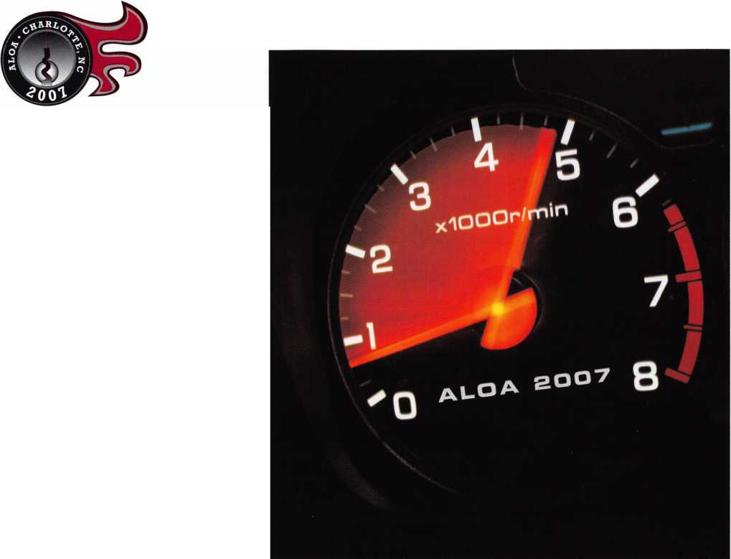

|  |  |  |  |
| --- | --- | --- | --- |
| 12. I offer my own informal orientation to association members I recruit. | OFT | SOM | RAR |
| 13. I give something of value — such as a small association gift,  a training guide, or timely information — to prospective members. | OFT | SOM | RAR |
| 14. I offer prospective members a complete "menu" of activities that would welcome their involvement. | OFT | SOM | RAR |
| 15. I make a mental inventory of the skills and talents of prospective members and try to match them up with the association. | OFT | SOM | RAR |
| 16. I'm careful to respect the time commitments and obligations of my new members. | OFT | SOM | RAR |
| 17. I introduce new members at convention and meetings. | OFT | SOM | RAR |
| 18. I ask the advice of new and prospective members on association and industry issues. | OFT | SOM | RAR |
| 19. I keep a running log of prospective members, packed with information about their needs and concerns. | OFT | SOM | RAR |
| 20. I maintain contact with my new members and make sure their association experiences are positive ones. | OFT | SOM | RAR |
| 21. When I'm not successful in recruiting a new member,  I debrief him to find out what I or the association is doing wrong. | OFT | SOM | RAR |
| 22. I talk with new and prospective members to find out which  ALOA services are right for them. | OFT | SOM | RAR |
| 23. When I find a prospective member who has leadership potential,  I act as his mentor. | OFT | SOM | RAR |
| 24. I keep track of membership-boosting strategies offered by the association, and try to put them into practice. | OFT | SOM | RAR |
| 25. I keep my ears open for successful membership development activities of other associations. | OFT | SOM | RAR |

So be honest: how many of these activities do you perform often or sometimes? If you put just six of these activi­ties into practice on a regular basis, you're doing a tremendous service to your association — and you may already be quite successful in identifying and involving new members.

If you practice these activities only rarely, pick a half-dozen that you can make part of your professional life each month. Just six. If you pursue these activities regularly — and you're firm in your followup with prospective mem­bers — you'll enlist the involvement and enthusiasm of your peers. And you may make a few new friends in the process.

These simple membership-building tasks will require very little of your time. But this very modest investment of time will pay tremendous dividends to your association, your colleagues and yourself — for years to come.

**50**

Keynotes • July/August 2006

/■—T—^ 4 4 ’t r

1 hank You

**gggjgi**

SARGENT AND GREEN LEAF

CHLAG

The Associated Locksmiths of America offers heartfelt gratitude to Sargent &- Greenleaf  
and Schlage for fifty years of Associate Membership and support of the organization.



Associate Membership

If you are not an Associate Member of  
Associated Locksmiths of America, Inc., consider the value of joining:

Members enjoy the following benefits

* Discounted exhibit space at the

ALOA Convention and Security Expo

* Priority choice of exhibit space at the

ALOA Convention and Security Expo

* A free listing each month in **Keynotes**

a valuable resource in the locksmith and security industry

* Discounted advertising in **Keynotes**

the fastest way to reach your target audience

* The use of the ALOA member logo on your forms and in advertising
* Free and unlimited access to the ALOA Membership Directory Online

Identify yourself as a leader in the security industry

Sign Up Today!

For more information, call Kim Hammond at (817)645-6778

Headquarters 3500 Easy St. • Dallas, Texas 75247 • (214) 819-9733 • (214) 819-9736 fax

ALOA Business Owners Group

YOUR

MSMBSTOH

In response to the need for connection among  
Locksmith/Security industry leaders, the elite ALOA  
Business Owner’s Group is being created.

At the ALOA 50^ Anniversary  
Convention and Security Expo in Las  
Vegas, ALOA is introducing the newest  
program specifically designed for the  
Security Business Owner.

The ALOA Business Owner’s Group will  
give business owners a chance to work  
together to share and solve common  
issues facing the security industry.

Contact the ALOA Office at  
1-800-252-3562 to receive information  
about this groundbreaking group today!

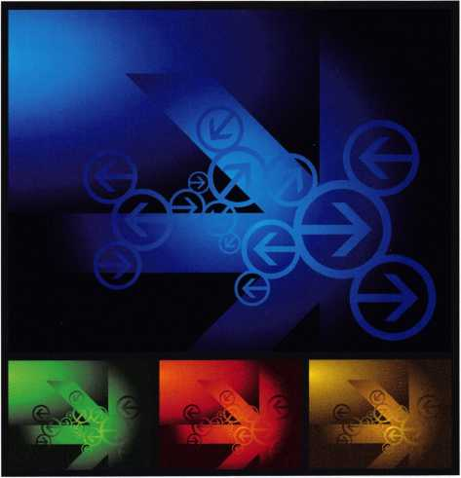

ALOA BUSINESS OWNERS GROUP

Bad Bobs

Yellow Pages Scheme

**by Tom ^J^dsworth** (reprinted and edited with permission from Door & Access Systems)

In the last few years, some dealers have discovered a way to make big money in the locksmithing business. Yellow Pages advertising is the cornerstone of the scheme.

Several details of the scheme are sleazy, many are deceptive, and some details are outright illegal. However, some dealers don’t care about that, and they end up giving the entire physical security business a bad name.

Here’s a general description of how the scheme would work for a hypothetical unethical dealer we’ll call “Bad Bob.”

1. Locate in a Large Metropolitan Area.

Since many of Bad Bob’s tactics might be viewed as unethical, he will target large-population centers where the consumer is very unlikely to know him. Even if he creates some angry customers who might tell a dozen people, Bad Bob knows he can still prey on hundreds of thousands of other people who don’t know what he’s doing.

1. Buy Giant Yellow Page Ads.

This is the key element of the strategy. Dealers have long recognized that Yellow Pages advertising is a critical ele­ment in any dealer’s marketing plan. Since consumers generally need door lock service only a few times in their lifetime, they will frequently rely on the Yellow Pages to find a local dealer.

In his Yellow Pages ad, Bad Bob’s strategy is to give the consumer the impression that he is credible. Here’s how he does it.

• Be huge. Bob buys a full-page full-color ad or even a two-page ad.

The consumers figure, “Gee, if he can afford a giant ad, he must be credible.” They don’t need to know that Bad Bob operates out of a house.

Be first. Bob does whatever it takes to be listed first. He will often create a company name that begins with “A,” because he knows that consumers often call the first name on the list.

Buy multiple ads. He often buys 2-4 full-page ads or a couple of double-truck ads (two-page ads). With all Bob’s ads listed first in the Yellow Pages, the consumer is extremely likely to call the phone number on at least one of his ads.

Use several company names. Bob often advertises under several company names, so the customer will call at least one of his numbers. The consumer will never know that Bad Bob is actually the only person behind all these companies.

Use as many brand names and logos as possible. Bob is usually not an “authorized” dealer of these brands, and this tactic is illegal. However, Bob knows that his Yellow Page rep will never check it out. Bob often uses recog­nized names. Even if a manufacturer seeks legal action against Bob, he knows they will often just send Bob a “cease and desist” letter. By then, this scheme will have earned Bob a boatload of money.

Focus on service work. Bob’s ads use big photos to target the consumer who needs quick service. Emergency serv­ice work increases his profit.

Promise quick response. Remember: Bob is targeting service work. His ad highlights “24-hour service” and “Emergency service within an hour.” Bob gets in that garageto that house or business fast, before a reputable locksmith claims the turf.

**54**

Keynotes • July/August 2006

Mention “Senior Citizen Discounts.” This phrase works every time for Bob. He might go ahead and give seniors some token discount, but he makes sure his “regular charges” are exorbitant. Then Bob laughs all the way to the bank.

Promise “Low Prices.” Bob often uses this time-proven phrase, except he doesn’t really charge low prices. Bob knows that consumers have no clue about the real cost of locksmithing services.

Post many phone numbers. In metropolitan areas, sub­urban homeowners like to believe the locksmith is in their neighborhood. So, Bob often publishes a differ­ent phone number for each of the major suburbs, but all calls are transferred to Bobs one location. A bunch of phone numbers is cheap, and they make Bad Bob look as if hes actually reputable.

Boast “Voted #1 in Customer Service.” This, too, is often false advertising, but Bob figures that his Yellow Page rep doesn’t care, and no one realizes that Bob is the only one who cast a vote! By the time Bob is forced to remove this from his annual ad, he will have scammed hundreds of people for mega-thousands of bucks.

Look reputable by displaying certain pictures. Good examples: (1) Clean-cut guy with a uniformed shirt and a clipboard, (2) New service trucks with Bob’s logo on them, (3) Expensive-looking buildings. None of these needs to be real. Bob knows that his Yellow Page rep can get these images and will even print Bob’s logo on the side of a picture of a blank service truck.

1. Negotiate Lower Prices for Yellow Page Ads.

Since the Yellow Pages are Bob’s largest expense, he must get the lowest possible price for these ads. To do that, Bad Bob is often part of a national chain of sleazy locksmiths. That way, the chain’s “central office” can negotiate sweet deals with low national rates.

1. Charge Exorbitant Prices.

These Yellow Page ads often cost Bob $250,000 to more than $1 million per year. To pay for that, Bob needs to maximize profits. So Bob doesn’t mess with measly 30-percent markups. He charges 5-20 times the

real cost. When the scheme is working properly, Bob rakes in more than $2100,000 per week.

1. Use Subcontractors as Technicians.

Bob needs to motivate his service guys to cooperate with the scheme. If Bob pays employee-technicians by the hour, he knows that the tech will have no motiva­tion to rack up a big bill and finish the job quickly. If the technicians are salaried employees, Bob usually needs to buy their trucks and tools and pay benefits and vacation time. Instead, Bad Bob hires subcontrac­tors who often have their own trucks and tools, and he pays them an attractive commission on each ticket. This gives them every reason to generate big tickets with every customer. Subcontractors are more likely to understand the profit motive and are less likely wimp out when Bob tells them to rack up at least $400 in charges to each customer.

1. A Warehouse is Unnecessary.

Why should Bad Bob pay for shop space, when others will do it for him? Since most of Bob’s income comes from service work, he doesn’t need to own or rent a building that stocks keys, door hardware, locks, and lock parts. Bob’s subs can pick up the items at any of several wholesale warehouses in his area.

1. A Storefront is Unnecessary.

A storefront might add a little credibility, but Bob knows that it’s really unnecessary and way too expen­sive. Bob often runs this entire scheme out of his own house, and his Yellow Page ads usually don’t list a physical address. As the ads generate hundreds of phone calls, Bob just dispatches his subs to each cus­tomer. Bob just takes calls and collects money. What if Bad Bob gets caught? No problem. He just takes his boatload of money and moves on to the next big city.

Note: Many of the above tactics can be part of an appro­priate marketing strategy, but problems arise when several of these tactics are used to deceive the public.

If this scheme is active in your area, we encourage you to distribute this story as a warning to your customers and report it to your state’s Attorney General’s office.

**55**

Keynotes • July/August 2006

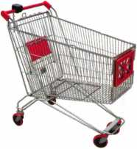

keynotes

Buyer'

Marketplace

SERVICE MANAGER/DISPATCHER

John Koons Locksmiths is looking for a person experienced in all phases of the trade in order to manage and dispatch our outside service staff. This position requires 9 hours minimum daily and every other Satruday 9-2. John Koons Locksmiths provides health insurance and paid days off. Applicants must be non-smokers and physically be able to assist in moving safes within our ware­house prior to delivery. We are always interested in hiring experienced locksmiths for outside service or in-shop postions with housing available for qual­ified applicants. Please call or fax resume to George Klein. John Koons Locksmiths, 3635 Fowler Street, Fort Myers, Florida 33901.

Tel. 1-800-282-8458. Fax 239-939-5869.

FREE WIRELESS AND LANDLINE  
VISA/MASTERCARD  
CREDIT CARD SYSTEMS FOR ALL  
ALOA MEMBERS.

[www.creditcardsystemsforfree.com](http://www.creditcardsystemsforfree.com)  
or call Bill at 847-263-1292

**ekey Fingerprint  
Access Control**

**TOCAhome**

**Standalone**

**TOCAnet**

**Network**

**Weather Resistant Self-Cleaning Scanner User Friendly**

**Your Finger is the Ke**

**(941)782-1227**

**[www.ekeyUSA.com](http://www.ekeyUSA.com)**

322I2J

Systems

IN-STOCK...MORE SAFES

***FREE Freight Program***

***(30 States)***

AMSEC FireKing

Gardall **hayman**

MEILINK **y/CTOR**

**TURPI tO**

**WHOLESALE SERVICE**

800-848-9790



Keynotes • July/August 2006

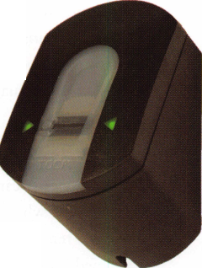

Punch SARGENT blanks

to factory specifications.

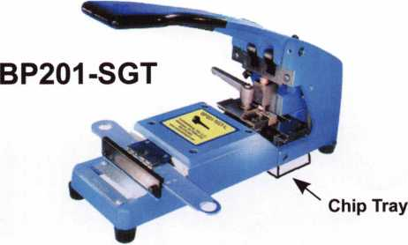

Try them hands on at A.L.O.A.  
in Las Vegas, NV • July 13-15

Available Exclusively from:

**Locksmithing, Uni. LLC**302-575-0993  
**[www.sargentpunch.com](http://www.sargentpunch.com)**

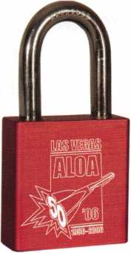

FREE ALOA PADLOCK

Coming to the ALOA show in July?

Be sure to stop by  
Pacific Lock’s Booth #513 to pick up  
your free ALOA 50th  
Anniversary PADLOCK.

Using a general purpose  
lubricant? **Be professional!**Use a specially formulated  
lubricant for the Locksmith  
and Safe Technician trade.  
You and your customers will  
be well pleased. **Guaranteed!**

$48°° + shipping per case.

12-1 loz. cans per case minimum order.  
Order via phone or fax. Credit cards accepted.  
Net 30 W.A.C. or send check with order.

Coast Safe & Lock Co., Inc.

P.0. Box 66257 • Mobile, AL 36606  
(251) 479-5264 • Fax (251) 471-6967

Keynotes • July/August 2006

**5**

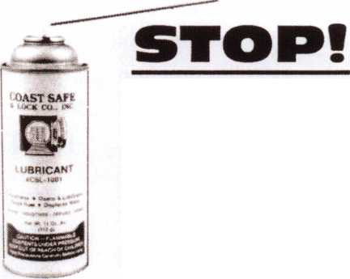

Up Close with the 2006 ALOA Scholarship Recipients

Wedve done it again. For yet another year, the ALOA Scholarship Foundation has dug deep to provide free locksmithing instruction to those aspiring locksmiths who otherwise would have been unable to attend the biggest show of them all - ALOA 2006. The good people you are about to meet are the benefactors of ALOA Scholarship gifts representing thousands upon thousands of dollars.

William Botek, CRL

has been very active in his  
local association and has  
worked in sev-

eral capac-  
ities for  
the Pacific  
Locksmith

Conference

including Chairman of the  
Pacific Locksmith  
Conference this year. He  
looks forward to participat-  
ing in his first ALOA  
Convention and sharing his

enthusiasm and knowledge with the younger genera­tion of locksmiths in his area.

Han Fossum

wants to partake in one of  
the best places for a lock-

smith to

gain con-  
nections  
and have

a better

understanding of  
the diversity in the industry.

He plans on taking the knowledge gained back to his job and using it to help understand and create fea­sible test methods for life safety, security, structural integrity and lifetime per­formance.

Kristen Oldenburg

is new to locksmithing hav­ing begun her career as a locksmith less than a year ago. She wants to gain more knowledge of all

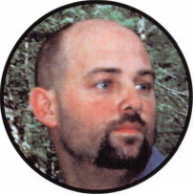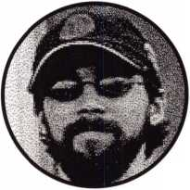

aspects of

locksmithing  
and feels the  
educational

opportunity

that ALOA offers will be a  
great help in her success as  
a locksmith.

Kevin Dona hoe

feels that the knowledge  
that he will gain at the  
ALOA convention repre-

sents an invalu-

able opportu-  
nity to grow  
his business  
and grow as

a locksmith. He  
wants to learn as much as  
he can about anything that  
his customers may ask  
relating to  
security.

David Hahn

received an introduction to  
locksmithing from his father

and has decid-

ed that he  
would like  
to pursue

the formal

training that is offered at  
the ALOA convention. His  
goal is to operate his own  
business and become an  
asset to ALOA and the  
security industry.

Mark Kaehler

is new to locksmithing hav-  
ing taken the

ALOA six

basic  
lock-  
smithing

course in 2005 he now  
wants to expand his knowl-  
edge of the industry to  
more advanced areas  
including access control  
and alarms.

John Ball

feels that his scholarship will enable him to strength­en his knowledge and allow him to learn new skills that will enable him to accomplish more as a locksmith. He is looking forward to his experience at the ALOA convention.



Faron Jackson

has been an ALOA mem-  
ber since 1997 and is  
interested in expanding his  
knowledge in the

more  
advanced  
automotive  
classes. He

also is a firm  
believer in the

sharing of knowledge that  
is practiced in ALOA and  
other associations which  
enables those who partici-  
pate to become more pro-  
fessional.

Wayne Rasmussen

has been involved in lock-  
smithing since 1992 and a  
member of ALOA since  
1994. He feels the ALOA  
convention is the best place  
to gain the

knowledge  
needed to

stay

informed

on new prod-

ucts and get hands on  
experience. In addition he

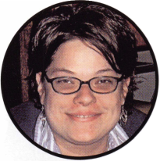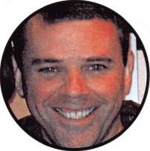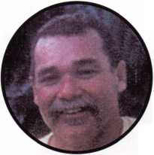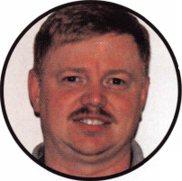

plans to use the knowledge  
gained at the convention to  
keep his business growing  
and operating in a profes-  
sional manner.

Lucas Krohn

feels that the opportunity  
presented by his scholar-  
ship will enable him to  
broaden his knowledge of  
the locksmith industry. He

hopes the

informa-  
tion from  
classes  
such as

Master Keying  
and Defense Against  
Methods of Entry will  
enable him to pursue more  
commercial locksmithing

and improve his customer  
satisfaction by the newly  
gained expertise that he  
will be able to provide.

Jason Wood

discovered locksmithing in  
2001 and has never  
stopped taking every

opportu

nity to  
gather  
knowl-  
edge

and apply it

to his profession. He feels that his scholarship is a wonderful opportunity to further his locksmithing career and will allow him to grow in the industry.

Reza Zahedi

has always had

an interest in  
the lock-  
smithing that  
his dad does.

Even though he

has just started learning  
locksmithing as a profes-  
sion he believes because of  
his interest and desire he  
has a lot of potential to be  
come a professional lock-  
smith. He enjoys working  
with his hands and meeting  
new people.

Gene Miller

wants the training received from his scholarship to enable him to be more competent and allow him to

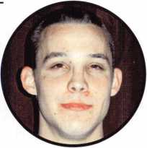

expand his

sphere of  
lock-  
smithing

abilities and

services. He believes that  
learning locksmithing is a  
life long experience.

Steve Lemoine

has been in the locksmith industry since 1984 and looks for every opportunity to learn everything he can to further his knowledge

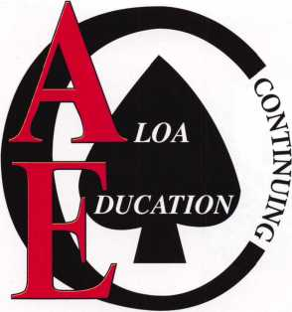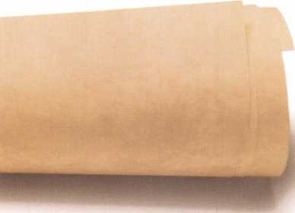

and skills as a locksmith.  
He is "honored to have

been chosen

for the  
scholar-

ship" and  
feels that

the knowledge  
received will enable him to  
continue his desire to bring  
integrity and professional-  
ism to the locksmith indus-  
try.

repair

tag

**KEY & LOCK**

4525 Hampl

CLAIM CHECK

your firm name here

_ t23 Main Street  
YOUR TOWN. STATE AND ZIP

Phone 123-4567

N* 4321

0004X15

IIWOICE

Professional Business Products

Invoices Tags *Call for a free*

Checks Key Fobs *brochure and samples*

**Business Magnets 1-800-355-6322**

Cards Labels [www.pbp2000.com](http://www.pbp2000.com)

•lOiioooooiHia ooiioaoooHOpg*;

*•00005 iu»»

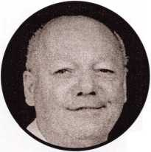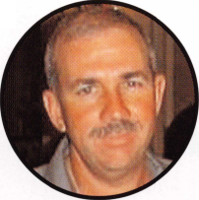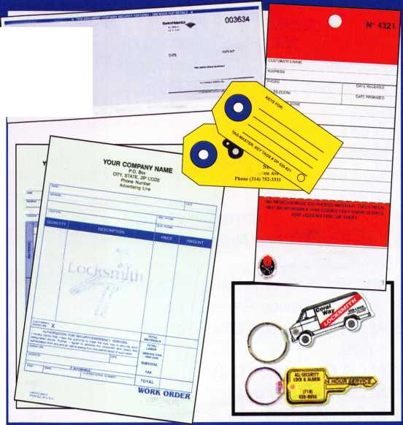

in a hurry-  
Use ALOA’s Fax On Demand  
service.

Just call 310-575-5027 and receive:

1. ALOA Index of Documents (1 pg)
2. Reasons to Join ALOA (2 pg)
3. Locksmith Career Summary (3 pgs)
4. Locksmith School List (1 pg)
5. ACE Class Schedule (1 pg)
6. Certification Information (5 pgs)
7. PRP Category List (1 pg)
8. ALOA Membership Application (1 pg)
9. ALOA List of Benefits (1 pg)
10. ASF Scholarship Application (1 pg)
11. ASF Scholarship Information (1 pg)
12. ALOA Video Library Order Form

(1 P9)

1. Safe & Vault Technicians Association Membership Application/Subscription Form (2 pgs)
2. Recertification Information (4 pgs)
3. Legislation Action Network Newsletter (2 pgs)
4. Various State Law Issues (8 pgs)
5. Industry Position Paper (1 pg)
6. ALOA Convention Class Schedule (3 pgs)
7. ALOA Convention Class Descriptions (30 pgs)
8. ALOA Convention Registration Forms (4 pgs)
9. Board of Directors Nomination Form (2 pgs)
10. ALOA Company Membership Application (2 pgs)

ALOA continues to provide

you with this and  
other great benefits  
and services!

310-515-5027

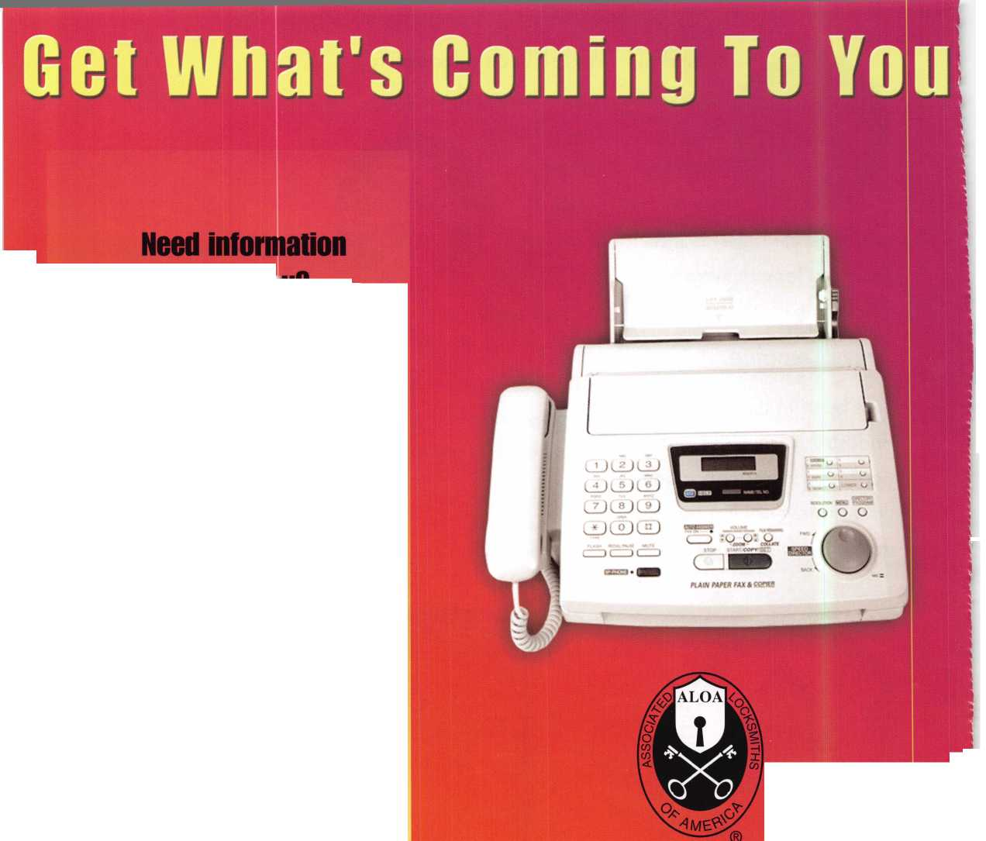

**The Victor e-lok.**

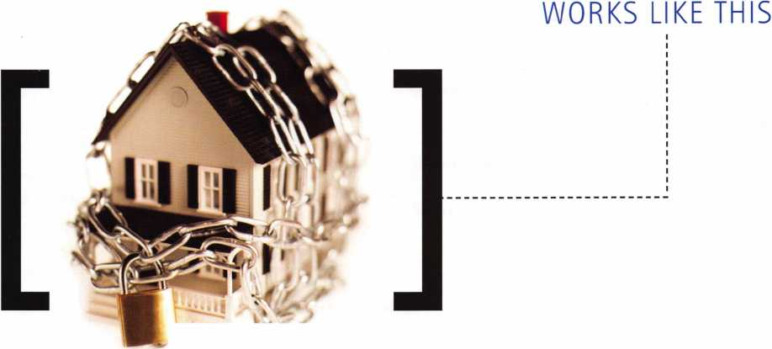

LOOKS LIKE THIS

No more fumbling for house keys. Welcome to the future of state-of-the art locks. The revolutionary Victor e-lok from BKS, a division of Gretsch-Unitas, is now available to meet your stand alone access control requirements.

**G-U**

Integrated deadbolt and latch

* No key
* Easily programmable  
  Burglar Alarm
* Rekeyable emergency key override
* Easily retrofittable to ANSI standard 161 prep.
* Heavy duty lock with clutch mechanism
* No wiring
* Low battery consumption
* 6 finishes available: 03, 04, 10B, 15, 26 and 26D
* Master code system
* Meets police/fire department standard
* Meets ADA requirements
* Panic exit function
* 13 patents/patents pending
* The only lock on the world market of its kind

House keys are a thing of the past. Enter a whole new

world with Victor e-lok. 1 2650

Visit us at the ALOA Show booth #1435.

G-U Hardware Incorporated

Patrick Henry Drive | Newport News, Virginia 23602 800-927-1097 | [www.g-u.com](http://www.g-u.com)

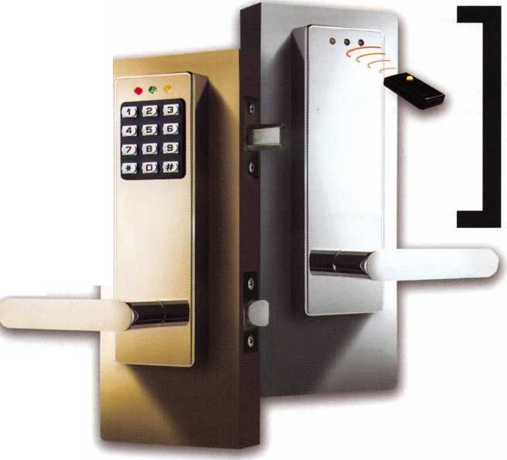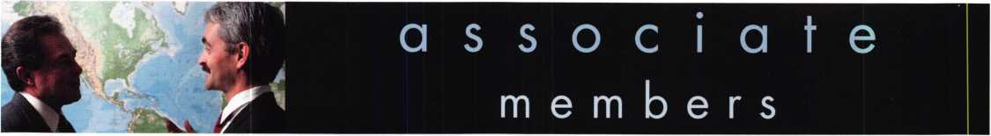

Distributor

**1st In Hardware, Inc.**

Phone: Phone: 410-646-9900 Fax: 410-646-0045 www. 1 stinhardware.com

**ADEL Fingerprint Technology, LLC**

Phone: 909-595-1222 Fax: 909-595-1667

**Accredited Lock Supply Co.**

Phone: 800-652-2835 Fax: 201-865-2435 [www.acclock.com](http://www.acclock.com)

**Andrews Wholesale Lock Supply**

Phone: 717-272-7422 Fax: 717-274-8659 [www.andrewslock.com](http://www.andrewslock.com)

**Boyle & Chase Inc.**

Phone: 800-325-2530 Fax: 800-205-3500 [www.boyleandchase.com](http://www.boyleandchase.com)

**Clark Security Products**

Phone: 858-974-6740 Fax: 858-974-6720 [www.clarksecurity.com](http://www.clarksecurity.com)

**Cook's Building Specialties**

Phone: 505-883-5701 Fax: 505-883-5704

**Dire's Lock & Key Company**

Phone: 303-294-0176 Fax: 303-294-0198

**Direct Security Supply, Inc.**

Phone: 800-252-5757 Fax: 800-452-8600

**Discount Key Machines.Com/Busch**

Phone: 800-332-8724 Fax: 407-363-4666

**Doyle Security Products**

Phone: 800-333-6953 Fax: 612-521-0166 [www.doylesecurity.com](http://www.doylesecurity.com)

**Dugmore and Duncan, Inc.**

Phone: 888-384-6673 Fax: 888-329-3846

**E. L. Reinhardt Co., Inc.**

Phone: 800-328-1311 Fax: 651-481-0166 [www.elreinhardt.com](http://www.elreinhardt.com)

**Ewert Wholesale Hardware**

Phone: 800-451-0200 Fax: 708-597-0881

**Foley-Belsaw Company**

Phone: 800-821-3452 Fax: 816-483-5010 [www.foley-belsaw.com](http://www.foley-belsaw.com)

**Fried Brothers Inc.**

Phone: 800-523-2924 Fax: 215-592-1255 [www.fbisecurity.com](http://www.fbisecurity.com)

**H.L. Flake Co.**

Phone: 800-231-4105 Fax: 713-926-3399 [www.hlflake.com](http://www.hlflake.com)

**Hans Johnsen Company**

Phone: 214-879-1550 Fax: 214-879-1530 [www.hjc.com](http://www.hjc.com)

**Hardware Agencies, Ltd.**

Phone: 416-462-1921 Fax: 416-462-1922 [www.hardwareagencies.com](http://www.hardwareagencies.com)

**IDN Incorporated**

Phone: 817-421-5470 Fax: 817-421-5468 [www.idn-inc.com](http://www.idn-inc.com)

**Instant Hardware Delivery, Inc**

Phone: 800-355-1107 Fax: 800-663-8518

**Intermountain Lock & Supply**

Phone: 800-453-5386 Fax: 801-485-7205 [www.intermountainlock.com](http://www.intermountainlock.com)

**International Electronics, Inc**

Phone: 800-343-9502 Fax: 617-821-4443

**Jo Van Distributors**

Phone: 416-288-6306 Fax: 416-752-8371 [www.jovanlock.com](http://www.jovanlock.com)

**L V Sales Inc**

Phone: 323-661-4746 Fax: 323-661-1314 [www.lvsales.com](http://www.lvsales.com)

**Lockmasters, Inc.**

Phone: 859-885-6041 Fax: 859-885-7093 [www.lockmasters.com](http://www.lockmasters.com)

**Locks Company**

Phone: 800-288-0801 Fax: 305-949-3619

**Locksmith Ledger International**

Phone: 847-454-2700 Fax: 847-454-2759 [www.lledger.com](http://www.lledger.com)

**McDonald Dash Locksmith Supply**

Phone: 800-238-7541 Fax: 901-366-0005 [www.mcdonalddash.com](http://www.mcdonalddash.com)

**Monaco Lock Co.**

Phone: 800-526-6094 Fax: 800-845-5625 [www.monacolock.com](http://www.monacolock.com)

**NLS Lock Supply Dba Nevada Lock S**

Phone: 702-737-0500 Fax: 702-737-7134

**Omaha Wholesale Hardware**

Phone: 800-238-4566 Fax: 402-444-1664 [www.omahawh.com](http://www.omahawh.com)

**Phoenix Safe International LLC**

Phone: 765-483-0954 Fax: 765-483-0962 [www.phoenixsafeusa.com](http://www.phoenixsafeusa.com)

**Positive Identity Solutions**

Phone: 704-663-1175 Fax: 704-660-1301 [www.pids-usa.com](http://www.pids-usa.com)

**RA-Lock Company**

Phone: 972-775-6301 Fax: 972-775-6316 [www.ralock.com](http://www.ralock.com)

**Security Distributors Inc**

Phone: 800-333-6953 Fax: 612-524-0166

**Security House**

Phone: 905-669-5300 Fax: 905-660-6313 [www.securityhouselock.com](http://www.securityhouselock.com)

**Security Lock Distributors**

Phone: 800-847-5625

Fax: 800-878-6400

[www.securitylockdistributors.com](http://www.securitylockdistributors.com)

**Southern Lock and Supply Co.**

Phone: 727-541-5536 Fax: 727-544-8278 [www.southernlock.com](http://www.southernlock.com)

**Stone & Berg Wholesale**

Phone: 800-225-7405 Fax: 800-535-5625

**Streetwise Security Products**

Phone: 252-830-5577 Fax: 252-830-5542

**The Locksmith Store Inc.**

Phone: 847-364-51 1 1 Fax: 847-364-5125 [www.locksmithstore.com](http://www.locksmithstore.com)

**Timemaster Inc.**

Phone: 859-259-1878 Fax: 859-255-0298 [www.time-master.com](http://www.time-master.com)

**Top Notch Distributors, Inc.**

Phone: 800-233-4210 Fax: 800-854-4146 [www.topnotch.bz](http://www.topnotch.bz)

**Turn 10 Wholesale**

Phone: 800-848-9790 Fax: 800-391-4553

**U.S. Lock Corp.**

Phone: 800-925-5000 Fax: 800-338-5625 [www.uslock.com](http://www.uslock.com)

**Wilson Safe Company**

Phone: 215-492-7100 Fax: 215-492-7104 [www.wilsonsafe.com](http://www.wilsonsafe.com)

Manufacturer

**A & B Safe Corporation**

Phone: 800-253-1267 Fax: 856-863-1208 [www.a-bsafecorp.com](http://www.a-bsafecorp.com)

**ABUS Lock Company**

Phone: 800-352-2287 Fax: 602-516-9934 [www.abus.com](http://www.abus.com)

**Access Security Products Ltd.**

Phone: 905-337-7874 Fax: 905-337-7873 [www.access-safe.com](http://www.access-safe.com)

**Adams Rite Mfg Company**

Phone: 800-872-3267 Fax: 800-232-7329 [www.adamsrite.com](http://www.adamsrite.com)

**Adesco Safe Mfg. Company**

Phone: 800-694-9340 Fax: 562-408-6427 [www.adesco.com](http://www.adesco.com)

**Adrian Steel Company**

Phone: 800-677-2726 Fax: 517-265-5834 [www.adriansteel.com](http://www.adriansteel.com)

**Advanced Diagnostics USA Inc**

Phone: 650-876-2020 Fax: 650-876-2022 [www.ad-mvp.com](http://www.ad-mvp.com)

**Alarm Controls Corporation**

Phone: 631-586-4220 Fax: 631-586-6500 [www.alarmcontrols.com](http://www.alarmcontrols.com)

**All Five Tool Company, Inc.**

Phone: 860-583-1691 Fax: 860-583-4516 [www.all5tool.com](http://www.all5tool.com)

**American Security Products**

Phone: 909-685-9680x2013 Fax: 909-685-9685 [www.amsecusa.com](http://www.amsecusa.com)

**BWD Lockcraft**

Phone: 973-728-3707 Fax: 973-728-3731 [www.bwdautomotive.com](http://www.bwdautomotive.com)

**Bianchi USA, Inc.**

Phone: 800-891-2118 Fax: 216-803-0202 [www.bianchil770usa.com](http://www.bianchil770usa.com)

**Buddy Products**

Phone: 312-733-6400 Fax: 312-733-8356 [www.buddyproducts.com](http://www.buddyproducts.com)

**CCL Security Products**

Phone: 800-733-8588 Fax: 847-537-1800 [www.cclsecurity.com](http://www.cclsecurity.com)

Keynotes • July/August 2006

**associate**

**members**

**CompX Security Products**

Phone: 864-297-6655 Fax: 864-297-9987 [www.compxnet.com](http://www.compxnet.com)

**D&D Technologies (USA), Inc.**

Phone: 714-677-1300x292 Fax: 714-677-1299 [www.ddtechusa.com](http://www.ddtechusa.com)

**DETEX Corp.**

Phone: 800-729-3839 Fax: 830-620-6711 [www.detex.com](http://www.detex.com)

**Don-Jo Manufacturing, Inc.**

Phone: 978-422-3377 Fax: 978-422-3467 [www.don-jo.com](http://www.don-jo.com)

**Door Controls International**

Phone: 800-742-3634 Fax: 800-742-0410 [www.doorcontrols.com](http://www.doorcontrols.com)

**Door Jamb Armor/A&G Security**

Phone: 201-490-5381 Fax: 201-490-5389 [www.djarmor.com](http://www.djarmor.com)

**Doorking Inc.**

Phone: 800-826-7493 Fax: 310-641-1586 [www.doorki](http://www.doorki) ng .com

**E-Lock USA**

Phone: 434-589-5913 Fax: 434-589-3738 [www.e-lock-usa.com](http://www.e-lock-usa.com)

**FireKing Security Products**

Phone: 800-457-2424 Fax: 800-896-6606 [www.fkisecuritygroup.com](http://www.fkisecuritygroup.com)

**Framon Manufacturing Company Inc.**

Phone: 989-354-5623 Fax: 989-354-4238 [www.framon.com](http://www.framon.com)

**G-U Hardware Inc.**

Phone: 757-877-9020 Fax: 757-877-9720

[www.g-u.com](http://www.g-u.com)

**HPC, Inc.**

Phone: 847-671-6280 Fax: 847-671-6343 [www.hpcworld.com](http://www.hpcworld.com)

**HY-KO Products Co.**

Phone: 330-467-7446 Fax: 330-467-7442

**Hammerhead Industries, Inc.**

Phone: 805-658-9922 Fax: 805-658-8833 [www.gearkeeper.com](http://www.gearkeeper.com)

**Ingersoll Rand Security Technologies**

Phone: 317-805-5713 Fax: 317-805-5779 [www.schlagelock.com](http://www.schlagelock.com)

**Jackson Corporation**

Phone: 323-269-8111 Fax: 800-888-6855 [www.jacksonexit.com](http://www.jacksonexit.com)

**Jet Hardware Mfg., Co.**

Phone: 718-257-9600 Fax: 718-257-0973 [www.jetkeys.com](http://www.jetkeys.com)

**KABA ILCO Corp.**

Phone: 252-446-3321 Fax: 252-446-4702 [www.kaba-ilco.com](http://www.kaba-ilco.com)

**KEY-BAK/West Coast Chain Mfg.**

Phone: 909-923-7800 Fax: 909-923-0024 [www.keybak.com](http://www.keybak.com)

**Kenstan Lock Company**

Phone: 516-576-9090x315 Fax: 516-576-0100 [www.kenstan.com](http://www.kenstan.com)

**Keri Systems Inc.**

Phone: 408-451-2520 Fax: 408-441-0309 [www.kerisys.com](http://www.kerisys.com)

**Knaack Manufacturing Co.**

Phone: 800-456-7865 Fax: 815-459-9097 [www.weatherguard.com](http://www.weatherguard.com)

**Kustom Key Inc.**

Phone: 800-537-5397 Fax: 800-235-4728 [www.kustomkey.com](http://www.kustomkey.com)

**LAB Security**

Phone: 800-243-8242 Fax: 860-583-7838 [www.labpins.com](http://www.labpins.com)

**La Gard Inc.**

Phone: 310-325-5670 Fax: 310-325-5615 [www.lagard.com](http://www.lagard.com)

**Lock America, Inc. dba L.A.I. Group**

Phone: 714-373-2993 Fax: 714-373-2998 [www.laigroup.com](http://www.laigroup.com)

**LockPicks.Com/Brockhage Tools**

Phone: 408-437-0505 Fax: 408-516-9642

**Lucky Line Products, Inc.**

Phone: 858-549-6699 Fax: 858-549-0949 [www.luckyline.com](http://www.luckyline.com)

**M.A.G. Manufacturing**

Phone: 714-891-5100 Fax: 714-892-6845 [www.magmanufacturing.com](http://www.magmanufacturing.com)

**MUL-T-LOCK USA, Inc.**

Phone: 800-562-3511 Fax: 973-778-4007 [www.mul-t-lockusa.com](http://www.mul-t-lockusa.com)

**Major Mfg, Inc.**

Phone: 714-772-5202 Fax: 714-772-2302 [www.majormfg.com](http://www.majormfg.com)

**Maxcess Card Systems Ltd**

Phone: 949-492-5964 Fax: 949-492-0415 www. maxcess-card .com

**Medeco Security Locks**

Phone: 540-380-5000 Fax: 540-380-5010 [www.medeco.com](http://www.medeco.com)

**Mil-Comm Products Co Inc**

Phone: 201-935-8561 Fax: 201-935-6059

**Promet Safe Inc.**

Phone: 860-436-6246 Fax: 860-436-6876 [www.promet-safe.com](http://www.promet-safe.com)

**Protex Safe Co., LLC**

Phone: 818-610-8030 Fax: 818-610-8004 [www.protexsafe.com](http://www.protexsafe.com)

**ROFU International Corp.**

Phone: 253-922-1828 Fax: 253-922-7272 [www.rofu.com](http://www.rofu.com)

**Rutherford Controls Int'l Co.**

Phone: 519-621-7651

Fax:519-621-7939

[www.rutherfordcontrols.com](http://www.rutherfordcontrols.com)

**STRATTEC Security Corp.**

Phone: 414-247-3333

Fax:414-247-3564

[www.aftermarket.strattec.com](http://www.aftermarket.strattec.com)

**Sargent & Greenleaf, Inc.**

Phone: 859-885-9411 Fax: 859-885-3063

[www.sargentandgreenleaf.com](http://www.sargentandgreenleaf.com)

**Sargent Manufacturing Co.**

Phone: 800-727-5477 Fax: 888-863-5054 [www.sargentlock.com](http://www.sargentlock.com)

**Schwab Corp.**

Phone: 765-447-9470 Fax: 765-447-8278 [www.schwabcorp.com](http://www.schwabcorp.com)

**Securifort Inc**

Phone: 819-359-2226 Fax: 819-359-2218 [www.securifort.com](http://www.securifort.com)

**Securitron Magnalock Corp.**

Phone: 775-355-5625 Fax: 775-355-5636 [www.securitron.com](http://www.securitron.com)

**Security Door Controls**

Phone: 805-494-0622 Fax: 805-494-8861

[www.sdcsecurity.com](http://www.sdcsecurity.com)

**Security Solutions**

Phone: 405-376-1600 Fax: 405-376-6870 [www.securitysolutions-usa.com](http://www.securitysolutions-usa.com)

**Select Engineered Systems**

Phone: 305-823-5410 Fax: 305-823-5215 [www.selectses.com](http://www.selectses.com)

**Townsteel, Inc.**

Phone: 626-858-5080 Fax: 626-858-3393 [www.townsteel.com](http://www.townsteel.com)

**UCA Inc**

Phone: 972-437-4696 Fax: 972-692-7056 [www.ibuttonlock.com](http://www.ibuttonlock.com)

**Videx Inc.**

Phone: 541-758-0521 Fax: 541-752-5285 [www.videx.com](http://www.videx.com)

**YSG Door Security Consultants, Inc.**

Phone: 800-438-1951 Fax: 800-338-0965

Service

Organization

**Allstate Insurance Company**

Phone: 847-551-2181 Fax: 847-551-2732 [www.allstate.com](http://www.allstate.com)

**Cardservice Mobile Solutions**

Phone: 561-210-8488 Fax: 561-953-6268 [www.cardservicems.com](http://www.cardservicems.com)

**Cross Country Automotive Services**

Phone: 800-541-2262 Fax: 781-393-0256 [www.argosi.com](http://www.argosi.com)

**Massglass & Door Service**

Phone: 888-742-8837 Fax: 805-497-2255 [www.massglass.com](http://www.massglass.com)

**SalesGenie.Com**

Phone: 402-593-4500 [www.salesgenie.com](http://www.salesgenie.com)

**The Mechanic Group, Inc.**

Phone: 845-735-0700 Fax: 845-735-8383 [www.mechanicgroup.com](http://www.mechanicgroup.com)

**Webster Safe & Lock Co., Inc.**

Phone: 901-332-2911 Fax: 901-332-2878 [www.webstersinc.com](http://www.webstersinc.com)

Keynotes • June/August 2006

STATE OF THE ASSOCIATION

ALOA continues to offer you more for your money by working smarter for you

By Charles W. Gibson, Jr., CAE, Executive Director

The Board of Directors requires that I make an annual report to the membership concern-  
ing the state of the association. The required financial report is published separately in this  
issue of Keynotes. I have been writing this report in a manner similar to the way I report to  
the Board. I think that this is a good way to demonstrate how the association's governance  
policy works. The Board establishes "Ends" or goals for the association. The staff then  
determines the manner (Means) in which these Ends are to be accomplished. The reports to  
the Board, and this one to the membership, show the progress made toward the accom-  
plishment of the Ends. This report covers the activities of 2005. For members who would  
like to know more about the Governance Policy, it is on-line at [www.aloa.org](http://www.aloa.org). You may  
also request a copy by calling the ALOA office (800) 532-2562. Copies will also be avail-  
able at the ALOA booth at our convention in Las Vegas.

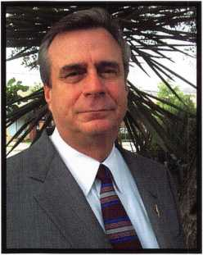

END 1: Legislation

In 2005, ALOA effectively represented members' interests concerning bills and regulations across all 50 states, including: electrical contractors' issues in Missouri; alarm issues in Mississippi; locksmith licens­ing (new and current laws) in Indiana, Maryland,

New Jersey, Oklahoma, Tennessee and Texas; auto­motive key origination in California, Pennsylvania and Wisconsin and continued working closely with the National Burglar and Fire Alarm Association to forge a lasting relationship and cut down on future harmful state legislation. On the national level, we worked closely with a coalition to support Association Health Plan Legislation in Congress.

ALOA worked closely with Texas on a positive ID poli­cy under the current licensing law and with the Oklahoma Master Locksmith Association to try to bring locksmiths under their current alarm law. We continued with support to the Tennessee Organization of Locksmiths (TOOL), the Middle Tennessee Locksmith Association and the East Tennessee Locksmith Association to help with their locksmith license bill.

We continue to work on the fight for access informa­tion for automobiles by leading the creation of the Vehicle Security Committee as part of our participa­tion with the National Automotive Service Task Force (NASTF), and hosting its first meeting at the ALOA Convention in Rosemont. We also helped begin the process of formalizing NASTF to make sure locksmiths were represented. ALOA moved forward with identi­

fying potential plaintiffs in a lawsuit against auto manufacturers concerning the release of key code information.

For the first time, we participated in the National Council of State Legislators (NCSL) Annual Conference with a booth at their convention, attended by over 900 state legislators. Legislators from Alaska,

Hawaii, Indiana, Maine, Maryland and Washington expressed interest in locksmith licensing, and we fol­lowed up with each one for possible legislation in 2006.

END 2: Recognition

One of the areas where we provide membership recognition is to security product manufacturers through the ALOA Annual Convention & Security Expo where over 250 manufacturers regularly exhibit, recognizing that ALOA members are the most quali­fied buyers and providers of security hardware and services. In addition, our sales staff contacts hundreds of additional companies to inform them of our exposi­tion. We are working with the Financial Security Products Association (FSPA, formerly NIBISA) to cre­ate a training program for locksmiths working in banks. A certification program and training facility are envisioned. We have also worked with NBFAA, ASIS and DHI on a variety of projects, mostly legisla­tion and education. ALOA is recognized by these groups as a viable professional organization. ALOA has had reciprocal arrangements with DHI regarding convention attendance at member rates. ALOA also



Keynotes • July/Aug 2006

has an agreement with DHI for providing training materials to members at a discount. ALOA is exchanging VIP passes and convention promotional material with the National Cargo Security Council that had their convention at BWI on July 18 - 20, 2004. ALOA is promoted the 2005 ALOA convention to the following industry groups: International Facility Managers Association (IFMA), Financial Security Products Association, Building Owners & Managers Association (BOAAA) and Association for Facilities Engineering (AFE). We continue to work closely with SHDA on legislation. I usually attend SHDA Board meetings and the Legislative Manager attends the SHDA convention. The US Department of Labor through the Bureau of Apprenticeship and Training has certified the updated ALOA National Apprenticeship Standards for Locksmiths. We have written the proficiency test for Locksmith Licensing in North Carolina. We will grade the tests and maintain the database for the state. ALOA has been approved by the Texas Department of Public Safety as a Locksmith/Security training facility. At the GPLA Convention last October, David Lowell, Bob Mock, Bill Young, Vernon Kelley and I met with representatives of the ILA. Discussions included a proposal that ALOA provide administrative services for the ILA. At this time the ILA is preparing a list of tasks that ALOA might perform. ALOA will then consider providing these services for a fee. ALOA may perform the tasks free for a period of time to develop the experience neces­sary to determine pricing. The ALOA logo is being used in combination with a link to our site by over 100 of the ALOA members. Over 30 of these mem­bers feature the logo on their sites. Associate members also link to the ALOA site. During the convention advertising period, this number increased. The ALOA logo is affixed to all correspondence. With the addi­tion of re-certification many distributors, manufactur­ers and associations have asked ALOA to recognize their training. Many of these have agreed to include in their advertising that their education meets ALOA requirements. They are being encouraged to use the ALOA logo.

END 3 - EDUCATION:

The ALOA Continuing Education (ACE) program con­ducted 160 full day and 34 half-day ACE classes & seminars at 21 locations for 2005. It should be noted that in an effort to bring ACE classes closer to the members, 90 of these full day classes were conducted away from the ALOA convention at the following sites: Kalamazoo, Michigan (3 times); Detroit, Michigan (2 times); Minneapolis, Minnesota; Secaucus, New Jersey; Denver, Colorado; Montgomery, Alabama; Dallas, Texas (2 times); Casper, Wyoming; Carlsbad, New Mexico; Portland, Oregon; Fargo, North Dakota; Appleton, Wisconsin; Sturbridge, Massachusetts and St Louis, Missouri.

On August 22 - 28, 2005 we conducted our first Six- day Basic Locksmithing Course at the new ALOA Training Center classroom. We had a full class of 12 students. On December 5-10, 2006 we conducted the second Basic Locksmithing Course and also had 12 students. More classes are planned for 2006.

In 2005 we conducted training in the areas outlined in the Ends statement as follows:

|  |  |  |
| --- | --- | --- |
|  | Classes | Students |
| 14% Automotive | 27 | 413 |
| 16% Electronic Security  12% Safe and Vault | 30 | 472 |
| Servicing | 24 | 354 |
| 48% Mechanical Security | 94 | 1415 |
| 10% Business | 19 | 295 |

Total number of student class days—2949

Proficiency Registration Program (A Component of Education):

1. We administered the PRP at 36 regular sittings with 460 participants in 2005.
2. In addition there were 45 ACE classes that provid­ed after class PRP exams. There were 368 students that chose the option to take the after-class PRP's. The pass rate for these exams is 90%.
3. Currently there are 717 CML's, 657 CPL's, 2733 CRL's and RL's (646 grand fathered RL's).

**67**

Keynotes • July/Aug 2006

1. There are 3630 registrants in the program who have taken but not passed some portion of the CRL requirement.
2. There are a total of 7737 participants in the PRP database at this time.
3. ALOA also administers the SAVTA STPRP. There are 11 CMST's, 206 CPS's and 195 who have taken and not passed the CPS or CMST exam.
4. The Mandatory Categories of the PRP along with L-03 Domestic Auto and L-04 Foreign Auto was translated into Spanish in order to facilitate administering the PRP exam to 43 Mexican lock­smiths in Mexico City. This resulted in the addi­tion of 43 new ALOA members from Mexico and laid the ground work for forming a larger ALOA presence in Mexico and Latin America.

END 4: COMMUNICATION

The two continuous forms of communication available to the membership are Keynotes and the web site.

Both of these vehicles routinely feature information about products, techniques and industry news. Below is a summary of the web activity for the past year.

Total Sessions 160,319

Total Pageviews 1,337,992

Total Hits 3,905,471

Total Bytes Transferred 46,132,729,120

Average Sessions Per Day 438.03

Average Pageviews Per Day 3,655.72

Average Hits Per Day 10,670.69

Average Bytes Transferred Per Day 126,045,707

Average Pageviews Per Session 8.35

Average Hits Per Session 24.36

Average Bytes Per Session 287,755

Average Length of Session 373

Part of the Communication End requires that members have access to manufacturers. Convention provides the members with direct access to the manufacturers, both on the show floor and in classes. There were 177 (including complimentary booths) exhibitors at the past convention, many of these were manufacturers. Many of the seminars and half-day classes at conven­tion were taught by manufacturers.

END 5 - PROFESSIONALISM:

The PRP is becoming more nationally recognized through the various state licensing agencies requesting either specific portions of our test (Illinois) or contract­ing with the ALOA PRP department to develop a cus­tomized test based on the ALOA PRP (North Carolina).

The most notable recent activity in this area is the new ALOA Bylaws requirement for re-certification. The activity that has resulted from this requirement includes articles in locksmith related publications, numerous comments on web sites, as well as calls from members and providers of education. Nothing has been done since the creation of the PRP that has caused more publicity than re-certification.

Members who pass the various levels of the PRP are listed on the ALOA website and in Keynotes maga­zine. In addition they receive a press release that can be sent to their local newspapers.

ALOA has participated with several industry groups on many issues. The Education Manager represents ALOA on the UL Standards Technical Panel for Physical Security Devices, (STP 687) which this last year updated the standards (related to fishing test methodology) for UL291 - Automated Teller Systems, UL687 - Burglary Resistant Safes, UL786 - Key Locked Safes, UL771 - Night Depositories, Currently they are working on a proposed High Security Electronic Locks Standard - UL2058.

He is also serving on the ASTM International newly formed Committee E36.20 - Certification/Registration Bodies whose scope is to establish an American National Standard that defines terms and processes related to personnel credentialing (i.e., licensure, certi­fication, registration, training, etc.). This standard will be used by personnel credentialing bodies to harmo­nize terminology and reduce confusion among the users - and users will reference this standard when requiring personnel credentialing. ASTM International, originally known as the American Society for Testing and Materials (ASTM), was formed over a century ago and is one of the largest voluntary standards development organizations in the world-a trusted source for technical standards for materials, products, systems, and services.

**68**

Keynotes • July/Aug 2006

FINANCIAL REPORT

The firm of Sutton Frost Cary was engaged to audit the 2005 ALOA financial records. The ALOA Audit Committee has reviewed this report. Parts of the Audit, the "Statement of Financial Position" (Balance Sheet) and the "Statement of Activities" (Profit and Loss) are printed with this article. The Auditor found that ALOA's financial records fairly and accurately portray ALOA's financial position.

The financial statements presented this year are unusual. The activity concerning the sale of our old building and the purchase of the new one are in these statements. That makes it difficult to compare this year's statement to last year's. The Statement of Activities separates the building related income and expense from our "regular" income and expenses. However, standard accounting procedures do not allow all of these expenses to be separated. In general only those expenses that can be depreciated are separate. Under our "regular" expenses, the auditor added a "moving expenses" line ($101,278). There were many other expenses associated with the building that are just in our normal lines. In all, these expenses are another $150,000. This means that, exclu­sive of any financial activity associated with the building(s), ALOA lost approximately $100,000 last year. Including the building financial activity, ALOA gained approximately $200,000.

After remodeling and repair, ALOA moved to its new headquarters in May of 2005. We have already conducted several classes in the new training facility. The new building adds greatly to the association's ability to provide services to members.

ALOA continues to be financially capable of providing the services specified by the Board of Directors.

ASSETS

STATEMENT OF ACTIVITIES

20042005

20042005

Current assets:

|  |  |  |
| --- | --- | --- |
| Cash | $537,850 | $533,319 |
| Certificate of deposit | 66,183 | 65,669 |
| Accounts receivable | 271,759 | 243,418 |
| Inventory | 62,796 | 63,993 |
| Prepaid expenses | 140,935 | 202,933 |
| Dues from affiliates | 62,721 | 27,969 |
| Deposit on Purchase of Property — | | 10,000 |
| Current portion of notes |  |  |
| receivable from affiliates | 17.891 | 18,995 |
| Total current assets | 1.186.637 | 1.141.794 |
| Property and equipment: |  |  |
| Land | 79,836 | 97,500 |
| Building and improvements | 307,352 | 643,873 |
| Furniture and equipment | 526.893 | 269.955 |
|  | 914,081 | 893,672 |
| Less accumulated depreciation | (724.443) | (179.900) |
| Property and equipment, net | 189.638 | 831.428 |
| Note receivable from affiliate, |  |  |
| less current portion | 120.504 | 101.509 |
|  | $1,451,936 | $2,119,574 |
| LIABILITIES AND NET ASSETS | | |
|  | 2004 | 2005 |
| Current liabilities: |  |  |
| Accounts payable | $60,737 | $97,970 |
| Accrued expenses | 43,139 | 58,358 |
| Current maturities of long-term debt | | 7,060 |
| Prepaid dues | 587,300 | 455,510 |
| Prepaid exhibit fees | 439.825 | 486.750 |
| Total |  |  |
| liabilities | 1,131.001 | 1.098,588 |
| Net assets- unrestricted | 320,935 | 1,020,986 |
|  | $1,451,936 | $2,119,574 |

Revenues

Membership dues and services

Convention

Management fee

Legislative Income

Advertising

Promotional programs

Interest

Educational programs Miscellaneous

Total revenues

Expenses

Administrative Convention Keynotes magazine Building operations Member services Depreciation Promotional programs Educational programs Committee Moving Expense

Total expense

Excess Income (deficit) from revenue over expenses

Gain on sale of property Increase in net assets

Net assets at beginning of year

Net assets at end of year

|  |  |
| --- | --- |
| $941,087 | $927,263 |
| 768,535 | 821,410 |
| 126,000 | 156,000 |
| 146,930 | 147,926 |
| 88,188 | 124,458 |
| 49,376 | 47,025 |
| 18,281 | 26,240 |
| 91,224 | 124,172 |
| 12,933 | 728 |
| 2,242,554 | 2,375.222 |
| 1,195,197 | 1,362,993 |
| 345,098 | 435,862 |
| 171,363 | 177,763 |
| 76,906 | 178,956 |
| 60,876 | 77,622 |
| 23,878 | 47,246 |
| 23,951 | 47,287 |
| 120,255 | 158,352 |
| 5,704 | 8,096 |
| — | 101.278 |
| 2,058,970 | 2,652,336 |

|  |  |
| --- | --- |
| 183,584 | (277,114) |
| — | 977,165 |
| 183,584 | 700,051 |
| 137.351 | 320.935 |

$320,935 $1,020,986

Keynotes • July/Aug 2006

**69**



THANK YOU TO THE LEGISLATIVE ACTION NETWORK COUNCIL MEMBERS!!

The Legislative Action Network (LAN) is an important tool in main­taining ALOA's legislative presences in State Capitals across the United States. For members who contribute $100 or more to the Legislative Action Fund, they become a member of the prestigious Legislative Action Network (LAN) Council. The Council is an important instrument in raising the standards of our profession through the legislative process by making sure that locksmiths have the final say in how our industry will be run. LAN Council mem­bers receive:

• The quarterly Legislative Action Network Update alerting you to important legislation in your state and around the country (same as LAN members)

* A comprehensive guide to lobbying in your state capital, so you can be the "voice of ALOA" to legislators.
* A lapel pin designating you as a special ALOA LAN Council member,
* Recognition in Keynotes magazine.
* Invitation to exclusive functions at the annual ALOA convention for LAN Council members.
* Complimentary Legislative Convention merchandise.

It's simple to join the LAN Council! Just go to [www.aloa.org/legislation](http://www.aloa.org/legislation) and click on "Join the Legislative Action Network!" Do it today!

LEGISLATIVE ACTION NETWORK COUNCIL MEMBERS

(as of 06/01/2006)

Kevin E. Ahrens CRL

Robert J. Akin Jr

Eugene R. Anderson RL, CPP,

AHC

Robert A. Arthur RL Larry H. Bachman CML Ryan L. Badeaux Dana L. Barnum CML Lawrence I. Barrett Sr, RL Lawrence I. Barrett Jr Robert Barton John S. Becker Sr Mark E. Blum CML, CPS Rolando Bouza Donald L. Brown CML Adrian D. Busse CPL, CPS Kyoung Oh Chang Elliott R Connor CPL John H. Cosby CPL Olen Cothron CRL Paul Davis Michael T. Day CPL Mark Dorn

Mike D. Dunkerley CPL Richard L. Dyer CPL, CPS Joe Earley

R. Terry Earll CML Alfred W. Evans Ronald G. Ferrill Glen W. Fessenden CML Michael Festa CRL Patrick A. Filholm CPL Michael L. Finn CML Aaron Max Fish Dan Floeck

Vincent L. Formon CML, CPS

Charles J. Gladd CML, CPS

Thomas R. Gonzales

Daniel M. Graffeo CRL, CMST

John J. Greenan CML, CPS

Grant H. Grein CRL

Kenneth A. Griffin CML, CPS

Lee Griggs

Eugene Gyure CRL

Neil A. Harding

Jim D. Harnden CRL

Paul W. Hawk CRL

Lucian Lee Hayden

Philip J. Heath

Scott L. Henke CPL, CPS

Edward J. Henning CPL

Claude A. Hensley

Jim W. Hetchler

Andy Hilverda

Edward A. Hite CML

John A. Ilk CRL, CPS

Howard H. Johnsen

Thomas R. Johnston

Martin J. Jordan RL

Joseph S. Kasenchak

David A. Keenan CRL

Danny R. Knight CRL

Karl R. Kretscn CRL

Richard A. Labbe

Clifford D. Lipscomb CML, CPS

Henry R. Lucier

Jack C. Magee III

William L. Mandlebaum CPL

Michael Marmo

Julie McCluney CRL

William J. McElheney CML

Thomas B. McKinney

Dennis D. McLeod

Barry L. McMenimon CPL

Christopher L. Melton CPL

Jerry L. Miller

Jimmy L. Mowry CML

John W. Murphy CRL

Autley Musselwhite

Bruce S. Nemec CML

Sean Olden

Tom W. Olson

Kevin R. O'Toole

Joseph H. Peek

John H. Perron RL

Richard R. Peterkin CPL

Joe Pielech CRL, CPS

Don F. Ponder CRL

John R. Presti Sr

James P. Pritchett CPL

James L. Queen, CML

Gordon R. Racine CML

Daniel J. Rackliffe CML Richard D. Rebori Richard J. Reichert CRL Jon Rickard Gerald G. Roraback Donald E. Rule CML Frank A. Schlesser Arthur M. Shoob Jr, CML Larry E. Smith CPL Lawrence F. Smith Jr, CML David P. Snyder Sr Marian M. Swann CRL Thomas W. Tate CRL David D. Taylor CRL Walter F. Taylor Jim Thomas

Rodney E. Thompson CPL

John E. Trone Jr, CPL

Masatoshi Uno

Thomas G. Vandersteen CML,

CPS

Marion J. Walters CRL

Paul A. Wesoly RL

James J. White

Eric H. Wilderson

Roger G. Williams RL

John H. Williamson CRUames

M. Young

William L. Young CML, CPS Mehdi Zahedi CRL Kathy A. Zaniolo CML

Keynotes • July/August 2006



g i s I a t i  
date

v

e

ALABAMA, OKLAHOMA AND TENNESSEE PASS LOCKSMITH LICENSING LAWS!

Through the hard work of the Alabama Locksmith Association and the Oklahoma Master Locksmith Association, both organizations were successful in passing locksmith licensing in just one year!! They took a novel approach: write locksmiths into existing alarm licensing statutes. After years of working toward state licensing, the Tennessee Organization of Locksmiths (TOOL), the Middle Tennessee Locksmith Association, and the East Tennessee Locksmiths led by the efforts of Jim Wiedman, CPL were finally suc­cessful of achieving their goal this year. Louisiana was successful in passing a bill that put existing locksmith licensing under the State Fire Marshall's office and opened up the licensing to more options. For a complete look at all these bills go to: <http://www.aloa.org/legislation/Leg_Map/ALOA_Map.htm>

(Due to space limitation, full articles on these licensing success sto­ries will appear in the September issue of Keynotes).

NUMEROUS LEGISLATIVE ACTIVITIES WILL KEEP YOU INFORMED AT CONVENTION!!!

Find out what's the latest happening in your state capitol. Find out how ALOA's new Take Action! will help you contact your state rep­resentative or senator about a certain bill. Get free popcorn.

Come to the "State of the States Roundtable"

This is just some of what you can expect this year from the Legislative department at the ALOA 2006 Convention and Security Expo in Las Vegas. Here are some of the highlights:

Thursday July 13, 2006 thru Saturday July 15, 2006 Noon to 5pm (Noon to 4pm Saturday)

LEGISLATIVE BOOTH AT SECURITY EXPO

Once again, we'll have the popcorn machine serving up fresh hot buttered popcorn but now we've added activities that you can participate in as well! On site we'll have information on all bills, and legislation in your state PLUS our UPDATED "Locksmith Lobbying for Licensing: A Guide for Influencing your State Legislature and Governor."

Free Convention merchandise for Legislative Action Network Council ($+100 and up donation) members.

Friday, July 14, 2006 1 pm to 12:30pm

NASTF VEHICLE SECURITY COMMITTEE MEETING

Come find out the latest happenings of the National Automotive Service Task Force's Vehicle Security Committee!

Friday, July 14, 2006 3pm to 4:30pm

STATE OF THE STATES ROUNDTABLE

This meeting is designed as a forum for ALOA chapters and local/state regional locksmith associations to share information about the state of locksmithing in their region and a dynamic way to share ideas. Primarily for the Chairman, President and Legislative representative from each organization, all locksmiths are encouraged to participate. This is the perfect opportunity to learn about what's going on in the industry across the nation.

Keynotes • July/August 2006

**Classifieds**

EMPLOYMENT

LOCKSMITH WANTED

Commercial, Residential, Auto Work for a Licensed contrac­tor. Salary & commission.

24 Hour Shop. Fax or mail resume to: J&J Locksmiths, 3201 Fulton Avenue, Sacramento, CA 95821.

Fax: 916-485-9385,

Ph: 916-482-4213

LOCKSMITH TECH WANTED

Sanders Lock & Key, San Dimas, CA. High volume shop. Residental, automotive, commerical, Commission based pay. Contact Chris at 909-599-3178.

LOCKSMITH WANTED

Locksmiths wanted at Liberty Lock & Safe! All Positions.

Fast Paced. Performance Pay, Great Benefits. Beautiful

weather. 29th Year in Business. Over 50 Employees and growing. Professional skilled locksmiths only. Call James at 702-284-5404.

INVENTORY CONTROLLER WANTED

Inventory Controller Wanted at Liberty Lock and Safe! Inventory experience and hardware knowledge are required. Call James at 702-284-5404.

SEEKING A NO BUY-IN PARTNER, TEAM PLAYER, LOCKSMITH

South Florida (Broward) Locksmith Company seeks an honest, dependable, and reli­able outside service person to service mostly commerical accounts. Excellent opportuni­ty for an individual dedicated to the Trade and Customer

service and to share in the benefits and profits of this 1 9 year old company. Most of the benefits of being a part­ner without the headaches. Health Insurance, Retirement, Vacation, Profit Sharing, Vehicle, Tools and Uniform. Contact Art at [ASLinc2@earthlink.net](mailto:ASLinc2@earthlink.net) with resume and requirements and more information. 954-989-4848.

WANTED TO BUY/SELL

KEY BLANK CATALOG WANTED

Looking for copy of llco Key Blank Catalog #19. Contact Roger Weitzenkamp at 970- 882-7191 or by mail at 25913 Road T.5, Dolores, Colorado 81 323.

Classified Advertising Policy

Classified advertising space is provided free of charge to ALOA members and for a fee of $2.00 per word, $40.00 minimum for non members. Classified ads may be used to advertise used merchandise and overstocked items for sale, "wanted to buy" items, business opportunities, employment opportunities/positions wanted and the like. Members or non members wishing to advertise services or new merchandise for sale may purchase a "Commercial Classified Ad" for a fee of $4.00 per word with a minimum of $ 100.00. Each ad will run for two issues. For blind boxes there is a $10.00 charge for members and non members. All ads must be submitted in writing to the Advertising Sales Department via fax at 817-645-7599 or through an email to [adsales@aloa.org](mailto:adsales@aloa.org) by the fifteenth of the month two months prior to issue date. ALOA reserves the right to refuse any classified adver­tisement that it deems inappropriate according to the stated purpose of the classified advertising section.

FOR SALE

Key Machine KD55 Unican. Contact Albemarle Lock and Safe b email at: [snowder- row@aol.com](mailto:snowder-row@aol.com) or call 1-434- 977-5397 and ask for Linda or Scott Johnson. Asking $450.00 plus shipping.

FOR SALE

Mobile Locksmith Business for Sale. Central New Jersey. Established 15 years, only locksmith in town. Hitop con­version van, key machines, tools. Offers considered. For more information please email: [isl245@comcast.net](mailto:isl245@comcast.net)

ELECTROPICK FOR SAFE

Brand new surplus HPC Electropick No. EPG-1. Factory fresh, unopened. List price $141. Sell for $60 plus $8 shipping to anywhere in the US. Check, money order or credit card. Please send email to George at [select- locks@aol.com](mailto:select-locks@aol.com) or fax to 925- 820-6698.

BUSINESS FOR SALE

Well established Lock and Security business for sale, located in sunny southern Colorado, serving the entire San Luis Valley and surround­ing area, a population of

approximately 50,000 and growing rapidly. We have 300 plus security accounts, locksmiths has limited compe­tition, gross income in the six figure range. Great hunting, fishing, sand dunes national monument, surrounded by mountains, skiing only an hour away. We have four long term employees, med­ical, retirement and bonuses are some of the benefits we offer. Sale includes four serv­ice vehicles, entire inventory and equipment, building sale includes two rentals presently occupied. For more informa­tion, please contact Bob or Ivan. Valley Lock & Security, Inc. 500 Main Street, Alamosa, CO 81101.

Tel. 719-589-5895.

Fax 719-589-4299. Valleyloc@fone. net

BUSINESS FOR SALE

Started in 1973, same loca­tion since 1978. Well over 50,000 blanks, 9 key machines, 2 Curtis # 15s with a lot of cams and carriages, plus all tools, inventory and accounts. Low rent, excellent landlord. Owner must retire due to health, will help with transition. $100,000 firrm.

609-646-9065 Monday- Friday 9a.m. - 1 pm 609-652- 6073 Evenings and week­ends.

BUSINESS FOR SALE

Well established locksmith business since the 1950's for sale due to health reasons. Serious inquiries only to Advanced Lock Service, 18 N. Van Brunt St. Englewood, NJ 07631.

BUSINESS FOR SALE

Mom and Pop Locksmith and Screen Business for Sale in Golden Valley, Arizona. Located between Kingman,

AZ and Laughlin, AZ in fast growing Mohave County. Health and age are our rea­sons for selling. Our Dodge Ram Van and Business have more than $75,000.00 in equipment and inventory. All is included. Three bedroom, two bath 24x24 detached garage (which now houses the business) on 1.7 acre lot with all utilities and no assess­ments owed. Make an offer that is reasonable for this area. 928-565-2294 or email at [lmburks@citlink.net](mailto:lmburks@citlink.net)

Kaba Access Control Introduces Kaba University

Kaba Access Control is pleased to introduce Kaba University. Simplex started the keyless revolution with the creation of the first mechanical pushbutton lock over 40 years ago. Since that time, users have been successfully certified throughout the United States, Canada and around the world - resulting in a strong dealer network that has made Simplex truly the industry leader in keyless access control and brought success to you, our dealers. Kaba University provides expanded pro­fessional training in the wide breadth of Kaba Access Control products.

Simplex Certification - Mechanical Pushbutton Locks

E-Plex Certification — Electronic Stand-Alone Access Controls

E-Plex Advanced Access Control Software Certification - Electronic Stand-Alone Access Controls

Peaks Certification - Patented Key Controls

Courses include hands-on training for an in-depth under­standing of products, product tips and shortcuts, as well as appropriate applications. Upon successful completion, you will receive:

* Certificate of Product Training
* Product Samples
* Listing on Kaba website as Factory Trained Dealer
* Points towards ALOA PRP re-certification

For additional information on our courses and scheduled dates, visit [www.kaba-access.com](http://www.kaba-access.com) or e-mail

**KABA UNIVERSITY**

COLLEGE OF ACCESS CONTROL

**74**

Keynotes • July/August 2006

ALOA Attendees... WIN!

Locksmith Nostalgia

Prints

Supporting Our Industry

Our locksmithing roots in North America go back to the early  
eighteen hundreds. Through the years the companies of  
the Kaba Group have supplied the industry with innovative  
products to help locksmiths compete in an ever changing  
world.

Visit the Kaba booth to see what’s new this year.

=Hnn

Key Systems

KABA

Access Control

KABA

Safe &

Container locks

ALOA attendees can win a complete set of four attractively framed Locksmith Nostalgia Prints at the Kaba Booth. A great addition to any shop, office or den. Visit us at the show!

*Th& ntvf Wy nuclim

**Booth 101 at ALOA [www.kaba-ilco.com](http://www.kaba-ilco.com)**

**KABA**

TOTAL ACCESS

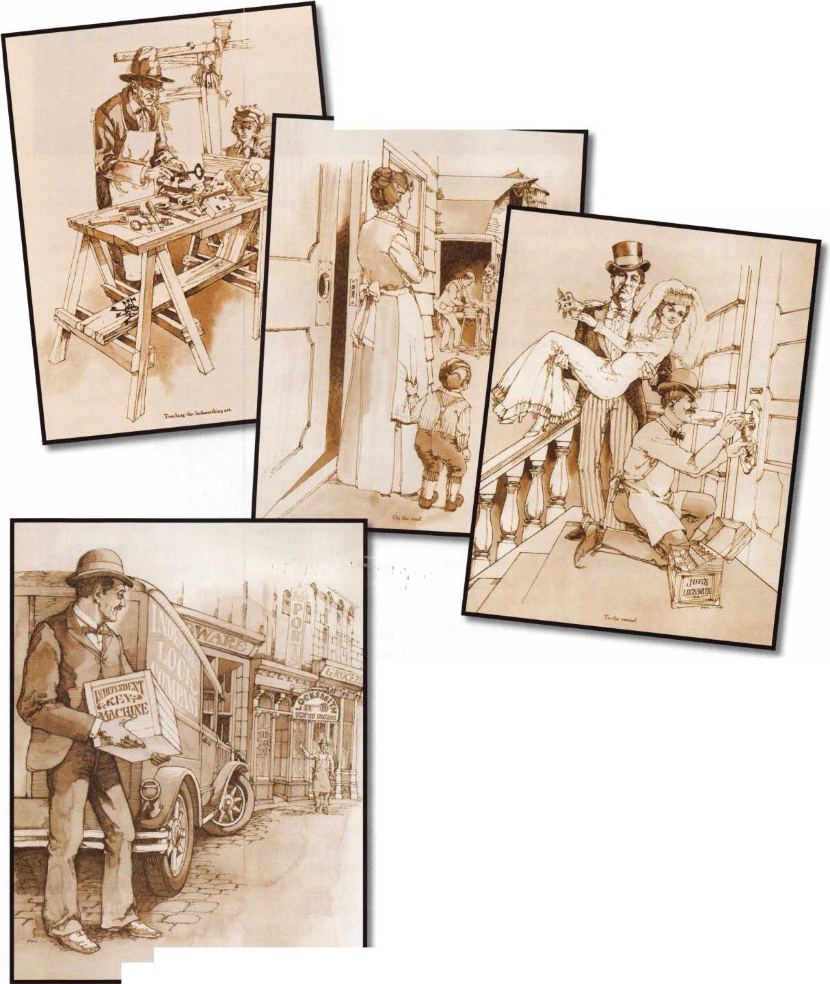

*f*

core

Announcing the Stanley® Sargent and  
Greenleaf Racing Sweepstakes

Grand Prize Winner Receives an All Expense Paid Trip for  
Two to the Big Race in Daytona Beach, Florida in 2007

Sargent & Greenleaf (S&G), a subsidiary of Stanley  
Security Solutions Inc., is excited to announce the  
Stanley® S&G® Racing Sweepstakes. From June 1st  
until September 30th, locksmiths and safe and vault  
technicians in the U.S. are eligible to enter the  
Stanley® S&G® Racing Sweepstakes with a  
chance to win the grand prize of an all expense  
paid trip for two to the big race in Daytona  
Beach, Florida in February 2007.

It's easy to enter. During the sweepstakes period  
June 1- September 30, purchase any number of par-  
ticipating S&G® products, then go to  
[www.sglocks.com/racing](http://www.sglocks.com/racing) and complete the registration

form*. Participating products are S&G® Biometric keypad;  
S&G® Audit Lock; S&G® Z02 Rotarybolt™ Safe Lock;  
S&G® Z02 D-Drive™ Safe Lock.

On October 31st, Sargent & Greenleaf will randomly select the grand prize winner and two-hundred fifty second prize winners. The Grand Prize winner will receive an all expense paid trip for two to the big race February 2007 in Daytona Beach, Florida.

The Grand Prize package includes airfare, tickets to the race, 3 night hotel accommodations, a rental car and $1000 cash. Second prize winners receive a Stanley® Sargent & Greenleaf® Racing T-Shirt.

*No purchase necessary. To learn how to enter without purchase, see the complete Official Rules, available at [www.sglocks.com/racing](http://www.sglocks.com/racing).

About Stanley Security Solutions

Stanley Security Solutions, a business division of The Stanley

Works, is a provider of access  
and security solutions for  
institutional, commer-

cial and industrial

businesses and  
organizations.  
With a strong  
emphasis on  
service,  
Stanley  
Security  
Solutions  
delivers a com-  
prehensive suite  
of security prod-

ucts, software and  
integrated systems directy

to end user customers. Stanley  
Security Solutions is committed to extending its position as a  
leading comprehensive resource for a broad and extensive  
array of solutions that span the entire security spectrum.

About Sargent and Greenleaf

Sargent and Greenleaf, a subsidiary of Stanley Security  
Solutions Inc., is one of the world's leading manufacturers of  
medium and high security locks and locking systems. Since  
1 857, Sargent and Greenleaf has provided security solu-  
tions to financial institutions, commercial businesses, govern-  
ments, and consumers around the world. Delivered through  
an international network of distribution partners, Sargent  
and Greenleaf® products continue to set the standard for  
quality, value and technical innovation. For more informa-  
tion, visit the company online at [www.sargentandgreen-  
leaf.com](http://www.sargentandgreen-leaf.com), or call (859) 885-9411.

**^DAYTONA'?/4**

\

llttill IM twilflf' *

fV —

£] Keynotes • July/August 2006

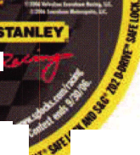

**Stop giving your profit to carpcntcrs and lumbcryardsi**

**FoUR-PI€C€ STEEL SYSTEM R€INFORC€S EXISTING ENTRY DOORS**

**Fix broken doorjambs and secure your hinges**

WITHOUT REMOVING THE DOOR

**Can be installed in under an hour and painted**

TO MATCH THE DOOR

**Standard**

SET

**Universal**

**Set**

**Door Shield**

**Hinge Shield**

**Once installed, pieces are**

BARELY VISIBLE. YOUR CUSTOMERS  
WILL FORGET THEY ARE THERE,  
UNTIL THEY NEED THEM

**Fits doors with**

STANDARD LOCK  
SPACING

**Fits doors** with

NON-STANDARD LOCK SPACING

**Come see us at ALOA booth I4ii**

**You HAVE NOT SEEN THIS PRODUCT BEFORE!**

HOMC SCeUBITT THAT ACTUALLY WORKS^BCFORC INTRUDCRS CMTCRI [WWW.DJARIMOR.COM](http://WWW.DJARIMOR.COM) 1-880-982-2294

© 2005 A&G Security LLC. All rights reserved. Door Jamb Armor and Because You Cant Afford False Security are trademarks of A&G Security LLC.

Info source: Bureau of Justice Statistics, US Department of justice, FBI Uniform Crime Report

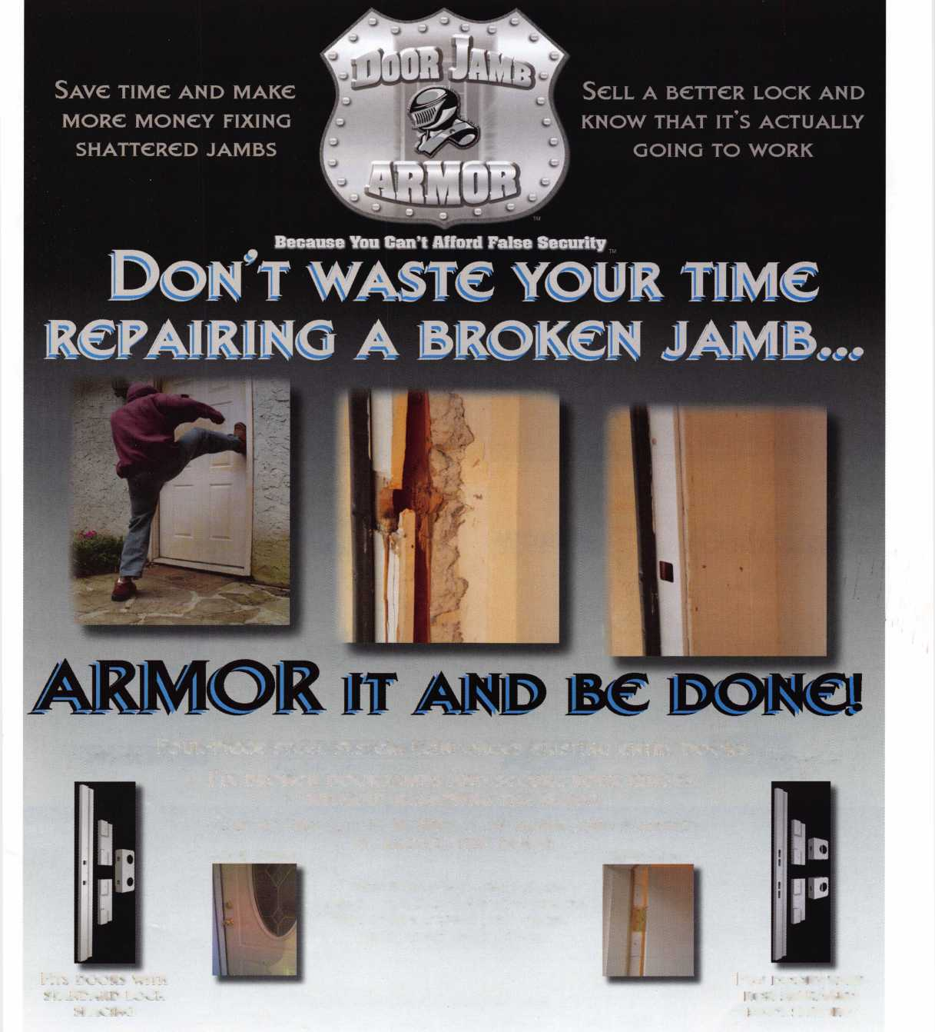

ASSA ABLOY

**The World's Leading Lock Group**

|  |  |  |  |
| --- | --- | --- | --- |
| S3 ABLOY |  | SINCE 1880  //£ '“'AfERICAN OB*0^ | Russwjn |
| -TCCURITROrr | Yale | medeco  HIGH SECURITY LOCKS | T  I.MUL-T-LOCK |
|  | ASSA | FOLGER ADAM  ELECTRIC DOOR CONTROLS | SARGENT |
|  | AIOA  Visit us at , 7 | | booth #301 |
|  |  | uu  1956-2006 |  |